Incamake y’ibyo twabwiwe n’abagenerwabikorwa ku byerekeranye n’akazi kabo.

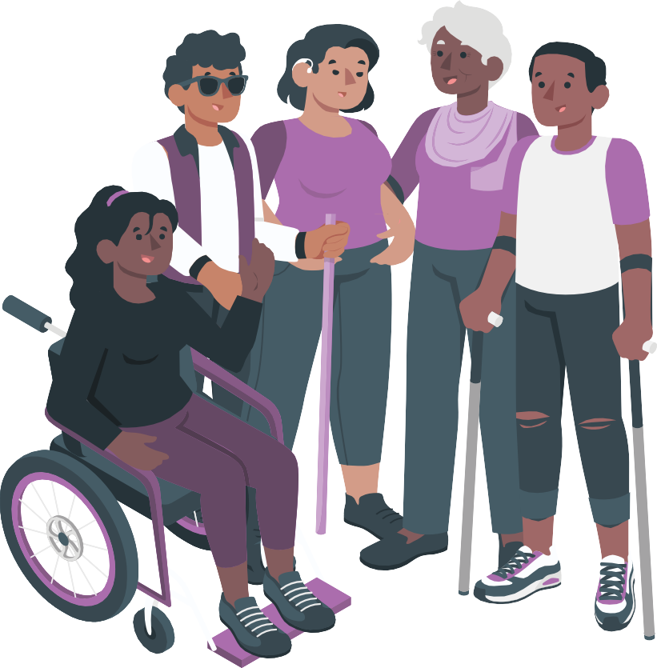

Easy Read Version

**Uko iyi nyandiko ikoreshwa**

Iyi nyandiko ni **incamake y’ibyavuye mu bushakashatsi**.



**Incamake** ni ubusobanuro bw’ikintu runaka mu magambo macye.

**Ubushakashatsi** ni uburyo bwo kumemya icyo abantu batekereza ku kintu runaka.

Umuryango wacu witwa **Disability Rights Fund**.



Twanditse igice cya mbere cy’iyi nyandiko.

Igice cya mbere cy’iyi nyandiko kiri ku mpapuro guhera ku rwa 2 kugeza ku rwa 11.

Twasabye kandi bamwe mu **bagenerwabikorwa** bacu kwandika inkuru ku byerekeranye n’ibintu bibatera ishema.



**Abagenerwabikorwa** niimiryango ikora ibintu bimeze **nk’ubuvugizi** ku byerekeranye **n’uburenganzira** bw’abantu bafite ubumuga.



**Gukora ubuvugizi** bisobanura kuvuga ku kintu kigufitiye akamaro.

**Uburenganzira** ni ibintu buri muntu wese agira.



Urugero, buri muntu wese afite uburenganzira bwo kubaho mu mutekano no kugira ubuzima buzira umuze.

Igice cya 2 cy’iyi nyandiko gikubiyemo 4.

Izi nkuru ziboneka ku rupauro rwa 12 kugeza ku rwa 19.

Iyo ubonye iri jambo ‘wowe’, bisobanura umuntu usoma iyi nyandiko.



Twanditse iyi nyandiko mu buryo byorohera uyisoma.

Harimo amagambo amwe akomeye.

Tuzajya



* Twandika amagambo akomeye mu ibara **rigaragara cyane**.
* Dutanga ibisobanuro byayo.

ushobora gusaba undi muntu kugufasha

* gusoma iyi nyandiko.
* kumenya ibyo iyi nyandiko yibandaho
* Kubona andi makuru.

**Ushobora kubona inyandiko y’umwimerere kuri uru rubuga rukurikira:** [**https://disabilityrightsfund.org/ta-learning-**](https://disabilityrightsfund.org/ta-learning-summary/) **Incamake** [**/**](https://disabilityrightsfund.org/ta-learning-summary/)

**Turi bande?**

Dutera **Inkunga** imiryango ihuza abantu bafite ubumuga.

**Inkunga** igizwe n’amafaranga atishyurwa. Abantu bahabwa ayo mafaranga bitwa **bagenerwabikorwa.**

Dutera inkunga imiryango y’abafite ubumuga yo muri



* Afurika
* Aziya
* Mu Birwa bya Karayibe
* Mu Nyanja ya Pasifike.

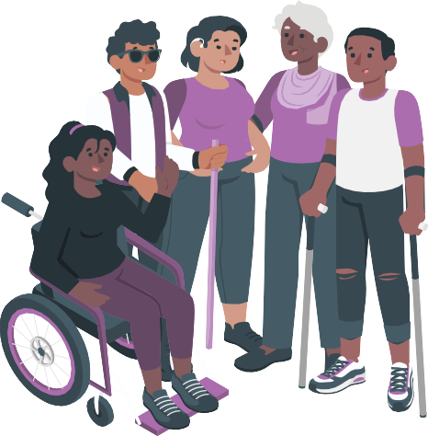Inkunga yacu yibanda ku burenganzira bukubiye mu **Masezerano ku byerekeranye n’Uburenganzira bw’Abantu bafite ubumuga.**

Amasezerano ku byerekeranye **n’Uburenganzira bw’Abantu bafite Ubumuga** ni amasezerano arebana n’abantu bafite ubumuga.

Amafaranga atanga akomotse ku nkunga akoreshwa mu bikorwa byo gukora ubuvugizi ku byerekeranye n’uburenganzira bw’abantu bafite ubumuga.

**Ibyerekeranye n’iyi ncamake**

Mu mwaka wa 2022, twasabye abagenerwabikora kutubwira ibijyanye n’akazi kabo.

Twabajije

* abagenerwabikorwa ibintu **bibatera ishema** kurusha ibindi

**Gutera ishema** bisobanura ko wishimiye ikintu wakoze.

* Ni ubuhe buryo bwiza kurusha ubundi twakoresheje mu gutera inkunga abagenerwabikorwa?
* ni gute twabasha gutanga ubufasha mu buryo bwisumbuyeho?



Abagenarwabikorwa 70 basubije ibibazo byacu.

Mu mwaka wa 2023, twasabye impuguke kudukorera ibi bikurikira:



* Gusoma ibisubizo byose byatanzwe kuri ibyo bibazo.
* Kutubwira ibyo abagenerwabikorwa bavuze.

Muri iyi nyandiko,

* turasobanura ibyo iyo mpuguke yatwibwiye



* Turabagezaho inkuru z’abagenerwabikorwa bane.

**Ibintu bitera abagenerwabikorwa ishema kurusha ibindi**

Abagenerabikorwa bavuze ko baterwa ishema n’ibintu byinshi.

Baterwa ishema no kuba barabaye umuryango ukomeye bakagira

* 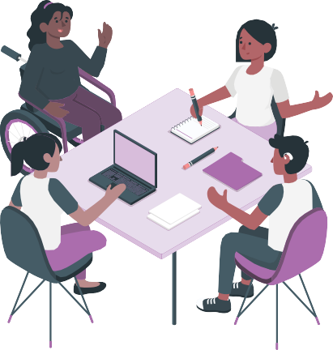abanyamuryango
* **Inama y’Ubutegetsi**

**Inama y’Ubutegtsi** ni itsinda ry’abantu bafata ibyemezo birebana n’umuryango runaka.

* **Politiki** zituma abantu babasha gukora ibintu neza.

**Politiki** iba igizwe n’amabwiriza agenga umuryango runaka aba asabwa gukurikizwa.

Baterwa ishema n’abantu babaza ibyerekeranye n’ibi bikurikira:



* Uburenganzira bw’abantu bafite ubumuga
* Uko babasha guhuriza mu buzima bumwe abantu bafite ubumuga n’abandi baturage.

Baterwa ishema n’uko Leta ibagisha inama ku byerekeranye n’uburyo yabasha gukora **amategeko** abereye kurushaho abantu bafite ubumuga.



**Amategeko** ni amabwiriza ashyirwaho na Leta aba agomba kubahirizwa na buri muntu uwo ari we wese.

Baterwa ishema no kuba abavugizi beza; bityo bakaba babasha gukora ibi bikurikira



* kuganira na leta ku byerekeranye n’amategeko akumira **ihezwa** rikorerwa abantu bafite ubumuga.

**Ihezwa** ribaho iyoumuntu runaka afatwa nabi ugereranyije n’uko abandi bantu bafatwa bitewe n’ikintu kimwerekeyeho.

* guharanira uburenganzira bw’abantu bafite ubumuga



* Kwiga uburyo bwo korohereza ubuzima abantu bafite ubumuga aho babana n’abandi baturage
* Kwigisha abantu benshi ibyerekeranye n’uburenganzira bw’abantu bafite ubumuga aho baba mu miriyango migari yabo
* Guharanira ko abantu babasha kuganira no gusoma mu buryo bumva bubabereye.

**Ni ubuhe buryo bwiza kurusha ubundi twakoresheje mu gutera inkunga abagenerwabikorwa?**

Twateye abagenerwabikorwa inkunga mu buryo butatu bunini bukurikira:

1. Twigishije abantu kumenya ibyerekeranye na



* + Uburenganzira bw’abantu bafite ubumuga
  + Gukorera abantu bafite ubumuga ubuvugizi ku byerekeranye n’uburenganzira bwabo
  + kureba niba Leta yubahiriza uburenganzira bw’abantu bafite ubumuga nk’uko buteganywa mu Masezerano yerekeranye n’Uburenganzira bw’abantu bafite ubumuga.



* + Uko bakora raporo ku byerekeranye n’uburenganzira bw’abantu bafite ubumuga.

1. Twafashije abagenerwabikorwa guhura n’abandi bantu bashya baturuka mu yindi miryango.

Imwe muri iyi miryango iri gufasha muri iki gihe abagenerwabikorwa gukora ubundi buvugizi.

1. Twafashije abakozi gushyiriraho imiryango yabo politiki nziza.

**Ni gute twabasha gutanga ubufasha mu buryo bwisumbuyeho?**

Abagenerwabikorwa bose batubwiye ko bashaka kwigisha abantu benshi kurushaho ibijyanye n’uburenganzira bw’abantu bafite ubumuga.



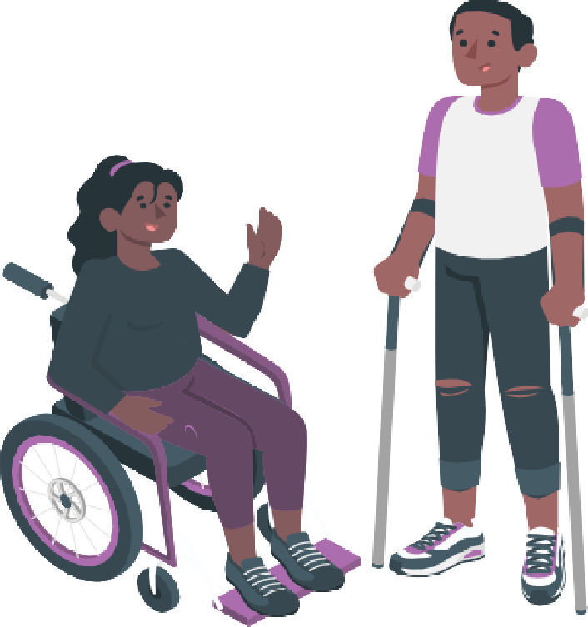Bashaka kandi ibi bikurikira:

* + Guhura n’abandi bagenerwabikorwa n’imiryango
  + Guhura umwe n’undi
  + Kwigira umwe ku wundi
  + Gukorera hamwe kugirango abantu bafite ubumuga babashe kubona uburenganzira ku isi hose.

Turashaka gufasha abagenerwabikorwa kujya babasha guhura kenshi kurushaho.



Ibi tuzajya tubikora

* + Abantu bagenda buhura ubwabo
  + Bahamagarana hakoreshejwe ikoranabuhanga (video calls).

Twitwa Fiji Disabled People’s Federation.

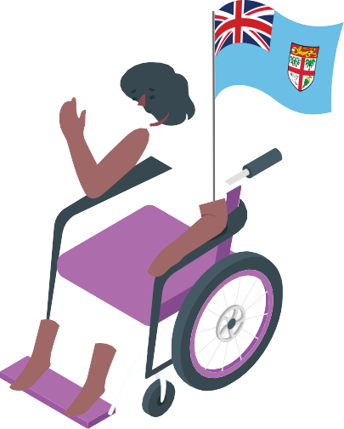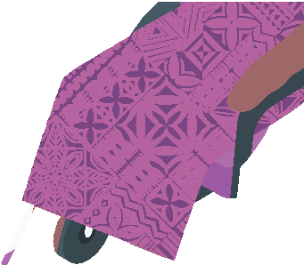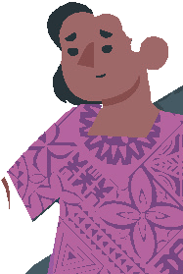

**Inkuru yo muri Fiji ku byerekeranye no gukorana na Leta mu guhindura amategeko na za politiki**

Twigisha abaturage ibyerekeranye n’uburenganzira bw’abantu bafite ubumuga.

Twigisha abaturage gukorera hamwe kugirango kugirango babashe gukora ubuvugizi neza kurushaho.

. Hari uburyo bwinshi twakozemo ibintu uko bikwiye.

Twakoze ibi bikurikira

* + twasabye Leta ya Fiji kutwizeza ko izakora amategeko meza abere abantu abantu bafite ubumuga



* + twafashije Leta gukora ibyo yavuze izakorera abantu bafite ubumuga muri Fiji
  + twafashije Leta kumenya umubare w’abantu bafite ubumuga baba muri Fiji
  + twafashije Leta kumenya ibyo igomba gushoramo amafaranga mu rwego rwo gufasha abantu bafite ubumuga
  + twaganiriye n’Urwego rushinzwe Amatoro rwa Fiji kugirango rubashe gutegura amatora **adaheza**



**Gutora** bikorwa mu gihe abatora bahitamo umuntu ujya muri Leta.

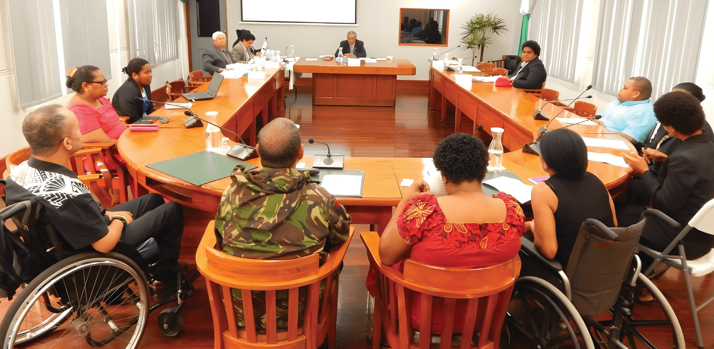

* + twafashije Leta guha serivisi abantu bafite ubumuga mu gihe cya COVID-19.



Disability Rights Fund yadufashije gukora ibi bikurikira:

* + guhura n’andi mashyirahamwe akora ubuvugizi

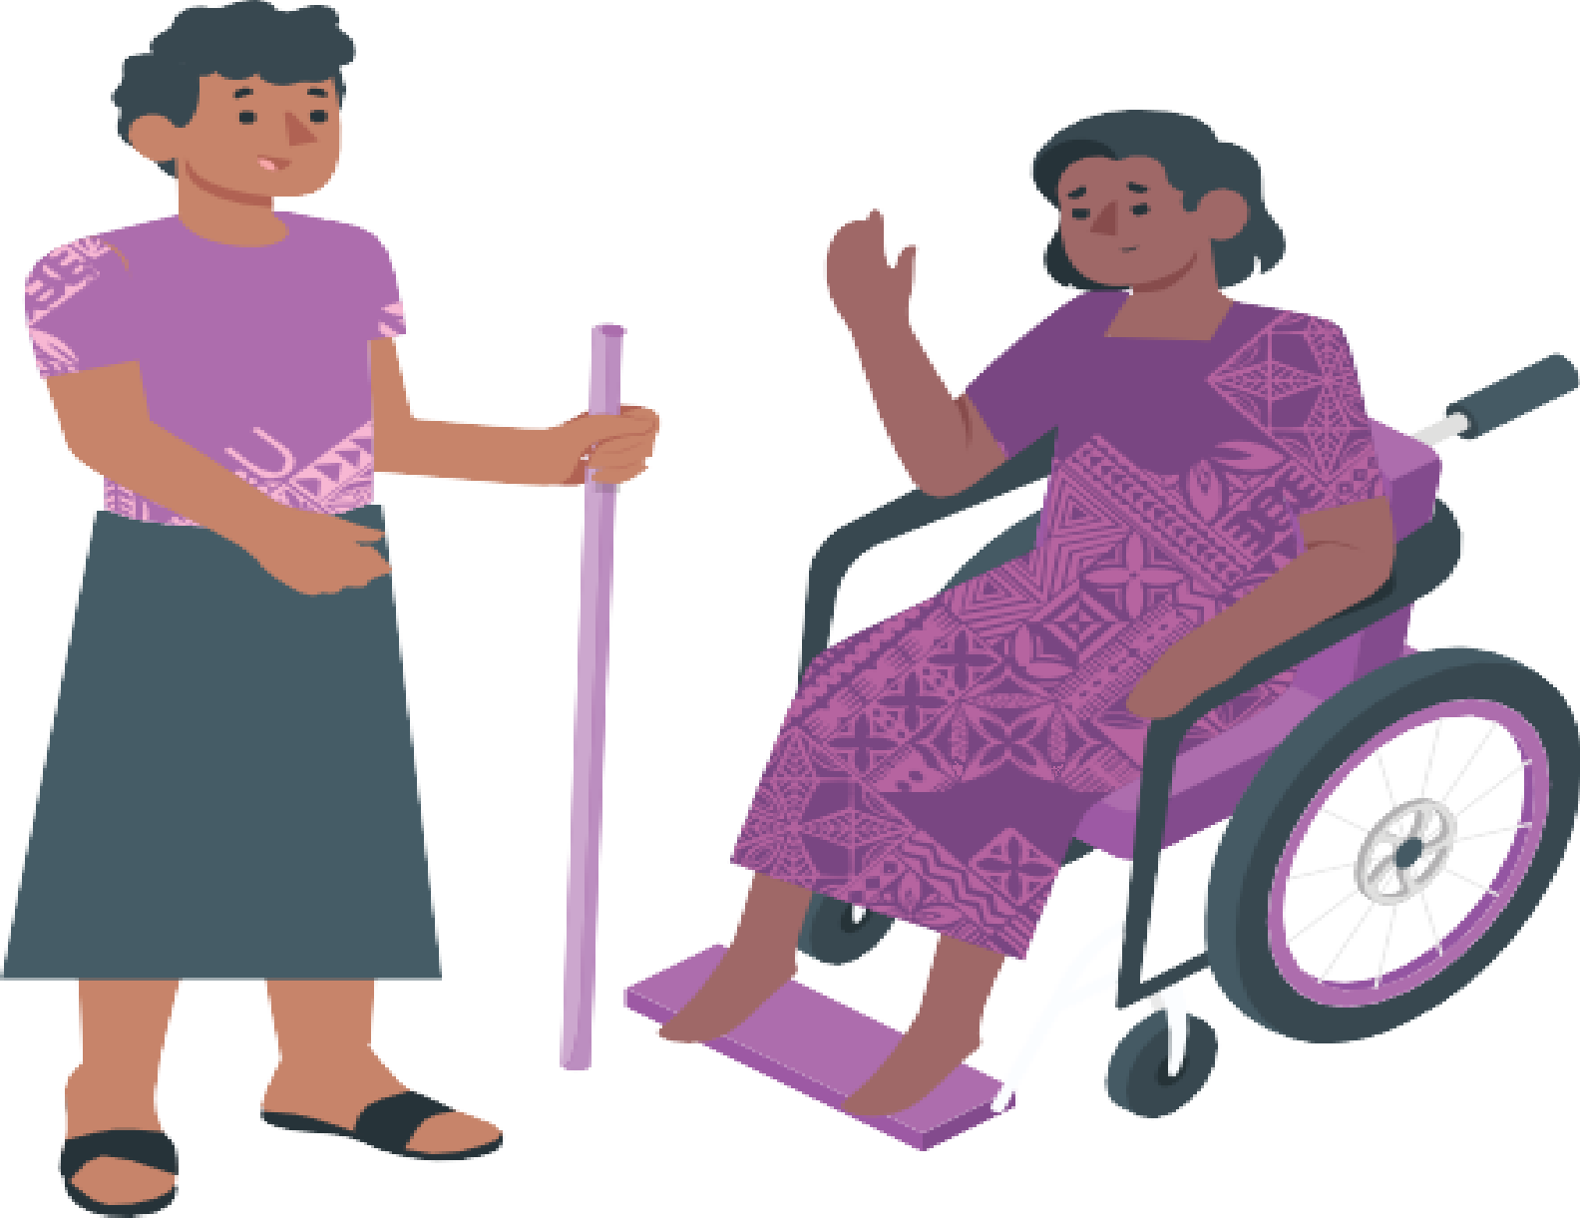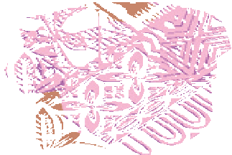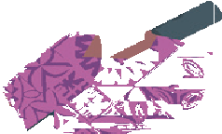

* + kwigisha abandi uko basaba leta gushora amafaranga ku bikorwa birebana no kwita ku bantu bafite ubumuga
  + kumenya uko abantu bafite ubumuga babaho muri Fiji
  + gusaba Leta n’indi miryango ibintu abantu bafite ubumuga bakenera.

**Inkuru yo muri Indoneziya irebana no gukorera ubuvugizi abagore n’abakobwa bafite ubumuga ku byereanye n’uburenganzira bwabo**

**14**

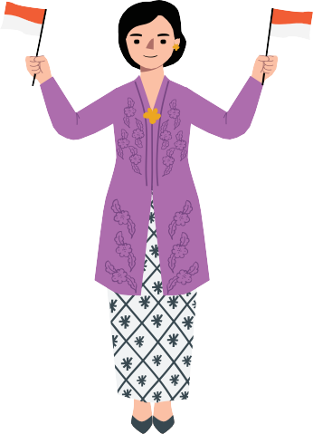Twitwa Himpunan Wanita Disabilitas Indonesia.

Mu kinyarwnda bisobanura Ishyirahamwe rya Indoneziya rihuza Abagore bafite ubumuga

Izina ryacu mu magambo y’impine ni HWDI.

Dukorana n’abagore n’abagabo bafite ubumuga muri Indoneziya.

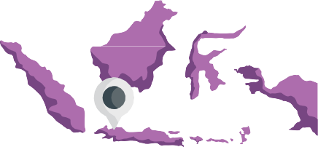Tuba i **Jakarta**.

**Jakarta** ni umurwa mukuru wa Indoneziya.

Dufite kandi ibiro hanze y’umurwamukuru. Twakoze ubuvugizi bwinshi.

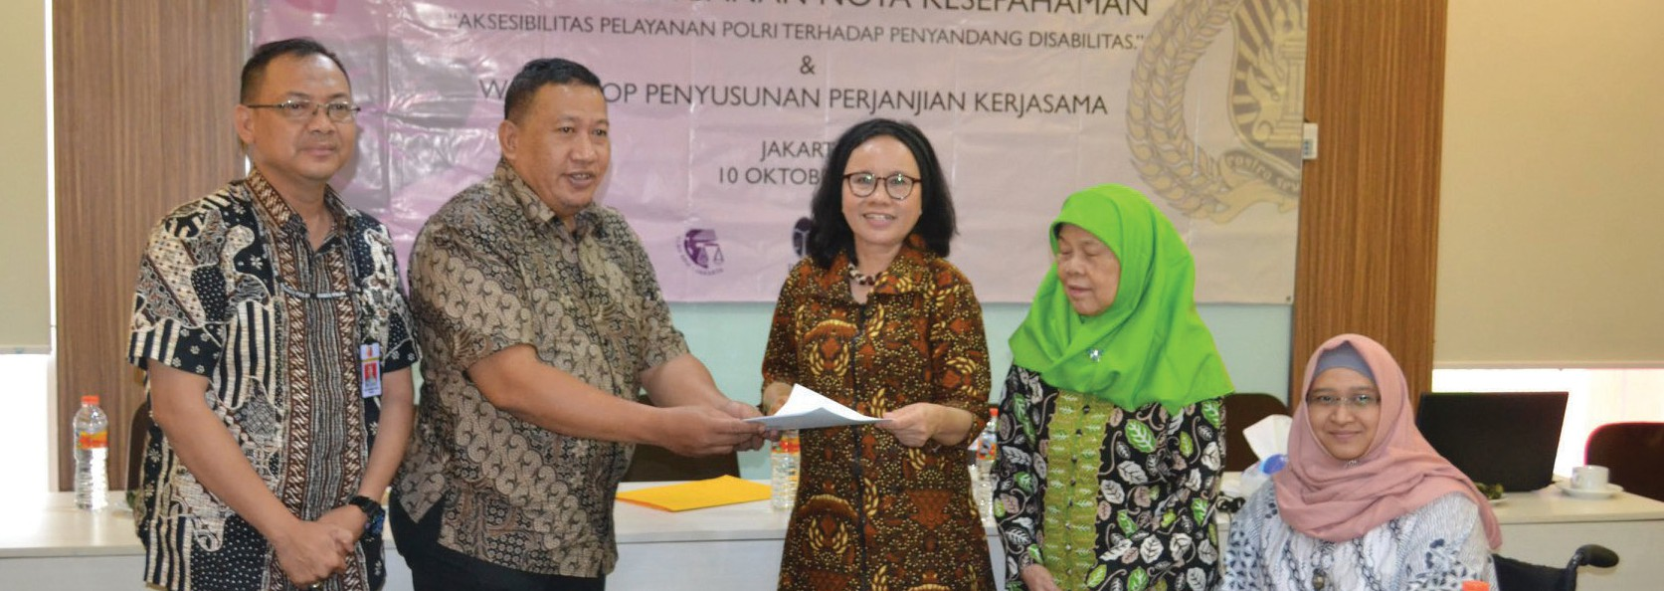

Twakoze ibi bikurikira:



* + Twigishije abagore bafite ubumuga uburyo babasha gukora ubuvugizi
  + twafatanyije na polisi gushyiraho serivisi nziza zibereye abagore n’abakobwa bafite ubumuga
  + Twaganiriye n’abantu uburyo abantu bafite ubumuga babagaho muri COVID-19.

Ibi twabikoreye kuri

* + radiyo
  + Interineti
  + Imbuga mpuzambaga.

Disability Rights Fund yadufashije guhura n’abandi bagenerwabikorwa n’imiryango.

Ibi byadufashisje kwigisha abandi bantu bafite ubumuga gukora politiki nziza zibereye abantu bafite ubumuga.

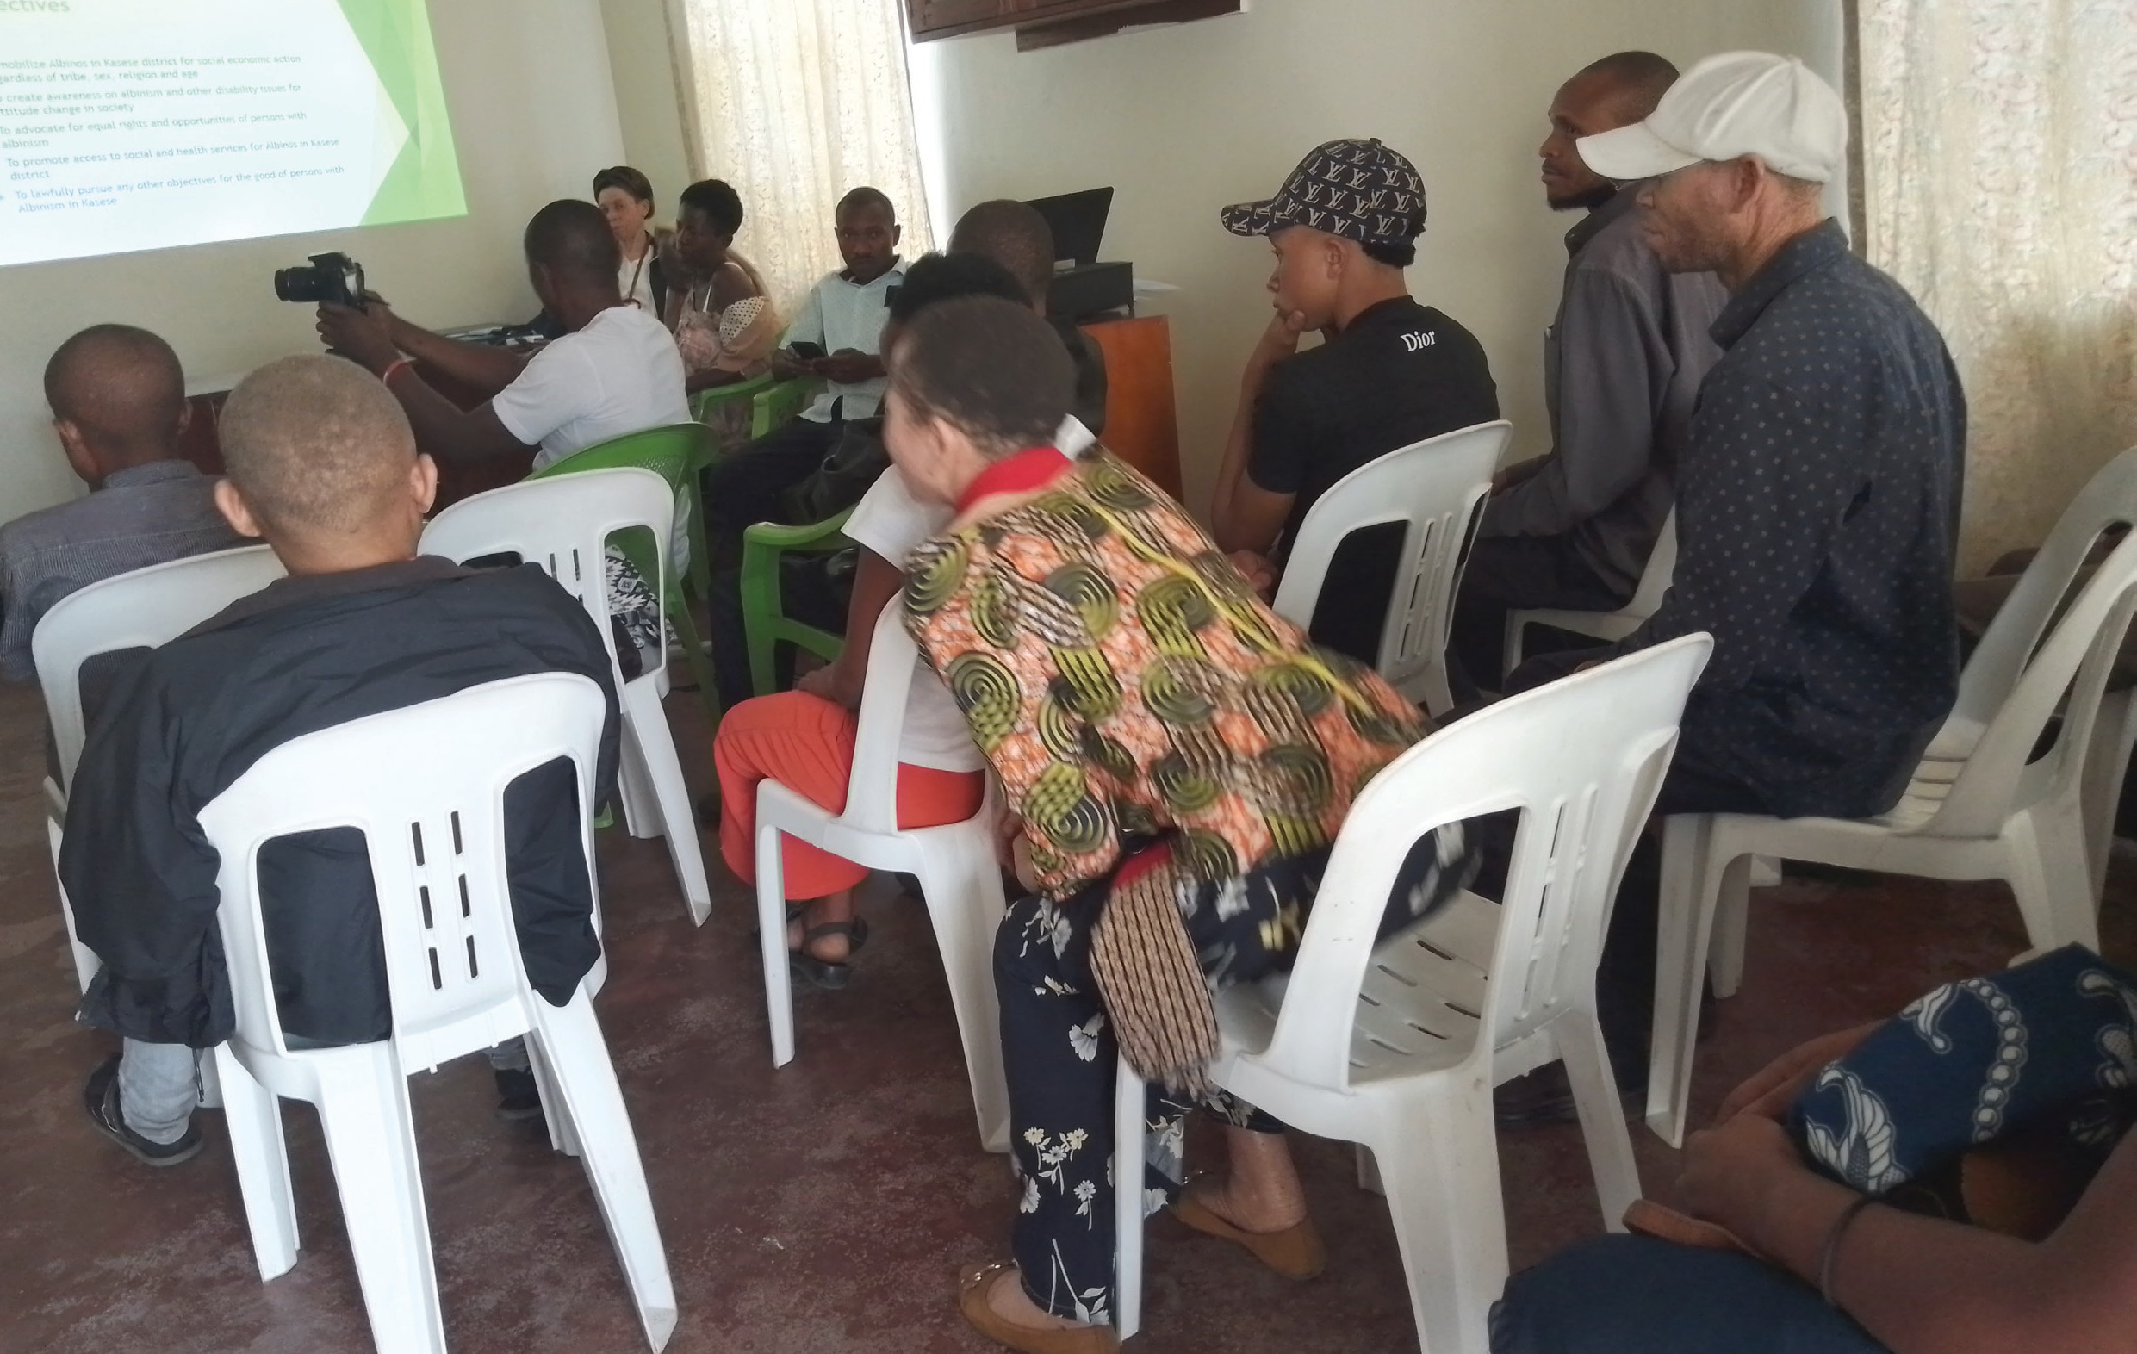

**Inkuru yo muri Uganda irebana n’uburyo bwo kubaka umuryango ukomeye**

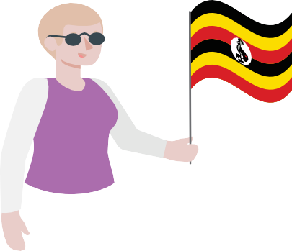Twitwa Lyakirema Initiative for Persons with **Albinism**.

Umuntu aba **nyamweru (Albinism) iyo** ari ntabara afite ku ruhu rwe, mu musatsi we cyangwa mu maso ye bidafite ibara.

Izina ryacu mu magambo y’impine ni LIPA.

Tuba muri **Uganda**.



Uganda ni muri Afurika.

Mu mwaka w ambere ishyirahamwe ryacu ryari rikinguye :

* + Ryarakuze riva ku banyamuryango 11 bafite ubumuga bw’uruhu rigera ku banyamuryango 53.
  + ryafunguye ibiro.
  + Ryabwiye abantu benshi ibyerekeranye n’ibyo dukora
  + Ryahisemo abagize inama y’ubutegetsi yaryo ya mbere
  + Ryashyizeho politiki igenga umuryango wacu.

Disability Rights Fund yadufashije gukora ibi bikurikira

* + gushyiraho politiki igenga ishyirahamwe
  + kwigisha Inama y’Ubutegetsi uko ikwiye gucunga umuryango wacu.

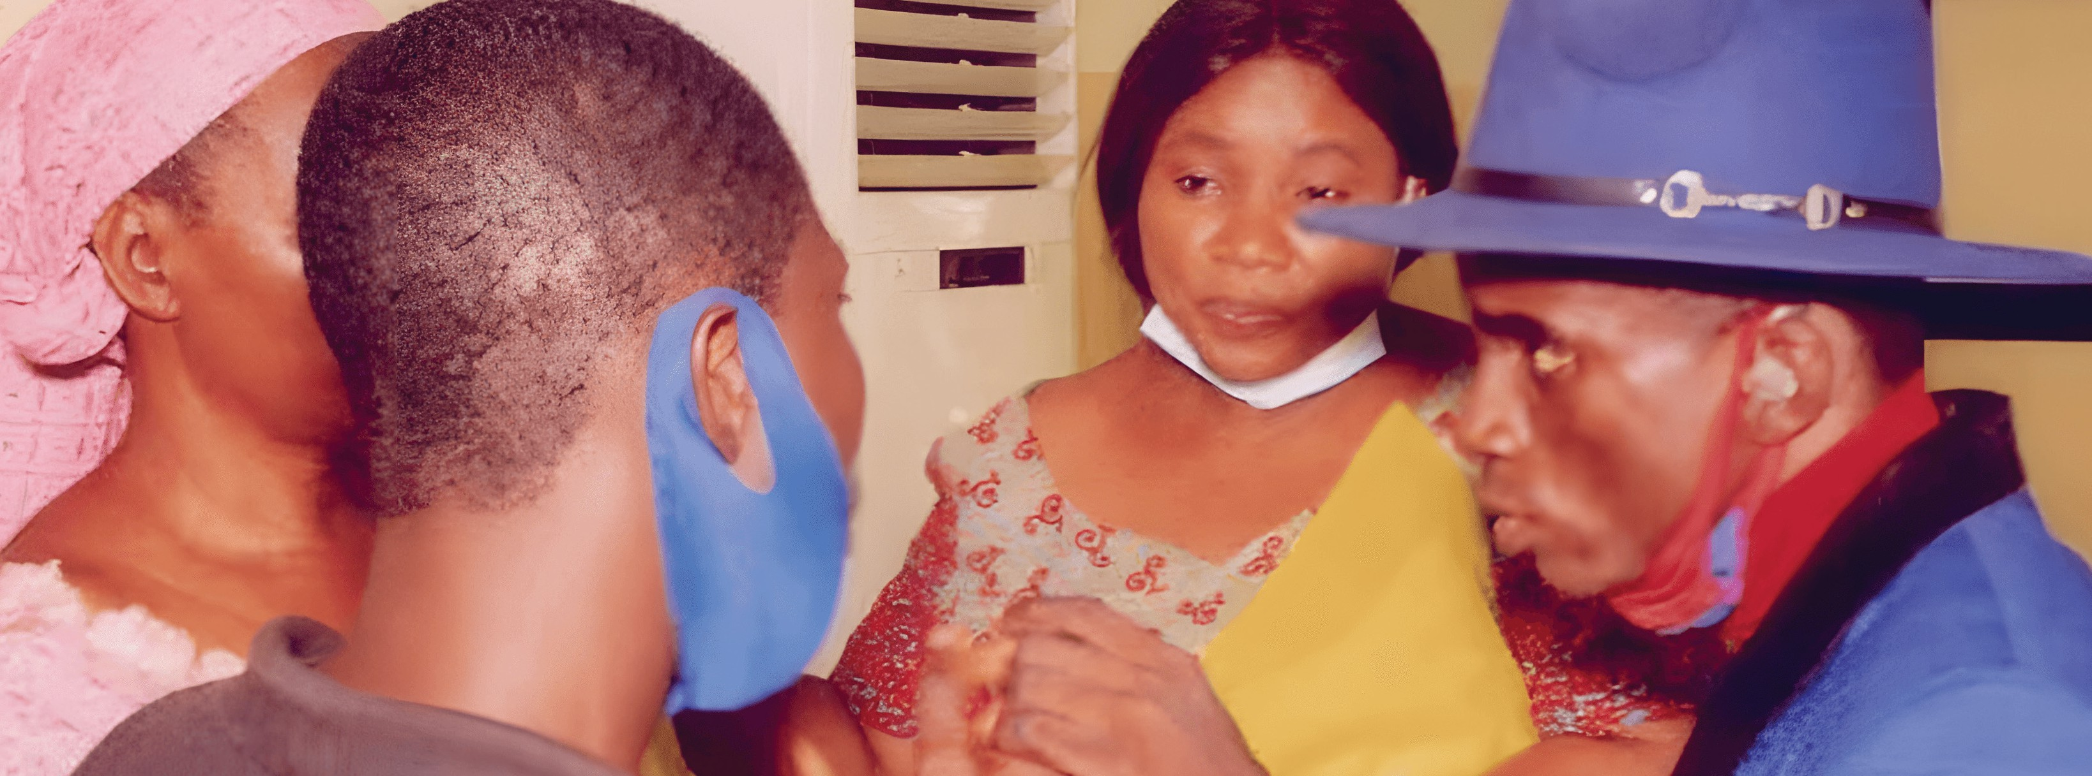

**Inkuru yo muri Nijeriya irebana no gukora ubuvugizi ku byerekeranye n’uburenganzira bw’abantu bafite ubumuga bwo kutumva no kutabona**

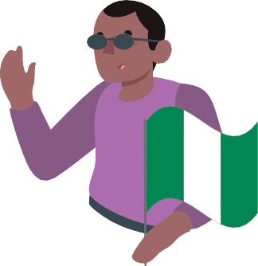Twitwa The Lionheart Ability Leaders International Foundation.

Izina ryacu mu mpine y’amagambo ni LALIF.

Tuba muri Nijeriya.



Nijeriya iba muri Afurika.



Dukorana n’abantu bafite ubumuga bwo **kutumva no kutabona** cyangwa bafite ubumuga bwo mu rwego **rw’imitekerereze**.

**Umuntu ufite ubumuga bwo kutumva no kutabona** ni umuntu utabasha kubona cyangwa kumva n’amatwi ye.



**Urwego rw’imitekerereze** bisobanura ubumuga bushingiye ku buzima bwo mu mutwe.

**18**

Twakoze ibi bikurikira

* + twaganiriye na Leta n’abaturage tubana na bo ibyerekeranye n’ubumuga bwo kutumva no kutabona n’ibyerekeranye n’ibyo dukeneye



* + Twakoze ubushakashatsi kugirango habashe kumenyekana umubare w’abantu bafite ubumuga bwo kutumva no kutabona muri Leta ya Lagos muri Nijeriya
  + ubu ni bwo bushakashatsi bwa mbere bwakozwe ku bantu bafite ubumuga bwo kutumva no kutabona muri Nijeriya!



* + twigishije ababyeyi n’abarimu uburyo bwiza bukoreshwa mu kuganira n’abantu bafite ubumuga bwo kutumva no kutabona.

Ababyeyi bashimishijwe cyane no kubona ko dushobora gufasha abana babo.

Disability Rights Fund yadufashije kubona abantu batwigisha uburyo bwo



* + gukora neza ubuvugizi ku byerekeranye n’ubumuga.
  + gukora raporo neza.



**19**

**Ukeneye andi makuru**

**Ushobora kubona andi makuru ku byerekeranye n’iyi nyandiko.**

* **Ushobora kureba ku rubuga rwacu rwa** [**https://disabilityrightsfund.org**](https://disabilityrightsfund.org/)
* **Ushobora kutwandikira kuri aderesi imeyili yacu :** [**info@disabilityrightsfund.org**](mailto:info@disabilityrightsfund.org)

**+1-857-265-2365** blendcreative.com.au