Disability Rights Fund (DRF) and Disability Rights Advocacy Fund (DRAF) Technical Assistance Learning Review Summary

FINAL

DMZ Partners in Sustainable Development

2023

Acknowledgements

Many thanks to all grantees who participated in the learning review. A particular thanks to members of the DRF Monitoring, Evaluation and Learning (GMEL) Reference group who provided guidance on key areas to explore and on recommendations for the next steps: Naomi Tai, Eve Naqio, Laxmi Nepal, Edy Supriyanto, Grace Jerry, Olive Namutebi, Esther Mukampogazi, and Simon Munde.

**CONTENTS LIST**

1 Executive Summary 2

2 Background 4

3 Our approach to reviewing the data (Methods) 4

4 Key Findings 5

4.1 Proudest achievements 5

4.2 DRF role in achievements 16

5 Reflections and Recommendations 22

**Appendices:** The following appendices are available from DRF/DRAF upon request. Please email [info@disabilityrightsfund.org](mailto:info@disabilityrightsfund.org) for a copy.

* Appendix 1: Additional detail on background and methodology
* Appendix 2: Sample DRF/DRAF Technical Assistance (TA) Questionnaire
* Appendix 3: DRF Grantee Monitoring Evaluation and Learning (GMEL) Reference Group TOR and Membership

**ACRONYMS**

|  |  |
| --- | --- |
| DRF/DRAF | Disability Rights Fund and the Disability Rights Advocacy Fund |
| OPD | Organization of Persons with Disabilities |
| PICs | Pacific Island Countries |
| SDGs | Sustainable Development Goals |
| UNCRPD | United Nations Convention on the Rights of Persons with Disabilities |

# Executive Summary

This learning review summarizes lessons learnt about key grantee achievements and the DRF role in providing support, if any, over a five-year period. A total of 70 organizations, from across four regions, completed questionnaires. The questionnaire formed part of DRF’s consultations to inform a new technical assistance strategy. The questionnaire was administered between April-May 2022.

Key achievements noted by three quarters of the organizations included:

* becoming stronger functioning organizations, with clear membership, organizational and governance systems and structures, and robust policies in place. This was particularly emphasized for newer organizations.
* greater visibility and recognition of the organization as a credible, functioning, and trusted organization, which opened doors for partnerships and advocacy success.
* building stronger networks and movements, including representation on varied decision-making platforms both within and outside of the disability community, and at both local and national level. This capacity for stronger networking was a strong cross-cutting theme for success in advocacy, and a role that DRF facilitated.

The achievements in advocacy were varied, which reflects the complexity of advocacy processes that grantees are engaged with. These advocacy successes ranged from:

* monitoring and holding local and national government to account in the domestication and/or implementation of varied country-specific policies. The local level engagement was particularly prominent in countries with political decentralisation.
* supporting research to inform their advocacy from national-level surveys through to better understanding of COVID-specific needs.
* awareness raising from engagement with a variety of government and media players at local and national levels, as well as community level awareness on disability rights and inclusion.
* influencing improved access to information and provision of inclusive services for people with sensory disabilities, including access to sign language interpreters and information in accessible formats.

The most popular areas of work documented by grantees in the questionnaire responses were inclusive education, inclusive employment, and the rights of women with disabilities. The latter particularly focused on gender-based violence and sexual and reproductive rights.

The second component explored in the questionnaire for this learning summary was the role of DRF in contributing to successes, as well as how any new knowledge, skills or partnerships gained are still being used now. The common thread was that it was no one single DRF contribution, but a synergy of different contributions that supported successes. These included, but were not limited to:

* technical support, such as training and advice, strengthened advocacy skills, for example, development of advocacy strategies, applying a human rights-based approach and better reporting on the UNCRPD.
* facilitated external exposure to and networks with other stakeholders, which in turn opened opportunities for new and varied partnerships.
* supported the strengthening of various organizational policies and membership and governance systems. In turn, a stronger organization was seen as a more credible and ‘trusted’ advocate. This appeared to have greater weight and significance for newly established and/or smaller organizations which may still be growing their profile.

A strong **recommendation** from almost every questionnaire response, and also from the Grantee Monitoring, Evaluation and Learning (GMEL) reference group, was the importance of promoting peer to peer learning for grantees, as well as learning opportunities from other relevant organisations. This could be in person meetings or virtual platforms. The opportunities could be country specific and/or regional/global. The emphasis should be on exploring topics in greater depth, drawing directly on OPD experiences and sharing resources. Recommended themes for discussion were many but should include 1) the unique challenges facing newly emergent OPDs, 2) the different structures and roles of umbrella OPDs, 3) building and maintaining coalitions for advocacy and 4) topics including social protection, DRR, and the ‘policy and practice gap’.

# Introduction and Background

A consultation with DRF grantees[1] was conducted in April-May 2022 to inform the new Technical Assistance (TA) strategy. The consultation focused on three key areas: i) big wins and reflections on the past; ii) vision setting for the future; and iii) exploring existing expertise within the OPD/disability movement. Tofacilitate accessibility and participation, countries and organizations could complete an online questionnaire and/or join an online consultation. A copy of the questionnaire is available in Appendix 1.

This learning review summary[2] draws from data provided in the TA strategy consultation questionnaires, and focuses on analysis of a sub-set of questions, namely:

1. What is your OPD most proud of achieving in the last 1-5 years? You can list more than one achievement.
2. In addition to funding, did any DRF/DRAF support help your OPD to achieve in these areas? If yes, what support was provided and what worked well to help your OPD?
3. How is your OPD using any new skills, experiences, capabilities that you acquired over the last five years now?

The learning review summary has been produced as a learning resource for DRF and DRAF grantees, the wider disability movement and other stakeholders. With consent, OPD quotes from their questionnaire responses have been added throughout the summary to support the findings. Four (4) Spotlight Stories drawing on OPD responses from across the three questions above have also been created and verified by the relevant OPD to showcase their achievements and DRFs contribution, if any.

# Our approach to reviewing the data (Methods)

In alignment with the DRF/DRAF model of participatory grantmaking, which puts decision-making in the hands of disability rights leaders and activists, a **Grantee Monitoring Evaluation and Learning (GMEL) Reference Group** was established**.**  The overall purpose of the group was to guide DRF/DRAF on its learning and sharing processes. In particular, on how to share lessons learned across its grant making portfolio. The members of the group were selected by DRF/DRAF Program Officers and consist of eight representatives of OPDs, selected from across the different regions, and reflecting the diversity of DRF/DRAF grantees. The group was established in October 2022, and met online on a six-weekly basis. The Terms of Reference and full group membership are provided in Appendix 2.

A simple thematic analysis was conducted where key themes from the data were identified through an iterative process of reviewing the data and discussions with the GMEL Group, DRF/DRAF Technical Assistance Director and external learning consultant. A selection of mini case studies were selected from across different regions to illustrate the interconnectivity of issues. For more detail on the methods and limitations see Appendix 3.

In total 70 organizations completed a questionnaire. In summary this included:

* OPDs form three regions (Africa, Asia and PICS) and across 13 countries[3].
* 16 umbrella organizations.
* 16 women with disabilities focused organizations.
* 8 emergent organizations.
* OPDs which represented varied types of disability: cross disability (23), deaf and hard of hearing (9), visual disability (8), intellectual and psychosocial disabilities (6), physical disabilities (7), albinism (4) and other (13)

# Key Findings

## Proudest achievements

In this section we explore the responses to the following question**:** **What is your OPD most proud of achieving in the last 1-5 years? You can list more than one achievement**. In terms of highlighting proudest achievements, almost every organization referred to several. The key areas of work are detailed below.

### **Advocacy**

Advocacy is an all-encompassing term. It is any action that speaks in favour of, recommends, argues for a cause, supports or defends, or pleads on behalf of others. It includes public education, regulatory work, litigation, and work before administrative bodies, lobbying, voter registration, voter education, and more[4]. It also includes approaches which aim to bring about more transformational change in communities[5]. The data reflect the complexity of advocacy work undertaken by DRF/DRAF grantees. The proudest achievements include awareness raising activities, the development/revision of new policies or laws, the ratification and domestication of policies at both a national and local level, representation of decision-making platforms, and compiling of evidence to inform these processes. Forty-one organizations highlighted **different elements of advocacy** as a proudest achievement.

#### Policy monitoring and revision

The revision and implementation of policies, laws, and guidelines was a broad category within advocacy (40 organizations). For the purpose of this learning review this included local policy ratification and domestication processes, which were country-specific.

Wide-ranging approaches to monitoring disability policies were identified. This was reflected across all DRF/DRAF regions, and at a local/regional/provincial level, by rural-based organizations, as well as organizations with a national network of membership. An important identified success was grantee **representation on key decision-making platforms**, including national and local task forces, working groups and committees. The role of such membership in leveraging success in advocacy is further reflected in discussing the role of networking and partnerships (Section 3.3.4). The breadth of the different types of platforms is illustrated in the examples below:

Supporting the establishment of National Commissions on Disabilities and other similar working group structures. ‘Pusat Pemilihan Umum Akses Disabilitas, PPUAD, Indonesia, & Centre for Citizens with Disabilities, CCD, Nigeria)

*‘*HUDIP made the District Task force co-opt a representative of a person with a disability for Hoima and Kikuube District ………. And they were able to successfully advocate for increasing the District Budget for the Health and Education departments so as to promote inclusive Health and Education.’ (Hoima District Union of Persons with Disabilities, HUDIP, Uganda)

‘Successfully advocating for the representation of persons with disabilities on various committee and in leadership roles.*’* (Pusat Pemilihan Umum Akses Disabilitas, PPUAD, Indonesia)

‘As an intersectional and self-assured individual, I am proud of my last 1–5 years of OPD for advocating and bringing CRPD and human rights to the lobby to ensure that the achievements that we strive for are realized. I was the first deaf and transwoman to enter the Fiji Parliament, which I took part in as a youth attorney general ….I committed to ensuring that the Fijian people see disability as a strength and the LGBTIQA+ community sees disability as a source of pride.’(Disability Pride Hub, Fiji, PICs)

Whilst the level of information provided in the questionnaire was sometimes limited, the data suggested a greater level of monitoring activities at a local level in countries with decentralized governments, for example in Indonesia, Nigeria, Rwanda and Uganda. This might suggest a greater level of opportunity for engagement with local government. Upholding national governments to account at a national level was more commonly facilitated by organizations based in the capital, and a role for umbrella organizations. For example, it was clear from the Indonesian umbrella organizations that they focused on monitoring implementation of disability policy within their decentralized political system. This was achieved through strong coordination across their networks.

A selection of advocacy achievements include:

**At national level:**

‘Monitoring progress and overseeing regulations by the Indonesian government, across various ministries, on disability policies.’ (Himpunan Wanita Disabilitas Indonesia, Indonesian Association of Women with Disabilities, HWDI, Indonesia)

Submitting shadow report to the CRPD committee. (Indonesian Association of Women with Disabilities, Indonesia, National Union of Disability Organisations, NUDOR, Rwanda)

‘Monitoring budgets at the national level.’ (DeafFlourish, DF, Republic of Marshall Islands)

At a **local/regional level:**

‘Monitoring of the inclusiveness of regional and local development programmes e.g. Covid recovery programmes.’ (Himpunan Wanita Disabilitas Indonesia, Indonesian Association of Women with Disabilities, HWDI, Indonesia)

‘Collecting data from local governments (provincial/regional/city/district) on implementation of regional policies and programmes strengthened networks with local government.’ (Himpunan Wanita Disabilitas Indonesia, Indonesian Association of Women with Disabilities, HWDI, Indonesia; Perkumpulan Penyandang Disabilitas Indonesia Provinsi Sulawesi Selatan, Indonesian Association of Persons with Disabilities South Sulawesi, PPDI-Sulsel, Indonesia; & National Union of Disability Organisations NUDOR, Rwanda)

‘In Uganda Women with disabilities were able to Petition the Luwero district Council to have a staff posted at the referral Centres such as HC III, HC IV and Luwero hospital.‘ (Lira District Disabled Women Association, LIDDWA, Uganda )

#### Evidence based policy

Several organizations (14) specifically detailed the importance of being involved in conducting research to inform their advocacy and/or project design. Examples include:

‘A second landmark achievement was the baseline survey to assess the incidence of deaf-blindness in Lagos State - the first survey in Nigeria to focus specifically on this marginalized group of individuals within the disability community. It laid the foundation of a database for these persons in Nigeria.’ (Lionheart Ability Leaders International Foundation, LALIF, Nigeria)

‘We are proud of producing a baseline survey on indigenous Batwa with disabilities, thanks to the support of [the Disability Rights Fund (DRF)](http://disabilityrightsfund.org/).The survey was carried out in ten (10) districts of Rwanda.’ (First People with Disability Organization of Rwanda FPDO, Rwanda)

‘[We conducted] a National spatial mapping for persons with albinism. ‘(Albinism Umbrella Organization, OIPPA, Rwanda)

This collation of data was important during the COVID pandemic, as part of that advocacy work further elaborated in Section 4.1.1.4 on COVID and in the below Spotlight on the work of Fiji Disabled People’s Federation.

**Spotlight on Fiji**

|  |
| --- |
| **Spotlight:** **The Fiji Disabled People’s Federation, Fiji** |
| The Fiji Disabled People’s Federation (FDPF) is an umbrella organization focused on promoting the rights of persons with disabilities. A key role of FDPF is to support OPDs in various ways to strengthen and collaborate on advocacy. Our collective successes are wide-ranging and include:   * Ratification of the UN Convention on the Rights of Persons with Disabilities in Fiji. * Enactment of the Acts on the Rights of Persons with Disabilities in Fiji and endorsement of the Fiji National Disability Implementation Plan. * The engagement and development of the disability census working group committee for the 2017 Fiji National Census of Organization of Persons with Disabilities. This resulted in budget inclusion specific for persons with disabilities within the Ministry of Women Children & Poverty Alleviation, Ministry of Housing, and Ministry of Youth & Sports. It also contributed to OPD’s knowledge to conduct inclusive budget analysis to support our advocacy. * Our OPD network engaged with Fiji Election Office and established an Election Disability Access Working Group with OPD representation. This resulted in an amendment to the Fiji Electoral Act, so that the electoral process was more inclusive. * A COVID-19 communication hub was established of various disability partners. This focussed on advocacy for an inclusive COVID communication strategy. Through engagement with the Ministry of Health and the community zone nurses within health facilities our partners ensured that support services were provided for those who required personal assistance in accessing health facilities.   DRF support has provided positive opportunities for us to engage organizations, especially the OPDs, to influence changes within decision making levels, especially during the COVID19 pandemic. The support provided over the years has enabled us to focus on strengthening skills and knowledge among OPDs in areas like understanding the process, procedure and methods to advocate for inclusive budgeting and collecting data on the situation of persons with disabilities. Strengthening knowledge and skills of OPDs was important during this COVID19 period. A lot of data was collated by and for persons with disabilities, which assisted OPDs to lobby for specific issues faced by persons with disabilities to government stakeholders and other partner agencies for the safety and protection of persons with disabilities at all levels. (FDPF, Fiji) |

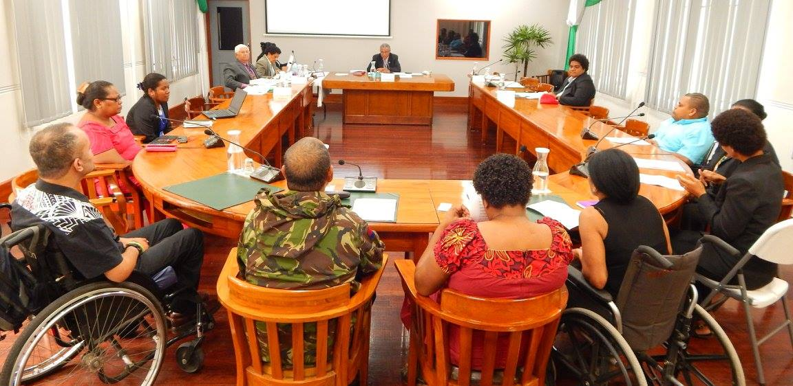

*Photos source: Fiji Disabled People’s Federation (FDPF), Fiji*

*Image description: Nine Fijian OPD representatives sitting around a board room table making their submission on CRPD ratification to Fijian Members of Parliament, also seated around the table.*

#### Awareness raising

A common theme within the area of advocacy was general **awareness raising** (21 organizations). It encompassed engagement with a variety of government players and the media, at both the local and national level. This included campaigns, for example, at community level to raise awareness about broader disability rights and better inclusion. This is illustrated here:

A campaign to voice the issue of protection of disability issues during the COVID-19 pandemic. (Himpunan Wanita Disabilitas Indonesia, Indonesian Association of Women with Disabilities, HWDI, Indonesia)

In addition to campaigns focused broadly on disability rights, the following section outlines achievements that focus on particular thematic issues.

#### Advocacy themes

**Inclusive education** (11 organizations) was a focus area, in particular noted by OPDs in the Africa region (10/11 organizations). This included several strands, and was almost always about working in partnership, to ensure that policy was translated into practice at different levels. This was addressed through training of duty bearers, establishing structures to guide implementation, and monitoring of budgets. Examples were illustrated at both the national and local level as illustrated in the following examples:

‘Through the funding support of DRF, we became active contributors to the quality implementation of Inclusive Education in Lagos state. Our focus on the budgetary process initiated conversations and action points on mainstreaming inclusive budgeting processes for children with disabilities. This action point has been achievable through the engagement and participation of the Education Committee representatives from OPDs, State Ministries, Departments and Agencies.’ (The IREDE Foundation, TIF, Nigeria)

‘We have advocated for students with albinism to access effectively inclusive education. Our advocacy result is that the Ministry of Education and Rwanda Education Board took a commitment at national level of providing examinations that are printed in large character ………. The Ministry also agreed to provide additional time ... due to their low vision…………………………. At the local level, districts and sector educational officers are aware of challenges affecting learners with albinism and they play a big role to train teachers and school leaders how to support them.’ (Albinism Umbrella Organization, OIPPA, Rwanda)

Advocacy for the **rights of women with disabilities** was an important achievement (11 organizations. Some of this work was about raising the profile of the rights of women with disabilities in general. Two specific categories of work were on **sexual and reproductive rights** (2 organizations) and **gender-based violence (GBV)** (6 organizations).

In terms of **gender-based violence**, organization talked about awareness-raising, ‘*becoming a major voice’* on the issue, and driving a stronger movement against GBV. There were examples of specific assistance to individual women with disabilities who had experienced GBV. In terms of scaling up the work against GBV, building partnerships was seen as critical in the work of the Indonesian umbrella organization, HWDI. The spotlight below outlines HWDI’s successful networks and partnerships to facilitate implementation:

**Spotlight on Indonesia**

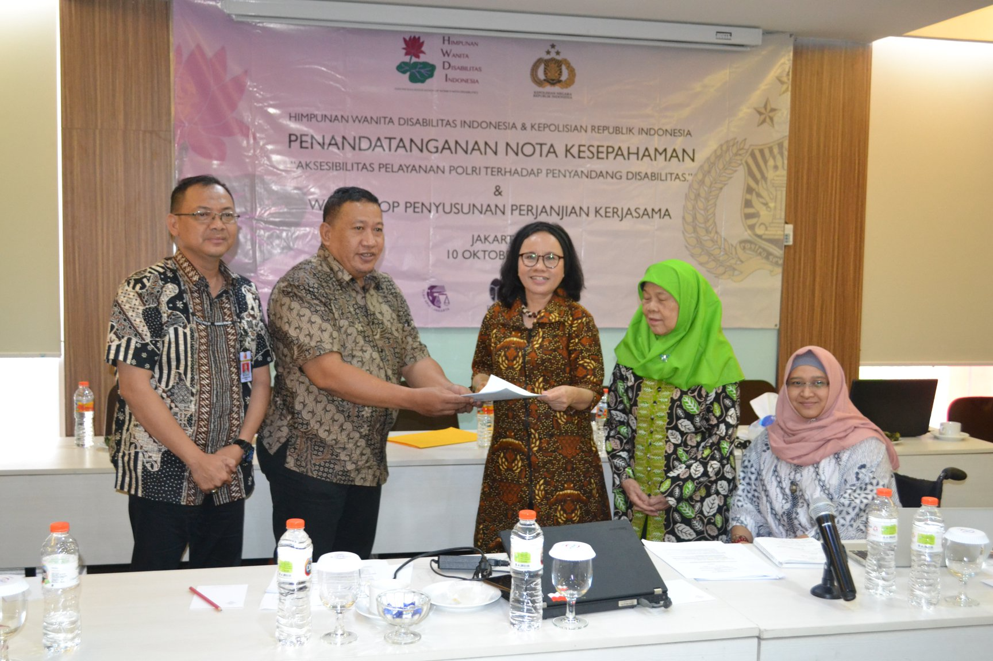

*Photo source: Himpunan Wanita Disabilitas Indonesia, Indonesian Association of Women with Disabilities (HWDI), Indonesia*

*Image description: HWDI Chair, Maulani Rotinsulu, and Ika Waskita, Ajun Komisaris Besar Polisi (National Police Headquarters) stand together holding the signed Memorandum of Understanding. They are joined by a representative of the National Police Headquarters, PPUA Chair, Ariyani, and DRF/DRAF Co-Director-Programs, Dwi Ariyani.*

|  |
| --- |
| **Spotlight:**  **Himpunan Wanita Disabilitas Indonesia, Indonesian Association of Women with Disabilities (HWDI) and HWDI-Sulawesi Chapter, Indonesia** |
| HWDI and HWDI-Sulawesi Chapter focus on women and girls with disabilities. HWDI is based in the capital with branches in other urban settings. The HWDI network has conducted wide ranging advocacy activities which includes:   * Increasing knowledge and skills of women with disabilities as strategic actors. This is not only in villages, but also at national level. By producing technical guidance, conducting interviews and media technical training, the HWDI network of women with disabilities in the regions is now lobbying, advocating and monitoring regional policy implementation. We use enumerators with disabilities so that discussions with women with disabilities are enriched and reflect the principles of *"No one left behind"* and *“Nothing about us without us.”* * Signing a Memorandum of Understanding (MOU) with the Indonesian National Police Headquarter to improve access to services for people with disabilities, HWDI also supports the establishment of Centres of Information and Consultation for Women with Disabilities  (PIK PPD) in eight provinces, this service is based on the Ministry of Women Empowerment and Child Protection decree. * Conducting campaigns during the COVID 19 Pandemic to voice the issues facing persons with disabilities, which included using radio and web-based live streaming.   The DRF/DRAF program officer has also provided valuable guidance on the development of safeguarding policies, and facilitating the sharing of learning from other grantees, and from other Civil Society Organisations (CSOs). As a result, we have been able to train other OPDs to develop safeguarding policies in accordance with the technical guidelines of DRF/DRAF. (HWDI Indonesia) |

Achievements related to **inclusive employment** (nine organizations from Africa and Asia region) were another key area. Most commonly organizations documented different types of training which they ran for persons with disabilities, engagement with vocational training centres, and successful targeting of business leaders to change attitudes. For example, as illustrated by Hope Inspired Foundation for Women and Youth (HIFWY) in Nigeria:

‘We are most proud of our Inclusive Employment Advocacy intervention called “Changing the Dialogue” which produced a documentary used as a tool to engage with industry leaders for the involvement of youths with disabilities in Nigeria’s workforce.’ (Hope Inspired Foundation for Women and Youth, HIFWY, Nigeria)

This learning review was conducted as countries were emerging from the COVID pandemic, and **COVID-related work** was highlighted by several organizations (6). This was both advocacy-related, including research, and improved service delivery.

‘HUDIP is among the very few organizations that were recognized by the COVID-19 District Task force of Hoima for actively participating and supporting efforts towards the fight against COVID-19. We offered Radio Talk shows for the COVID District Task force teams’ (Hoima District Union of Persons with Disabilities, HUDIP, Uganda)

Throughout this report, COVID- related work is cross-cutting, for example see also the Case Study from the Fiji Disabled People’s Federation (Section 4.2.5). A more targeted question about COVID to grantees[6] could further elaborate the extent and detail of this work.

Other key areas of achievement included advocacy on inclusive **health** (5), **social protection** (2) and inclusive **political processes** (4). It was surprising perhaps, given the known volume of work being conducted on disaster risk reduction (DRR), that limited information was provided. However, some grantees selected to focus on that in another section of the consultation and explains why it is not captured here, such as in the example from Samoa where grantees play a valuable role in their representation on DRR decision-making bodies and Tonga where a grantee highlighted member education on DRR:

‘Nuanua O Le Alofa Inc. is a member of many national organizations, such as the Samoa NGO umbrella organization, and have successfully advocated for the inclusion of the voice of persons with disabilities in the national advisory body for disaster and climate change’ (Nuanua Oo Le Alofa, National Advocacy Organization of Persons with Disabilities, NOLA, Samoa)

‘We have some members of us had skills and experiences in the area of CRPD, education, disaster and climate change etc. They [are] able to strengthen the capacities of the members and established the strong foundation of the Organization’ (Lavame'a Ta'e'iloa Disabled People Organization, LATA, Tonga)

#### Accessibility of information

Another success, most notably highlighted amongst the 14 organizations that work with people with sensory disabilities, was both advocacy activities and inclusive service provision to promote improved access to information. This is also a cross-cutting issue across other themes. This is illustrated in the examples below:

‘Capacity building for Nigerian publishers on the production of books in accessible format’ (Nigeria National Association of the Blind, NAB-National, Nigeria)

‘Having the opportunity to commence the documentation of Nigerian Sign Language, exclusively by the Deaf and for the Deaf community in Nigeria’ (Nigeria National Association of the Deaf, NNAD, Nigeria)

‘Promoting the Solomon Islands sign language’ (Solomon Islands Deaf Association, SIDA, Solomon Islands)

‘In 2020, we successfully advocated for the Government of Samoa to include sign language translation on the Prime Minister's State of Emergency Address as part of their response to COVID-19.’ (Deaf Association of Samoa, DAS, Samoa)

‘Disability rights activists together with Rwanda National Union of the Deaf mobilized on the local level demanding national initiatives to address barriers facing the Deaf people.‘(Rwanda National Union of the Deaf, RNUD. Rwanda)

### Organizational Strengthening

The second main category of ‘proudest achievements’ is related to organizational strengthening, which links into the role that DRF/DRAF have played, and this is explored further in section (Section 4.2).

Overall, approximately three quarters of the organizations (51) described different elements of ‘internal’ organizational strengthening as their proudest achievements over the last five years. These internal elements included registration, membership strengthening, governance, organizational policies and procedures including finances. Alongside this came better visibility and recognition for the organization. As explored in Section (4.1.2) this contributes to the OPDs being seen as more credible, functioning, and trusted organizations. In turn, this opens doors for partnerships which can contribute to stronger advocacy.

#### Organizational systems and structures

Overall, 21 organizations described a mix of registration, strengthened membership and governance as important achievements over the last five years.

Ten organizations described the formal registration of their organization as an OPD. These organizations are from the PICs region, Uganda, Rwanda, and Malawi.

Twelve Organizations described how they increased their membership base. In addition to increasing membership, the quality of the engagement and mobilisation of their members was also identified. In some instances organizations were establishing new offices, such as Lyakirema Initiative for Persons with Albinism, Uganda, who described their mobilisation from 11 to 53 members, whilst also establishing an office and appointing new staff. For others it was about setting up clear membership structures at sub-county/provincial level. The cascading of training to their membership and other OPDs was seen as another important area of work that grantees were proud of (13 organizations). This included training to their wider membership, ‘*teaching our members about advocacy*’, within the wider OPD movement and with other partners outside of the disability sector. This included training on leadership, as well as on advocacy skills.

Interlinked with registration and membership was strengthening of governance structures as an important success (nine organizations), particularly noted by Ugandan organizations (five). This was seen as necessary for a ‘functional’ organization and went hand in hand with staff training.

The development of organizational policies was also a key area of success (12 organizations), with particular reference to the PSEAH policy, as well as the development of a strategic plan. Examples were provided by grantees from all regions with the exception of Asia (Indonesia), and particularly important for organizations that identified as newly established.

#### Networks and movements

Achievements in strengthening networks, movement building, and development of coalitions was elaborated by over a quarter of the organizations (21), with examples given from all the countries. It was often intertwined with the value of greater visibility which allowed them to build and strengthen strategic partnerships, both within and outside of the disability community, and at both local and national level. The particular important role that DRF/DRAF was seen to play in facilitating this is detailed under DRF/DRAF role (Section 3.3), and again the value of being on various decision-making platforms is again emphasised. Examples include:

‘Networking with other relevant stakeholders has been done. These included Luwero District Local Governments, legal service providers, and Civil Society Organizations providing services to women in Luwero District.’ (Luwero Disabled Women Association, LUDDWA, Uganda)

‘[We are] a member of many national organizations e.g. Samoa non-government umbrella organizations, the National Council of Women….[and have] successfully advocated for the inclusion of the voice of persons with disabilities in the National Advisory Body for Disaster and Climate change.’ (Nuanua O Le Alofa, National Advocacy Organization of Persons with Disabilities, NOLA, Samoa)

‘[We have] obtaining consultative status with the United Nations (UN) Economic and Social Council, in the NGO branch, Office of Intergovernmental Support and Coordination for Sustainable Development, Department of Economic and Social Affairs, United Nations. ...Building and maintaining strategic partnerships within and outside the Disability Community’ (Hope Inspired Foundation for Women and Youth, HIFWY, Nigeria)

***Spotlight on Uganda***

|  |
| --- |
| **Spotlight:**  **Lyakirema Initiative for Persons with Albinism (LIPA) Uganda** |
| Lyakirema Initiative for Persons with Albinism (LIPA) is based in a rural setting in Uganda. In our one year of operation we:   * Mobilized 53 from 11 persons with Albinism to join the organization in the last one year. * Established an office with two staff, computer and other office equipment. * Registered LIPA with local authorities and now in the process of registering at district and national levels. * Conducted a general assembly and elected the first Board. The Board is now meeting quarterly. * Formulated and approved organizational policies (Constitution, PSEAH [Prevention of Sexual Exploitation, Abuse and Harassment Policy], CPP [Child Protection Policy], Finance Policy and Human Resource Policy).   The DRF consultant helped us in policy development, training of the BOARD on roles and management. The training conducted by the consultant is helping our Board in supporting the ED [Executive Director] to grow the organization through membership mobilization, conducting meetings and financial control. In the next year we will develop the strategic plan. (LIPA, Nigeria) |

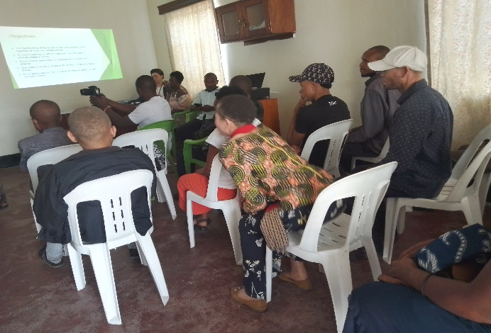

*Photo source: Lyakirema Initiative for Persons with Albinism (LIPA), Uganda*

*Image description: LIPA Board members participating in management training. They are sitting in rows watching the presentation slides projected on a wall.*

## DRF/DRAF role in achievements

In this section of the learning review we examine the following questions: **‘The DRF/DRAF support that helped your OPD to achieve in these areas?’**, **‘What worked well?’**, and **‘How is your OPD using any new skills, experiences, capabilities that you acquired over the last five years now?**’.

In practice, these questions were answered in an integrated way, so the findings are combined. The questions also capture any new knowledge and skills acquired and applied, although not exclusively as a result of the contribution from DRF/DRAF.

### Synergy of contributions

Whilst different elements of DRF/DRAF support are detailed as important for success, in practice it is a synergy of factors. Whilst technical training and support are seen as key, this can also facilitate external exposure, which in turn can facilitate opportunities for partnerships. In this example, being seen as a ‘trusted’ advocate appears key to then leveraging funding.

‘[DRF/DRAF] provided national training, such as advocacy workshops, and grantees convening etc. International exposure through various events as a speaker was important for us to be a recognized and trusted advocate organization for rights of women with disabilities. That opened up new connections for funding’ (Rwandan Organization of Women with Disabilities, OWDHP, Rwanda)

DRF/DRAF support can contribute to strengthening the legitimacy of the organization, which appeared more significant for some organizations, particularly newly formed and/or smaller organizations which may have less of a profile.

### Technical support role

A cross-cutting theme was the important **role of external consultant(s) and access to technical training.** This included the value ofgeneral DRF/DRAF program staff, providing formal training, general support and signposting to opportunities. Examples of their contribution varied, but a substantial emphasis was their pivotal role in supporting different threads of organizational strengthening, including the development of polices and strategic plans, and specific input on advocacy.

‘The PO consultation provided technical support for the formulation of safeguarding policies PSEAH and CPP, sharing learnings from other grantees, providing opportunities for grantees to participate in other meetings conducted, facilitating meetings with other CSOs, technical assistance through programs implemented by grantees.’ (Himpunan Wanita Disabilitas Indonesia, Indonesian Association of Women with Disabilities - South Sulawesi, HWDI-SS, Indonesia)

‘What worked well was the support from the Uganda capacity fund consultant who always in a timely manner provided technical guidance to ensure the organization remains focused on its strategic direction to achieve its mission.’(Kiboga Disability Rights Initiative, KIDRI, Uganda)

‘Yes, the DRF/DRAF support is the gateway of opportunities for us, being our first international donor with funding that comes with technical assistance that guides us during implementation. We received financial and technical support to develop policies as well as advocacy supports towards recognition of Nigerian Sign Language as an official language in Nigeria.’ (Nigeria National Association of the Deaf, NNAD, Nigeria)

### Internal organization strengthening

Approximately three quarters of the organizations (57) identified the key role of DRF/DRAF in supporting ‘internal’ organization strengthening. This included strengthening the development of organizational structures and systems, setting up organizational policies and procedures, including governance, finance, and membership systems. This ties in with key achievements in this area elaborated on in Section 3.2.2.

#### Organizational policies and procedures

Policy development, including the development of a strategic plan, was a common area identified (23) for the valuable technical support from DRF/DRAF; this was provided through training for staff and board members. Some organizations reflected on how this impacted on the overall quality of their work. A small number of organizations commented on how this improved their visibility and/or credibility as an organization to have these policies in place.

‘[The] DRF project officer helped a lot in getting most of the work …… in advising how policies were to be drafted ……………We are using the skills gained to improve how we conduct our work with children, how workmates behave at the workplace.’ (Epilepsy Warriors Foundation, EWF, Malawi)

‘The Childhood Protection Policy & Sexual Harassment Policy – it strengthened our organization’s legibility, credibility, and integrity.’ (DeafFlourish, DF, Republic of Marshall Islands)

Several organizations, notably the umbrella organizations, referred to cascading this training to use with other OPDs and/or with other services providers. This was most commonly noted in all the OPD umbrella organizations in Indonesia, for example as illustrated by HWDI Sulawesi below. HWDI Sulawesi Selatan described the technical support from the DRF/DRAF program officer to formulate its own policies and in turn HWDI Sulawesi Selatan supported others to develop their policies:

‘[We] implemented PSEAH and CPP Policies within the institution and encouraged district-level organizations to implement and or formulate the same policies in accordance with the resources owned. [We] trained other OPDs to develop institutional safeguarding policies in accordance with the technical guidelines of the DRF/DRAF’ (Himpunan Wanita Disabilitas Indonesia – Sulawesi Selatan, Indonesian Association of Women with Disabilities - South Sulawesi, HWDI-SS, Indonesia)

#### Finance management policies

The development of financial policies and procedures, as well as support for resource mobilisation, were identified as valuable for being more effective organizations, most notably highlighted in the Africa rural context. All 18 organizations which identified this issue were from the Africa region and 11 of 18 were NGOs in the rural context, as illustrated in the following quotes.

‘We are only one year in operation and the training conducted by the consultant is helping our board in supporting the ED to grow the organization through membership mobilization, conducting meetings, and financial control… Linked with stronger financial policies [with] the important technical support from DRF specifically on resource mobilisation.’ (Lyakirema Initiative for Persons with Albinism, LIPA, Uganda)

‘DRF supported HIFWY with resource mobilization training for staff, board members and volunteers. The training support opened our eyes as an organization, and enabled us to understand our strategic and competitive advantages. This helped us to reposition ourselves, creating new partnerships and professional relationships in relation to our organizational objectives.’ (Hope Inspired Foundation for Women and Youth, HIFWY, Nigeria)

### Advocacy skills

In addition to activities focused on strengthening everyday OPD functioning, the DRF/DRAF support training on advocacy was identified as an important input (25 organizations), which overlaps with their successes on advocacy. Organizations reflected on the value of support to develop their advocacy strategy, adopting a rights-based approach in their application of the UNCRPD, and better documentation, which could be accompanied by improved visibility of the grantee.

‘DRF/DRAF provided support in technical assistance. Through technical assistance, board and staff members of the organization were trained and supported to develop the advocacy strategy which helped RUB to achieve all the milestones mentioned above such as the ratification of the Marrakesh Treaty, adoption of the SNE&IE (Special Needs Education and Inclusive Education) policy, introduction of the use of technology in schools, signing the MoU with the Rwanda Basic Education Board among others.‘ (Rwanda Union of the Blind, RUB, Rwanda)

‘The Albino Foundation has been using a rights-based approach to all her advocacy initiatives and engagements.’ (The Albino Foundation, TAF, Nigeria)

‘Honestly, without DRF, PCO will be like a vehicle without oil and fuel. DRF supported our public awareness, advocacy and training/workshops in Pohnpei State, Yap State, Chuuk State, and Kosrae State.‘ (Pohnpei Consumer Organisation, PCO, Federated States of Micronesia)

More specifically, almost a quarter of organizations (17) reflected on the particular value of being trained on how to strengthen their documentation and shadow reporting on the UNCRPD. A sub-set of these grantees (5) explained that they were better equipped for robust reporting to the UN and other committees. This was particularly highlighted in the Nigerian context by three grantees, following a specific training:

‘DRF’s support via technical training workshops has been vital in the creation of alternative reports regarding issues of disability rights that we have presented to various international committees over the last two years. This has not only helped the organization build capacity but also ensured that our work matches international standards.’ (She Writes Woman Mental Health Initiative, SWW, Nigeria)

‘Training of OPDs, DPOs and PWDS on shadow reporting, rights-based advocacy and outcome tracking with funding from DRF has strengthened the knowledge of the participants on the best approach to write shadow reporting and better ways to do advocacy, achieve result and track outcomes.’ (Centre for Citizens with Disabilities, CCD, Nigeria)

**Spotlight on Nigeria**

|  |
| --- |
| **Spotlight:** **The Lionheart Ability Leaders International Foundation (LALIF) Nigeria** |
| The Lionheart Ability Leaders International Foundation (LALIF) in Nigeria works with youth, children, and older persons with Deaf-blindness and psychosocial disabilities.  Our first major achievement was the roundtable discussion on deaf-blindness/Usher Syndrome held on Tuesday 15th December 2020, wherein for the first time, government officials, representatives of other disability clusters, the press and the general public learnt for the first time about the conditions, the nature and needs of individuals with deaf-blindness. It was a landmark event which laid the foundation for subsequent discourses about Deaf-blindness among other disability clusters and especially the Lagos State Office for Disability Affairs.  The second landmark achievement was the baseline survey to assess the incidence of deaf-blindness in Lagos State- the first survey in Nigeria to focus specifically on this marginalized group of individuals within the disability community. It laid the foundation of a database pf persons with Deaf-blindness in Nigeria.  The third major achievement was a training workshop organized for parents and teachers on the means of communicating with and teaching individuals with Deaf-blindness in Lagos State. Apart from being the first-time educational officers were exposed to this line of knowledge, it was a day of joy to see the relief on the faces of parents at the knowledge that there was now an organization standing for the interests of their children.  A key support from DRF was providing a technical assistance training, organized by the Centre for Citizens with Disabilities, which built our knowledge of effective advocacy for the implementation of the UNCRPD, the SDGs and the GDS commitments. It also exposed us to the principles, knowledge and skills of effective shadow writing and reporting. (LALIF Nigeria) |

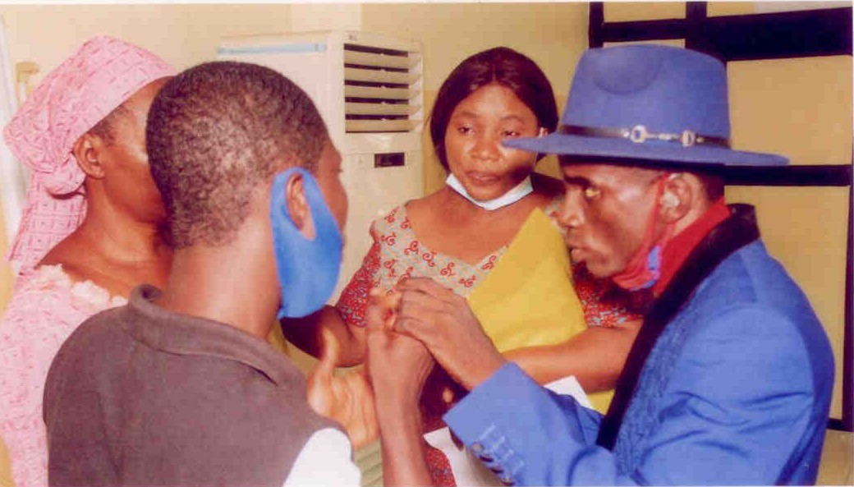

*Photo source: The Lionheart Ability Leaders International Foundation (LALIF), Nigeria*

*Image description: LALIF's Executive Director, Solomon Olakunle, in a group teaching practical communication skills for persons with Deaf-Blindness. Mr Olakunle is using tactile communication with a participant.*

### Networking and partnerships

Almost half of all grantees (33 organizations) described the invaluable role of DRF/DRAF in terms of facilitating their networking and partnerships, and how this was instrumental to their successes. Sometimes this was attributed to DRF/DRAF directly supporting the development of the network. For others it was about general ‘exposure’ to national and international players, often facilitated by DRF/DRAF. Other organizations reflected on their organization being strengthened through the various support options offered by DRF/DRAF, and this in turn was a catalyst to opening doors. These partnerships were both within and outside of the disability sector, although there were fewer examples provided that were not disability specific.

‘The knowledge and skills [from DRF] are being used to build partnership and networks of OPDs and other Development Partners, for example, the National Coalition of Human Rights Defenders-Uganda.’ (Lira District Disabled Women Association, LIDDWA, Uganda)

‘The DRFs network of contacts and partners has also proven to be indispensable in allowing us to make contact with key stakeholders in various institutions related to our efforts regarding legislative advocacy. ‘(She Writes Woman Mental Health Initiative, SWW, Nigeria)

The role of these partnerships varied, but their importance was a cross-cutting issue throughout the survey. Partnerships were used to share ideas, promote synergy, to more effectively monitor government policies and programmes, to develop policies, and to strengthen mobilisation, as illustrated by the following example:

‘We leverage and follow up on the network provided by DRF. At the national level, we have been greatly helped by DRF’s assistance in opening a network of OPDs at the local level in the formulation of social protection policy papers. …. At the international level, we are greatly helped to contact several international experts in providing input on our advocacy.’ (Indonesia Mental Health Association, IMHA, Indonesia)

In the Pacific Islands context, the role of DRF/DRAF support in promoting a more intersectional and inclusive disability movement was highlighted, for example:

‘Yes, of course [DRF support helped], it [OPD] was started by the DRF grant, and our new name is DPH [Disability Pride Hub]. Participants, in my opinion, have a greater understanding of the diversity of SOGIESC and intersectionality. Important values for understanding the identified people with diversity, SOGIESC, and Intersectionality, as well as for increasing participation and obtaining data and information from them.’ (Disability Pride Hub, DPH, Fiji)

‘DRF and DRAF have support all persons with disabilities in our country to participate fully in society and enjoy equal rights and opportunities. We do this [by] providing awareness, facilitating workshop to rural area and Island [communities], e.g. Ha’apai, Vavau and supporting advocacy of persons with disabilities (OPDs). Because of the importance of broadening and diversifying movements so that no one is left behind.’ (Tonga National Visual Impairment Association, TNVIA, Tonga)

Partnerships with government departments, and with international partners were identified as key to grantee advocacy success. This included increased representation on various instrumental committees/decision-making boards and collaborating with government services to improve inclusive provision. Whilst this was not always directly attributed to DRF/DRAF input, the responses indicated that this was part of the organization being more visible, respected and trusted, which ‘*opened a gateway’*, as illustrated below:

‘Yes [DRF support did help]. To be part of the UPR and the Governance Steering Committee ………under the World Bank was due to the DRF activities, which the media then used to advocate for inclusive environment for disability rights organizations in Malawi.’ (Human Rights of Women and Girls with Disabilities, HRWGD, Malawi)

‘DRF supported HIFWY with OPD Strengthening. The training support opened our eyes as an organization, enabled us to understand our strategic and competitive advantages. This helped us to reposition ourselves as an organization, creating new partnerships and professional relationships in relation to our organizational objectives …… our resource mobilization strategies have improved, and we are able to source alternative resources through partnerships and collaborations with other OPDs and mainstream Organizations. ‘ (Hope Inspired Foundation for Women and Youth, HIFWY, Nigeria)

‘We were incorporated 5 years ago and have since developed as a national agency with staff who are well represented and respected throughout national mechanisms. ‘(Deaf Association Samoa, DAS, Samoa)

One consequence of this increased credibility, illustrated by a small number of grantees, was the opening of **new partnerships for funding**:

‘[DRF/DRAF] Provided national advocacy workshops, and grantees convening etc. International exposure through various events as speaker was important for UNABU to be a recognized and trusted advocate organization for rights of women with disabilities that then opened up new connections for funding.’ (Rwandan Organization of Women with Disabilities, OWDHP, Rwanda]

# Reflections and Recommendations

In this section we reflect on some key recommendations which have emerged from this learning review process. This includes input from the GMEL group.

Many of the questionnaire responses provided a useful summary of achievements. However, it would be valuable in future to complement the survey with in-depth interviews, drawn from a sample of diverse OPDs; this would allow us to explore issues in greater detail. At the same time it would help address some country-level differences in detail provided in online questionnaires. For example it was noticeable that more limited information was provided in the PICs region. This would enable us to respond to a request from the GMEL reference group for greater detail on selected topics.

In some thematic areas, limited data were collected. For example, on membership diversity and DRR. This is not a reflection of the extent of work being done in these areas, which is known to be substantial, but indicates that to capture more information it would be useful to have targeted questions. So, for example, it would be helpful to explore in greater detail how organizations have addressed diversity within the membership and wider movement, challenges experienced, and how these challenges are being addressed.

Many of the advocacy successes for DRF/DRAF grantees are at both national and local level. They are often very context specific, but decentralisation of government in some countries appears to offer both opportunities and challenges for local level implementation of UNCRPD. It may be useful to explore this and consider any implications for technical support.

In addition, the GMEL group highlighted that it would be useful to learn more from other OPDs across regions about the following areas:

* Understanding the different models of umbrella organizations, including lessons learnt from different contexts, and how to decentralize the work of the disability movement to grassroots. This level of detail was not possible from the questionnaire, and it would be useful to follow up on this.
* Experiences of new and emergent organisations and groups, particularly peer to peer dialogue about how they are forming, what strategies they are using to advocate, how they are engaging with the broader movement to gain a sense of kinship and support among groups in similar early stages of growth.
* The need to better understand how coalitions can both be established, but also maintained. The development of networking, partnerships and coalitions are a cross-cutting theme in both achievements and the role for DRF/DRAF. The level of detail is limited, and it would be valuable to explore in greater depth.
* There are successes identified for advocacy on gender-based violence. Many of the examples are for successes at addressing and supporting individual cases of GBV and achieving redress. Indonesia OPDs did provide some examples of how to scale this up, and it would be useful to look at opportunities for scaling up in more detail.
* Many grantees have worked on COVID-related work and have been highly successful. There is useful learning to capture there, and this would benefit from a more targeted piece of learning.
* Gather more detail and sharing on particular topics. These include, but are not limited to:
  + social protection
  + inclusive education
  + the gap between policy and practice
  + inclusive employment and economic empowerment
  + the rights of women with disabilities, and effectively addressing gender equality in advocacy
  + disaster risk reduction
  + improving accessibility – structural, physical, and information.

1. This excluded Myanmar and Nepal which were both in periods of transition.
2. Data collected from the online virtual consultations largely focused on other aspects of the technical assistance questionnaire.
3. Written submissions were received from the following countries: Africa (Malawi, Nigeria, Rwanda, Uganda); Asia (Indonesia); and Pacific (Federated States of Micronesia, Fiji, Kiribati, Papua New Guinea, Republic of Marshall Islands, Samoa, Solomon Islands, Tonga). Cook Islands, Haiti, and Republic of Palau selected the online virtual consultation as the most suitable option for their context rather than written submissions.
4. DRF glossary which uses the definition of Bolder Advocacy, an initiative of Alliance for Justice, Website accessed 3/22/16 <http://bolderadvocacy.org/afj-on-advocacy/glossary>
5. Coe, J. & Schlangen, R. 2019 No Royal Road: finding and following the natural pathways in advocacy evaluation. *In:* CENTER FOR EVALUATION INNOVATION (ed.).
6. There was not a specific prompt question about COVID-related work. This is likely to have degenerated more information.