**Making sure that people with disabilities can take part in work on climate change**

A group of people sitting in chairs, showing three people using assistive devices




**What is in this document**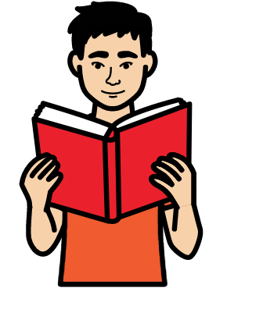

| **About this document** | Page 2 |
| --- | --- |
| **Why people with disabilities should take part in work on climate change.** | Page 4 |
| **What is stopping people with disabilities from taking part in work on climate change.** | Page 6 |
| **What should happen next** | Page 8 |
| **What Morgan says. He is a person with Down syndrome.** | Page 11 |

**About this document**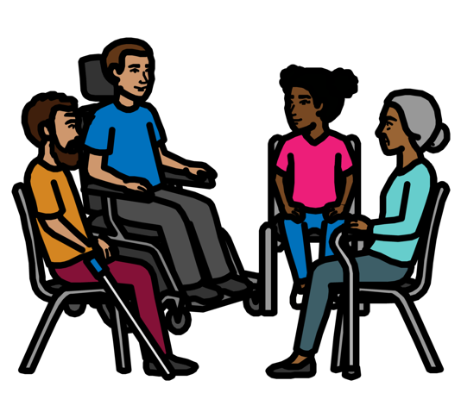

This document is about how to make sure that people with disabilities can take part in work on climate change.

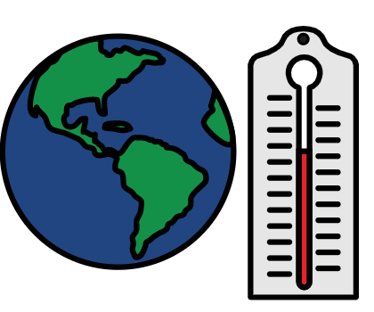

Climate change is about the earth getting warmer.

This is causing big problems for people, animals and plants.

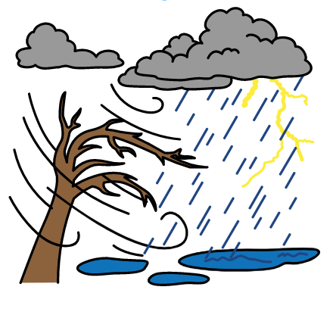

For example, there are more big weather problems now.

Like floods, too much heat and bad storms.

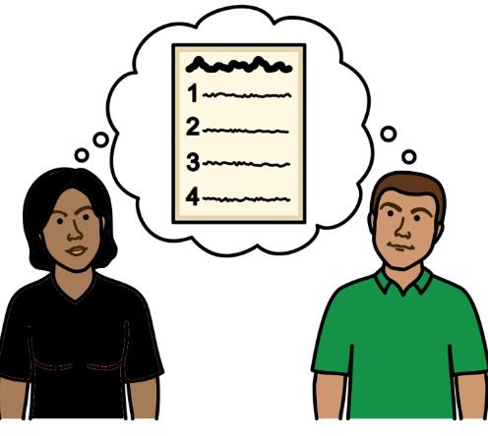

Countries need to deal with climate change problems.

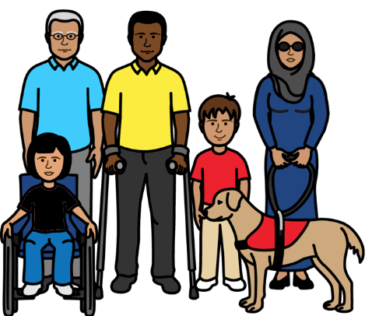For example, they should make plans about keeping everyone safe and making sure they get the right support.

Plans about climate change should work well for all groups of people.

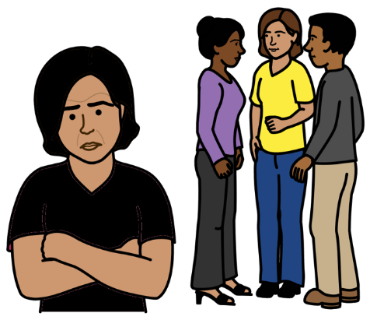

But people with disabilities are often left out of climate change plans.

This is unfair because people with disabilities often have worse climate change problems.

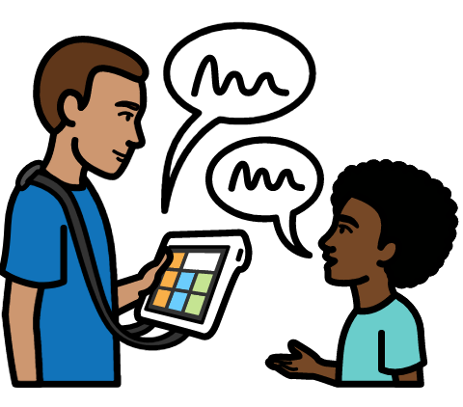

Some people looked into climate change problems that people with disabilities are having.

They talked to people with disabilities and other organizations to find out more.

This document is about what these people found out.A cartoon of a child pointing at a piece of paper with a list


This document is about:

* Why climate change can be worse for people with disabilities.
* How to make sure that people with disabilities can take part in work on climate change.

**Why people with disabilities should take part in work on climate change**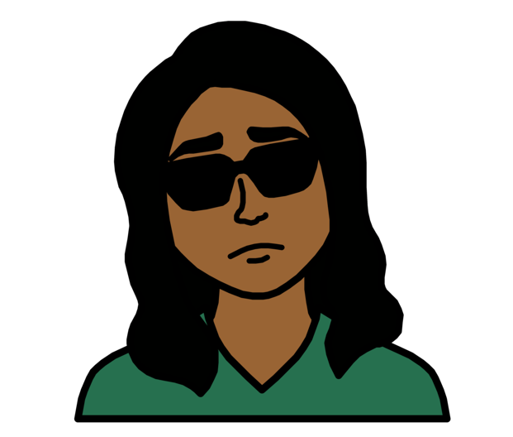

Climate change problems are often worse for people with disabilities.

For example, many people with disabilities are already poor.

But climate change may stop them from working and earning money.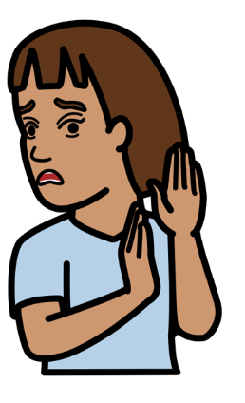

More violence can happen to people with disabilities when there are big problems in the world.

Like floods or too much heat.

This can be worse for women and young people with disabilities.

A child sitting at a desk, trying to write on a paper


People may not make information easy for people with disabilities to understand.

Like information about climate change and how to keep safe.

Many support services are not easy for people with disabilities to use.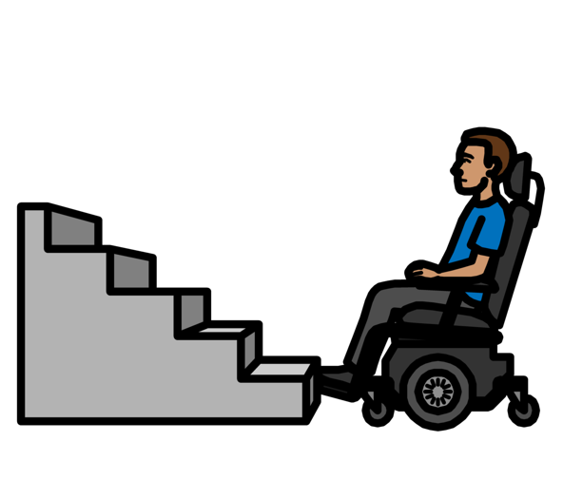

Like safe places for people to go to in an emergency.

Or healthcare services.

This can put people with disabilities in danger.

Or it can make their health worse.

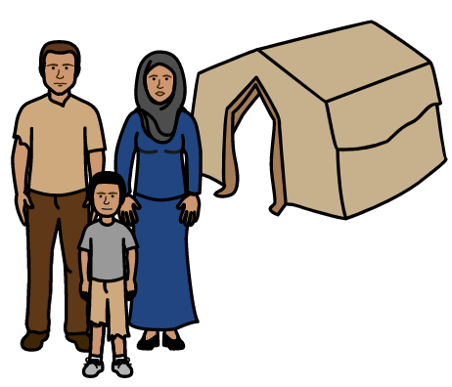

Many people with disabilities need to leave their homes because of big weather problems.

That means they may lose other support and things they need.

Like wheelchairs or hearing aids.

A group of people talking together and one person left out


People with disabilities are often left out of plans about climate change.

That means they cannot say what they need or share their ideas.

**What is stopping people with disabilities from taking part in work on climate change?**

Many organizations of people with disabilities do not have much money for climate change work.

Or they may only have money for a short piece of work. 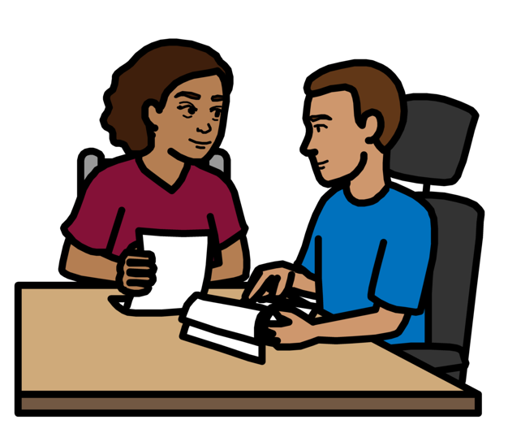

People with disabilities may not know much about climate change work.

They may need training to take part.

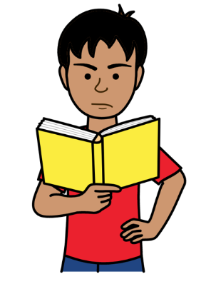

Many things can make it hard for people with disabilities to take part.

Like information that is hard to understand.

And buildings that are hard to get into.

There is not enough information about climate change problems for people with disabilities. 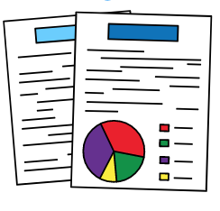

This can make it hard to show what is happening and why things need to change.

A person with hand on chin, thinking


People may have unfair ideas about people with disabilities.

For example, they may think that people with disabilities do not know much.

That means they may leave people with disabilities out.

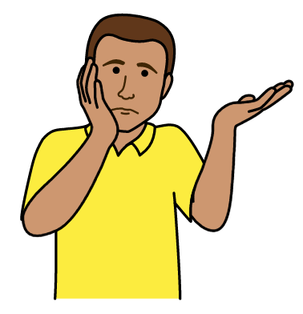

Organizations that give money for climate change work do not always think about people with disabilities.

For example, they may not know much about people with disabilities and how they could take part.

**What should happen next**



There are organizations that speak up about climate change and try to stop it.

There are organizations that give money for climate change work.

There are organizations of people with disabilities.

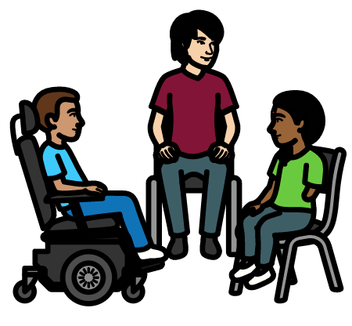

They all want people with disabilities to take part in climate change work.

That means all the organizations need to work together.

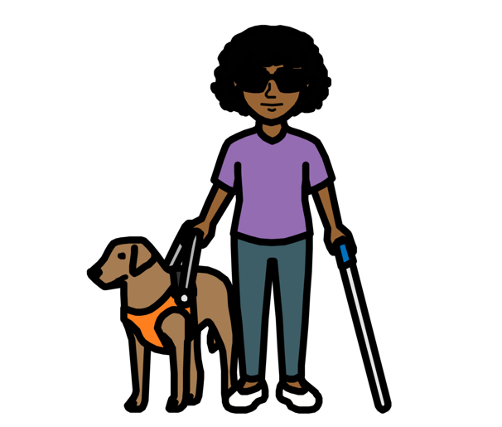

They need to make sure that people with disabilities can take part in climate change work.

Like work to make sure that everyone gets the right support with climate change problems.

People with disabilities should not be left out.

**A list of things for the organizations to do**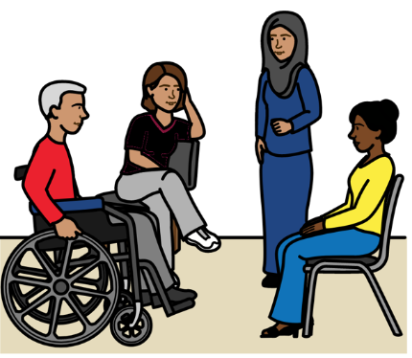

There should be support for different organizations to work together.

They can learn how to include people with disabilities in their work.

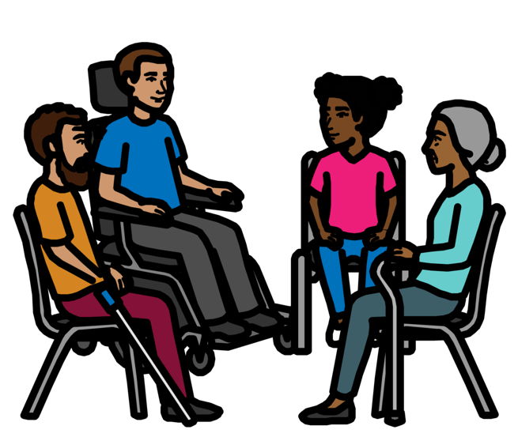

People with disabilities should help to make plans and decisions about climate change.

Everyone should check how the plans are working for people with disabilities.

That means all groups of people with disabilities.

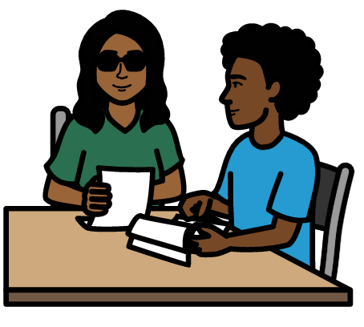

There should be better training for organizations of people with disabilities.

And organizations that speak up about climate change.

This will help them to work together on climate change.

There should be more money to support people with disabilities to take part in climate change work.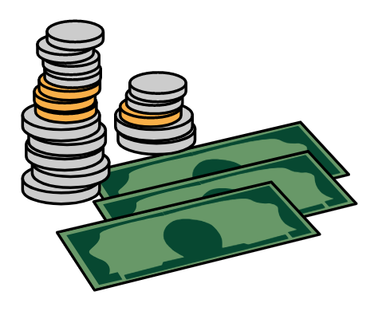

That means more money for

organizations of people with disabilities.

And more money for organizations that speak up about climate change.

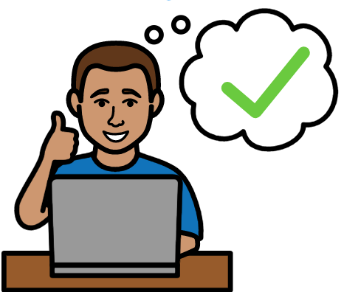

It should be easy for people with disabilities to ask for money for climate change work.

For example, there should be information that is easy to understand about what to do.

A person using a wheelchair talking to a standing person


There should be more work to look into climate change problems for people with disabilities.

This will help everyone to know what needs to change.

**What Morgan says. He is a person with Down syndrome.** 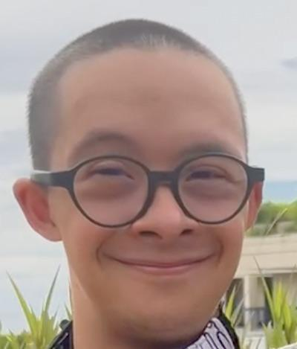

My name is Morgan Mazé.

I am 26 years old and I live in Indonesia.

I have Down syndrome.

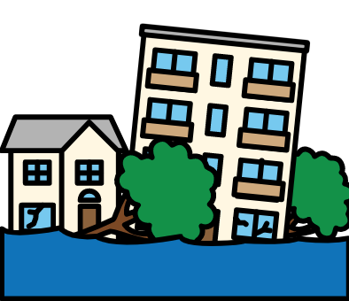

I learned about climate change through a class that my organization held for me and my friends. That organization is YAPESDI.

Before that I did not know how climate change makes life worse for people with disabilities like us.

For example, my friend had to leave her house when there was a flood.

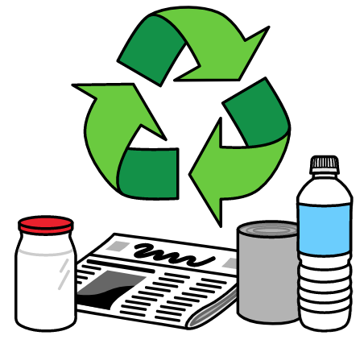

We know about the problem now so we are doing more about it.

For example, we are trying not to throw things away as much.

And we are saving gas and electricity where we can.

My friends and I are working together to make these small changes. 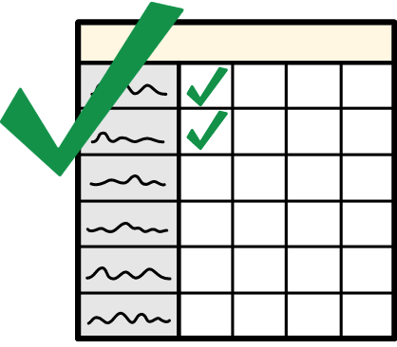

We hope they will make a big difference.

But there is still a lot to do.

A group of people sitting in chairs, showing three people using assistive devices


It is very important for people with disabilities to take part in climate change work.

I hope everyone will see that.

A group of people holding signs and walking with a person using a wheelchair holding a sign


When people with disabilities take part it can really help to change things.

We can all work together to fight climate change.

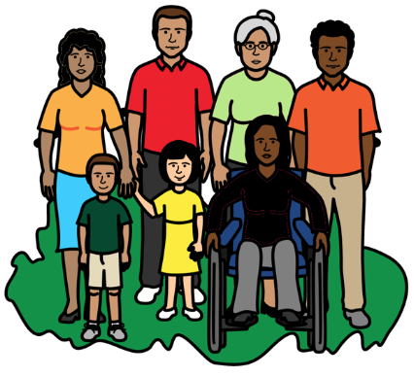

We can do that in a way that makes the world better for everyone.

Text saying that people need permission to use the images in this document 