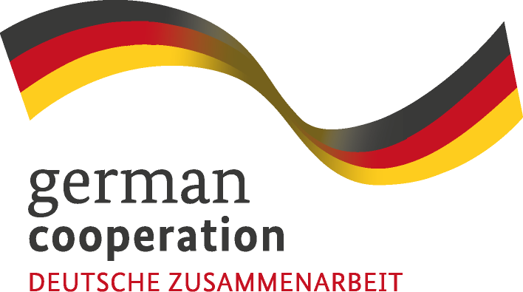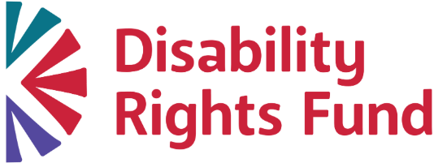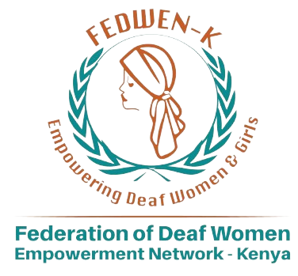



Regional Needs Assessment on Strengthening the Leadership of Deaf Women in East and Southern Africa

Commissioning Organization: Federation of Deaf Women Empowerment Network Kenya (FEDWEN)
Consultant: Rachel Chomba
Date: April 2026
Countries Covered: Kenya, Malawi, Rwanda, Tanzania, Uganda, Zambia, Zimbabwe.

This report is funded by the German Federal Ministry for Economic Cooperation and Development (BMZ) and supported by the Deutsche Gesellschaft für Internationale Zusammenarbeit (GIZ) GmbH.

TABLE OF CONTENTS
TABLE OF CONTENTS 3
EXECUTIVE SUMMARY 6
LIST OF ACRONYMS 11
ACKNOWLEDGEMENTS 12
1. INTRODUCTION 15
2. OBJECTIVES AND RESEARCH QUESTIONS 17
2.1 Overall Objective 17
2.2 Specific Objectives 17
3. SCOPE OF THE STUDY 19
4. METHODOLOGY 20
4.1 Study Design 20
4.2 Data Collection Methods 20
4.3 Sampling Strategy 21
4.3.1 Sample Size 22
4.3.2 Sampling Categories 22
4.4 Data Analysis 23
4.5 Data Collection Limitations and Delimitations 24
4.5.1 Limitations 24
4.5.2 Delimitations 25
4.6 Ethical Considerations 26
5. RESPONDENTS' DEMOGRAPHICS 27
5.1 Overview of Respondents 27
5.2 Distribution by Country 28
5.3 Gender Distribution 28
5.4 Age Distribution 29
5.5 Disability Type 31
5.6 Role in Organisation 31
5.7 Length of Involvement 33
5.8 Women in Leadership 34
5.9 Leadership by country 35
6. FINDINGS AND DISCUSSION 37
6.1 Leadership, Participation, and Inclusion 38
6.1.1 Knowledge and Capacity on Policy Frameworks 38
6.1.2 Leadership Representation 40
6.1.3 Barriers to Leadership 44
6.1.4 Access to Leadership Opportunities 49
6.1.5 Institutional Support and Inclusion 51
6.1.6 Participation in Advocacy and Policy Spaces 53
6.2 Priority Needs and Areas for Support 56
6.3 Summary of Key Findings 58
6.4 Cross-Cutting Regional Insights 61
6.5 Participation in Cross-Movement Spaces 63
7. CONCLUSIONS 66
8. RECOMMENDATIONS 68
8.1 Strengthening Leadership Pathways and Mentorship 68
8.2 Institutional Reform for Inclusive Governance 68
8.3 Investment in Communication Accessibility 69
8.4 Expanding Capacity Beyond Advocacy 69
8.5 Addressing Socio-Economic Barriers 70
8.6 Strengthening Peer Support and Community Cohesion 70
8.7 Strengthening Institutional Funding and Sustainability 70
8.8 Promoting Regional Collaboration and Learning 71
8.9 Establishing Regional Digital Platforms and Resource Hubs 71
8.10 Strengthening Participation in International and Regional Leadership Forums 71
9. COUNTRY SPOTLIGHTS 72
9.1 Kenya 72
9.2 Rwanda 73
9.3 Malawi 75
9.4 Uganda 76
9.5 Tanzania 78
9.6 Zambia 79
9.7 Zimbabwe 81
ANNEX I – LIST OF PARTICIPATING ORGANISATIONS 83
ABOUT THE BRIDGE PROJECT 85
ABOUT FEDWEN 85

EXECUTIVE SUMMARY
This report presents the findings of a Regional Needs Assessment on strengthening the leadership of Deaf women across East and Southern Africa, covering Kenya, Malawi, Zambia, Uganda, Tanzania, Rwanda and Zimbabwe. 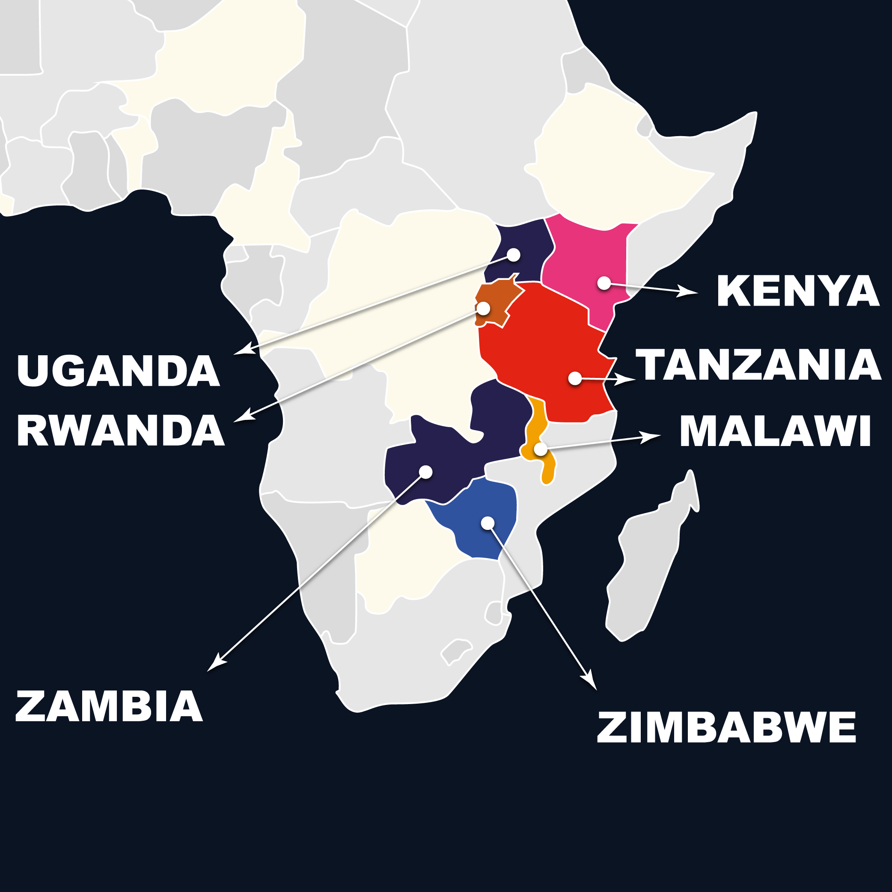Commissioned by the Federation of Deaf Women Empowerment Network Kenya (FEDWEN), the assessment examines leadership capacity, representation, participation, advocacy priorities, and the structural barriers shaping Deaf women’s engagement within disability movements, governance systems, and policy processes. The assessment employed a mixed-methods approach, integrating an online survey with Key Informant Interviews (KIIs) and Focus Group Discussions (FGDs). It was guided by a Deaf-led and participatory approach, ensuring that Deaf women were actively involved in the design, data collection, and interpretation of findings.
By centring lived experiences and using accessible communication methods, the assessment ensured that the voices, perspectives, and priorities of Deaf women were meaningfully captured throughout the research process. This approach enabled both quantitative mapping of trends and in-depth exploration of lived experiences, providing a comprehensive understanding of the factors influencing Deaf women’s leadership across the region. This approach also enabled the identification of systemic gaps between grassroots engagement and institutional leadership pathways.
The findings reveal a consistent regional pattern: Deaf women’s leadership is widely constrained by interconnected structural, institutional, and socio-cultural barriers, despite growing recognition of their leadership potential. While Deaf women are increasingly present within organizations and advocacy spaces, their participation often remains limited in visibility, influence, and decision-making authority. A critical gap identified is the disconnect between awareness and application of policy frameworks. Although many Deaf women demonstrate familiarity with international and national instruments such as the United Nations Convention on the Rights of Persons with Disabilities (UNCRPD), national legislation, and the Sustainable Development Goals (SDGs), there is limited capacity, access, and institutional support to translate this knowledge into effective advocacy and leadership practice. Persistent communication barriers, particularly the lack of accessible information, the inconsistent availability and quality of sign language interpretation and other communication assistive devices, and exclusion from informal decision-making spaces, further restrict meaningful engagement in policy and governance processes.
Representation within leadership structures remains uneven and, in many cases, superficial. Deaf women are frequently concentrated in lower-level roles, with limited progression into senior leadership positions. In some contexts, including Deaf-led organizations, leadership remains male-dominated, reflecting persistent gender inequalities within both mainstream and disability-specific systems. In addition, the limited availability of disaggregated data on Deaf women’s leadership further constrains visibility, accountability, and targeted interventions to address these disparities.
The assessment also highlights significant gaps in leadership development systems. Across countries, access to mentorship, leadership training, and structured pathways for advancement is limited and fragmented. These gaps are further shaped by inequalities related to age, geography, and socio-economic status, with older Deaf women and those in rural areas facing heightened exclusion.

This is reinforced by a “representation paradox,” where efforts to promote broad inclusion are challenged by disparities in literacy, exposure, and policy engagement capacity, highlighting the need for balanced and targeted leadership development approaches.
Barriers to leadership are multiple and intersecting. Across all countries, participants consistently identified communication challenges, financial constraints, discrimination, and limited access to information as key obstacles. These are further reinforced by institutional perceptions of accessibility as a cost burden and by social factors such as domestic responsibilities, early motherhood, and low confidence and self-esteem resulting from long-standing exclusion. In addition, intra-community dynamics, including limited mentorship, gatekeeping, and weak support systems, continue to hinder leadership development.
Despite these challenges, the assessment identifies a strong foundation for progress. Deaf women across the region demonstrate high levels of motivation, resilience, and readiness to lead. There is a clear and urgent demand for leadership development, mentorship, policy engagement training, and economic empowerment initiatives. The findings call for targeted, sustained, and systemic investment in inclusive leadership systems. Advancing Deaf women’s leadership requires moving beyond symbolic inclusion towards practical, intersectional, and system-wide approaches that address structural barriers, strengthen leadership pathways, bridge the gap between grassroots participation and institutional leadership, and ensure meaningful participation in decision-making processes at all levels.
The recommendations from these findings point to the need for coordinated, multi-level action to strengthen Deaf women’s leadership across the region. Priority interventions include establishing structured leadership pathways through mentorship and capacity development; strengthening institutional accountability to ensure inclusive and gender-responsive governance; and investing in accessible communication systems, including qualified sign language interpretation and inclusive information formats. There is also a need to address socio-economic barriers by supporting economic empowerment and reducing participation costs, while fostering peer support, collaboration, and unity within Deaf communities. Advocacy efforts should focus on increasing representation of Deaf women in decision-making spaces, promoting policy implementation and accountability, and advancing inclusive frameworks that recognise the diversity of Deaf women, including Deafblind and hard-of-hearing individuals. There is also a need to strengthen the inclusion and representation of Deaf women in international and regional leadership and advocacy forums, ensuring their meaningful participation in global disability, gender, and development platforms through targeted funding, accessibility support, and preparatory capacity building. Strengthening funding for Deaf women-led initiatives and creating regional platforms for knowledge sharing and collective advocacy will be critical to achieving sustainable and transformative leadership outcomes.

LIST OF ACRONYMS
NADs – National Associations of the Deaf
FEDWEN – Federation of Deaf Women Empowerment Network Kenya
UNCRPD – United Nations Convention on the Rights of Persons with Disabilities
KII – Key Informant Interview
FGD – Focus Group Discussion
CEDAW- Convention on the Elimination of All Forms of Discrimination Against Women
ADP- Africa Disability Protocol
SDGs- Sustainable Development Goals
UNCRPD - United Nations Convention on the Rights of Persons with Disabilities
CSO- Civil Society Organisations
OPD- Organisations of Persons with Disabilities


ACKNOWLEDGEMENTS
This report was developed from research conducted under the BRIDGE Project implemented by the Federation of Deaf Women Empowerment Network Kenya (FEDWEN). We are extremely grateful to the Disability Rights Fund (DRF) for supporting this initiative and for providing both financial and technical backing that made this regional assessment possible. The BRIDGE project is funded by the German Federal Ministry for Economic Cooperation and Development (BMZ) and supported by the Deutsche Gesellschaft für Internationale Zusammenarbeit (GIZ) GmbH.
We would therefore like to specifically thank the DRF for their continued support, guidance, and commitment to advancing the leadership and inclusion of Deaf women across East and Southern Africa.
Secondly, we would like to thank all relevant stakeholders at national, organizational, and community levels across Kenya, Malawi, Rwanda, Tanzania, Uganda, Zambia and Zimbabwe who contributed data and insights through key informant interviews, focus group discussions, and the online survey. Without the participation and openness of these stakeholders, this assessment would not have been possible.
These stakeholders included representatives from National Associations of the Deaf; Deaf-led organizations; government institutions; civil society organizations; educators; community leaders; and Deaf women themselves, leaders, youth, and grassroots participants, whose lived experiences form the foundation of this report.
We would also like to recognize the contribution of the research consultant, Rachel Chomba (Zambia), who led the design, coordination, and implementation of this assessment.
Her expertise, leadership, and commitment to inclusive, participatory research approaches were instrumental in ensuring the quality and depth of the findings presented in this report.
Lastly, but not least, we acknowledge the dedication of the research and data collection teams across all participating countries: Rose Kwamboka (Kenya), Tamandani Baira (Malawi), Malise Lawrence (Tanzania), Isaac Muhumuza (Uganda), Charity Chileshe (Zambia), Agness Chindimba (Zimbabwe), who worked tirelessly to ensure inclusive, accessible, and high-quality data collection processes. Their commitment ensured that Deaf women were meaningfully engaged and that their voices were accurately captured.
We also extend our sincere appreciation to the leadership of the Federation of Deaf Women Empowerment Network Kenya (FEDWEN) for coordinating this assessment and for their unwavering commitment to strengthening inclusive leadership systems for Deaf women in the region.

1. INTRODUCTION
Disability inclusion remains a cornerstone of equitable development and humanitarian response frameworks globally. Across many African countries, disability inclusion has gained increasing recognition within policy frameworks, including commitments aligned to the United Nations Convention on the Rights of Persons with Disabilities (UNCRPD). These commitments affirm the right of persons with disabilities to participate fully and equally in all aspects of public, social, and political life.
Despite this progress, regionally grounded data on Deaf women’s leadership representation within National Associations of the Deaf (NADs) and Deaf-led organizations, as well as their participation in women’s rights, feminist, and disability movements, remains limited. While Deaf movements across East and Southern Africa have grown in strength and visibility, Deaf women continue to face intersecting structural, institutional, cultural, and gendered barriers that restrict their meaningful participation in leadership and governance structures (Humanity & Inclusion, 2024; UN Women, 2025).
The Federation of Deaf Women Empowerment Network Kenya (FEDWEN) initiated this Regional Needs Assessment across seven countries, Kenya, Malawi, Zambia, Uganda, Tanzania, Rwanda and Zimbabwe, to identify capacity, knowledge, governance, leadership, and structural gaps that limit Deaf women and their organizations from meaningfully participating in regional and international policy processes.
This assessment examines Deaf women’s knowledge and capacity to engage with policy processes, their representation in leadership and governance structures, available leadership pathways, and the advocacy initiatives they are involved in. It further analyses organizational culture, institutional readiness, and systemic barriers affecting inclusive leadership.
The findings contribute to strengthening evidence-based advocacy, informing gender-responsive institutional reforms, and shaping regional programming and donor strategies aimed at advancing inclusive, accountable, and sustainable leadership systems for Deaf women across the region.
Humanity & Inclusion (2024); UN Women (2025). See:
- https://www.hi.org/sn_uploads/document/B30-Powerful-yet-overlooked-REPORT-24Oct2024.pdf
- https://www.unwomen.org/sites/default/files/2025-02/cso-beijing30-report-national-perspectives-from-women-with-disabilities-en_0.pdf

2. OBJECTIVES AND RESEARCH QUESTIONS

2.1 Overall Objective
The overall objective of this assessment is to identify capacity, knowledge, governance, leadership, and structural gaps that limit Deaf women and their organisations from meaningfully participating in regional and international policy processes, leading coordinated advocacy and accessing leadership -strengthening pathways across Kenya, Malawi, Rwanda, Zambia, Uganda, Tanzania, and Zimbabwe.

2.2 Specific Objectives
- To examine Deaf women’s knowledge and capacity to use international and regional policy instruments and processes to shape advocacy priorities and initiatives.  - To assess the level and nature of representation of Deaf women in leadership and governance structures within NADs and disability movements, women’s rights and feminist movements across the six countries. | 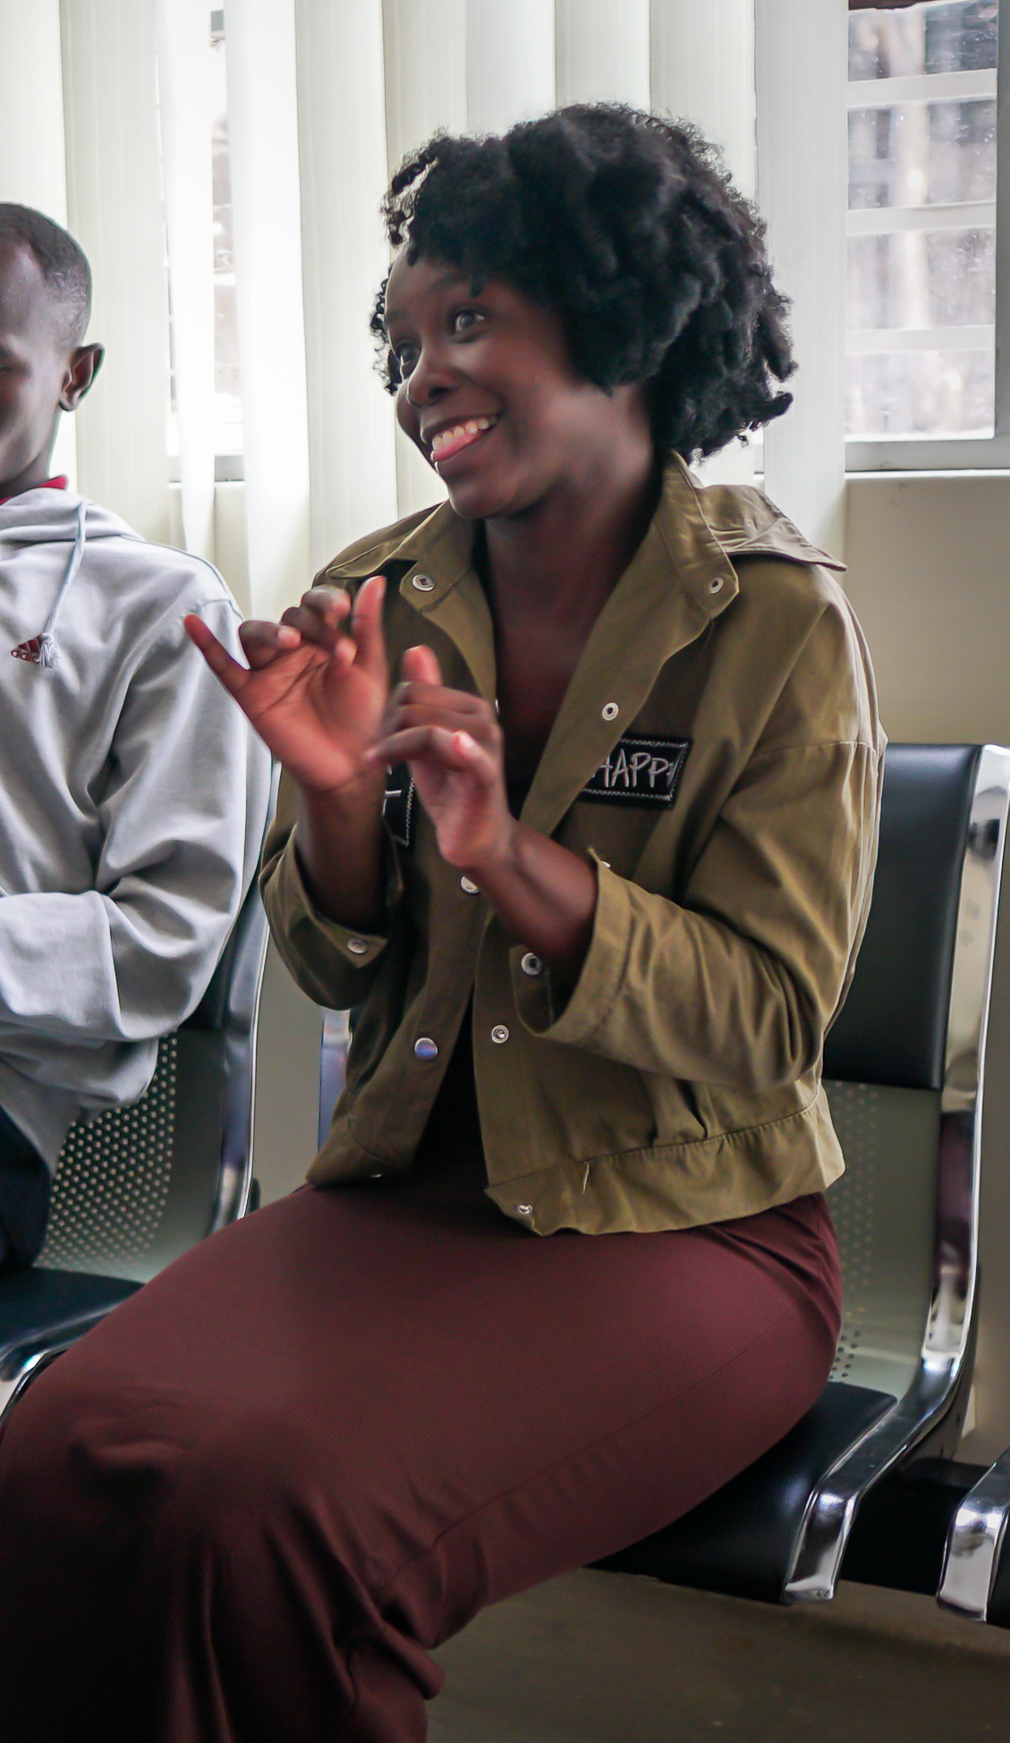

- To examine leadership pathways and participation processes available to Deaf women seeking leadership roles.
- To identify structural, cultural, financial, and organizational barriers affecting Deaf women’s participation and advancement in leadership roles.
- To document good practices and identify priority actions for strengthening sustainable and inclusive leadership systems for Deaf women across the region.

3. SCOPE OF THE STUDY
The Regional Needs Assessment focuses on the following thematic areas:
- Deaf women’s knowledge and capacity  - Representation within National Associations of the Deaf (NADs) and Deaf-led organisations  - Participation in disability movements, women’s rights, and feminist movements  - Leadership pathways and governance participation  - Institutional capacity and gender responsiveness  - Structural and systemic barriers affecting leadership. | 
Comparative regional trends across Kenya, Malawi, Zambia, Uganda, Tanzania, Rwanda and Zimbabwe. The study aims to generate actionable recommendations to strengthen evidence-based advocacy, inform gender-responsive institutional reforms, and support regional programming and donor strategies to advance inclusive leadership systems for Deaf women.

4. METHODOLOGY

4.1 Study Design
The study adopted a mixed-methods, participatory, and guided by a Deaf women-led rights-based approach, integrating quantitative and qualitative techniques to generate robust, triangulated evidence on leadership, governance, and inclusion within National Associations of the Deaf (NADs).

4.2 Data Collection Methods
Method | Purpose | Participants | Output
Online Survey | Generate quantitative data on leadership, governance, and barriers | NAD members, Deaf women | Statistical dataset for comparison
Key Informant Interviews (KIIs) | Explore governance systems and institutional dynamics | NAD leadership, board members | Institutional insights
Focus Group Discussions (FGDs) | Capture lived experiences and leadership journeys | Deaf women, youth, grassroots | Thematic narratives
The study used three methods: an online survey to generate quantitative data from NAD members and Deaf women; key informant interviews with leadership and board members to explore governance systems; and focus group discussions with Deaf women and the community participants to capture lived experiences and leadership dynamics. 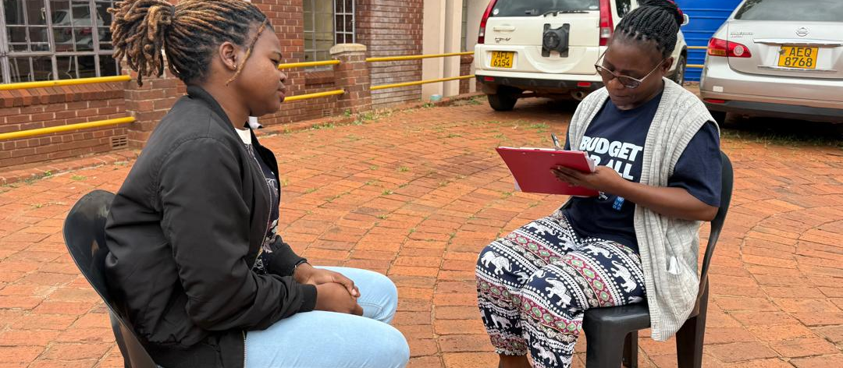

4.3 Sampling Strategy
The study employed a purposive, inclusive sampling strategy to ensure representation across leadership levels and social groups, as outlined in the structure below:

NAD/OPD/CSO/ALLIES - Leadership (Executive, Board, Committees)
↓
Deaf Women Leaders
↓
Emerging & Aspiring Leaders
↓
Youth Representatives
↓
Grassroots Deaf Women

4.3.1 Sample Size
A total of 30 KIIs were conducted, with 6 key informants per country. These informants included leaders of Organisations of Persons with Disabilities (OPDs) and National Associations of the Deaf (NADs), Deaf women leaders, advocates, and other stakeholders with relevant expertise in disability inclusion and leadership.
In addition, two FGDs were conducted per country, each comprising 6 participants, resulting in a total of 12 participants per country and 60 participants across all countries. FGD participants were primarily Deaf women from diverse backgrounds, including youth, community members, and emerging leaders, to capture a range of lived experiences and perspectives. The online survey targeted a minimum of 30 respondents per country. In several countries, this target was exceeded due to wide dissemination through organisational networks and community platforms, enhancing the breadth of quantitative insights captured.
Overall, the sample size was designed to ensure a balance between depth and breadth, allowing for both detailed qualitative insights and broader trend analysis across the region.

4.3.2 Sampling Categories
Category | Purpose
NAD Leadership | Governance and decision-making insights
Deaf Women Leaders | Leadership experiences
Emerging Leaders | Leadership pipeline analysis
Grassroots Women | Lived experiences
Youth Representatives | Inter - generational perspectives
This sampling technique ensured a diverse representation of participants across gender, age, and diverse experiences.
The study engaged NAD leadership for governance insights, Deaf women leaders for leadership experiences, emerging leaders to assess leadership pathways, grassroots women to capture lived realities, and youth representatives to provide intergenerational perspectives.

4.4 Data Analysis
- Quantitative data was analysed to generate descriptive statistics and cross-country comparisons.
- Qualitative data was analysed using thematic analysis to identify patterns, experiences, and systemic issues.
- Data triangulation was applied across all tools to enhance validity and reliability.
Data Source | Purpose
Survey | Validates trends
KIIs | Explains governance systems
FGDs | Captures lived experiences
Survey data validated trends, key informant interviews explained governance and institutional dynamics, and focus group discussions captured lived experiences, ensuring a comprehensive and triangulated analysis.

4.5 Data Collection Limitations and Delimitations

4.5.1 Limitations
This study was guided by a Deaf women-led and participatory approach, with data collection conducted using sign language in virtual and physical engagements for Key Informant Interviews (KIIs) and Focus Group Discussions (FGDs). While this approach strengthened inclusivity and ensured that Deaf women lived experiences were authentically captured, conducting sessions virtually presented some challenges, including variations in internet connectivity and occasional limitations in the interpretation of complex or technical concepts.
Data collection was undertaken across multiple countries in East and Southern Africa, which introduced contextual and logistical complexities. Differences in country contexts, time zones, technological access, and varying levels of organizational capacity influenced the consistency of data collection processes and depth of engagement across locations. These variations may have affected the comparability of findings across countries.
The sample size, while appropriate for qualitative depth and regional analysis, presented limitations in terms of representativeness. Participation was largely drawn from individuals connected to Organizations of Persons with Disabilities (OPDs) and advocacy networks, which may have excluded more marginalized Deaf women, particularly those in rural or hard-to-reach areas.
In addition, the online survey component introduced limitations related to literacy and digital access. Variations in literacy levels among respondents, as well as differing levels of familiarity with written language and digital platforms, may have affected comprehension and response accuracy, potentially influencing the depth and inclusiveness of the quantitative data.

4.5.2 Delimitations
The study was intentionally designed with defined boundaries to ensure focus and feasibility. It was conducted across Kenya, Malawi, Rwanda, Uganda, Tanzania, Zimbabwe, and Zambia, selected to provide a regional perspective across East and Southern Africa. As such, the findings are specific to these contexts.
To support inclusive and contextually grounded data collection, Deaf regional researchers were engaged in each country. These researchers played a critical role in facilitating access to participants, leveraging existing networks and community linkages.
Data collection was conducted through a combination of virtual and in-person approaches. While KIIs and FGDs were primarily conducted through virtual platforms, some researchers utilised opportunities during ongoing conferences, meetings, and community gatherings to conduct face-to-face interviews and discussions.
This approach enhanced participation and allowed for broader engagement, particularly among individuals who may not have been reachable through virtual platforms alone.
To further enhance accessibility, the survey was interpreted and adapted into local languages to support comprehension among participants with varying literacy levels.
Methodologically, the study prioritised a Deaf-led, participatory approach, with a strong emphasis on capturing the lived experiences of Deaf women.
While perspectives from other stakeholders were included through KIIs, the primary focus remained on Deaf women’s leadership, participation, and inclusion.
The study, therefore, focused on generating in-depth, contextually grounded insights into the factors shaping leadership outcomes across the region.

4.6 Ethical Considerations
The study adhered to international ethical standards, ensuring respect, dignity, and inclusion. The study ensured:
- Accessible informed consent processes
- Use of sign language and inclusive communication approaches
- Confidential handling of participant data
- Secure storage and anonymisation of information
- Cultural and linguistic appropriateness of tools
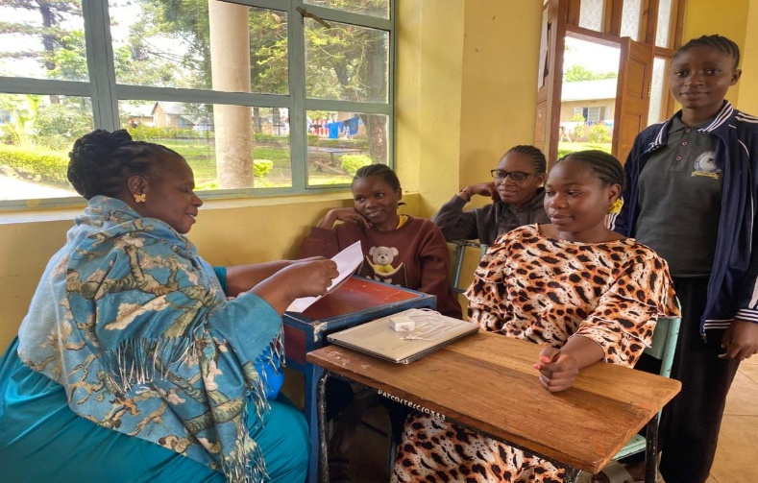

5. RESPONDENTS' DEMOGRAPHICS

5.1 Overview of Respondents
A total of 287 respondents participated in the online survey, 30 respondents participated in the KIIs, and 60 respondents participated in the FGDs across seven countries in East and Southern Africa: Zimbabwe, Zambia, Uganda, Malawi, Kenya, Rwanda, and Tanzania. The sample reflects a diverse range of participants, including Deaf women leaders, emerging leaders, youth representatives, and grassroots participants.
The distribution of respondents across countries and demographic categories provides a strong basis for regional analysis and comparison.

5.2 Distribution by Country
The respondent distribution reflects a broad regional representation across seven countries. Zimbabwe contributed the largest proportion (21.9%, n = 63), followed by Zambia (18.5%, n = 53) and Uganda (16.7%, n = 48). Malawi (13.2%, n = 38) and Kenya (12.5%, n = 36) also recorded substantial participation. | Chart 5.1: Distribution by country.  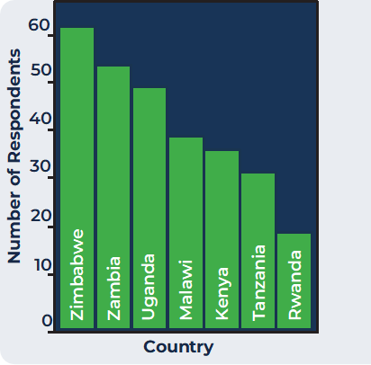
Notably, Tanzania’s contribution increased to 10.5% (n = 30) following the inclusion of additional translated responses, strengthening representation from East Africa. Rwanda contributed 6.6% (n = 19), further enhancing the regional scope of the dataset.
Chart 5.1: Distribution by Country
Overall, the distribution reflects a well-balanced regional sample, enabling robust cross-country comparison and strengthening the validity of the findings.

5.3 Gender Distribution
The number of respondents as shown were Females: 71.2 % (n = 205) and Males: 28.8 % (n = 81)
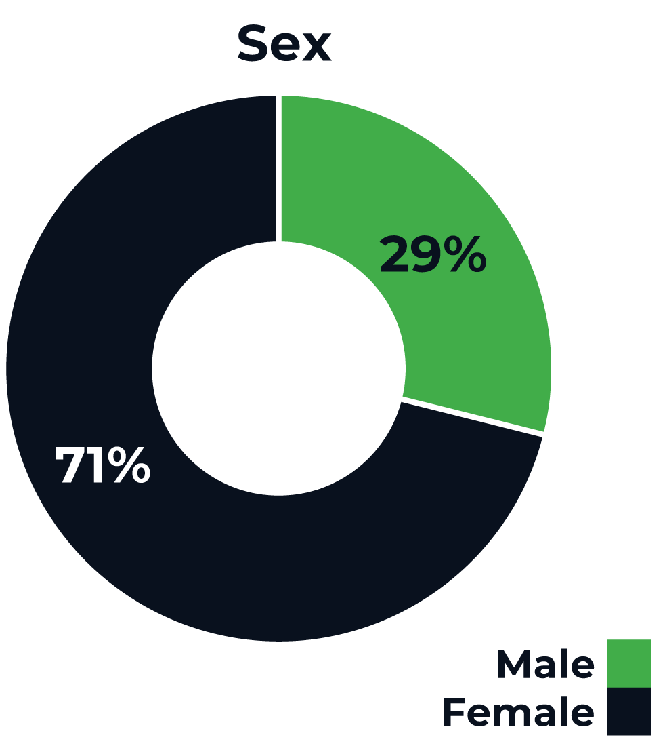
Chart 5.2: Gender distribution
Interpretation:
The majority of respondents were female, aligning with the focus of the study on Deaf women’s leadership. The inclusion of male respondents provides complementary perspectives on leadership dynamics and organisational structures.

5.4 Age Distribution
The age distribution was such that: 25–34 years: 38.7% (n = 109); 35–44 years: 25.9% (n = 73); 45–54 years: 15.6% (n = 44); 18–24 years: 14.2% (n = 40) and 55+ years: 4.6% (n = 13). This data is summarised below:
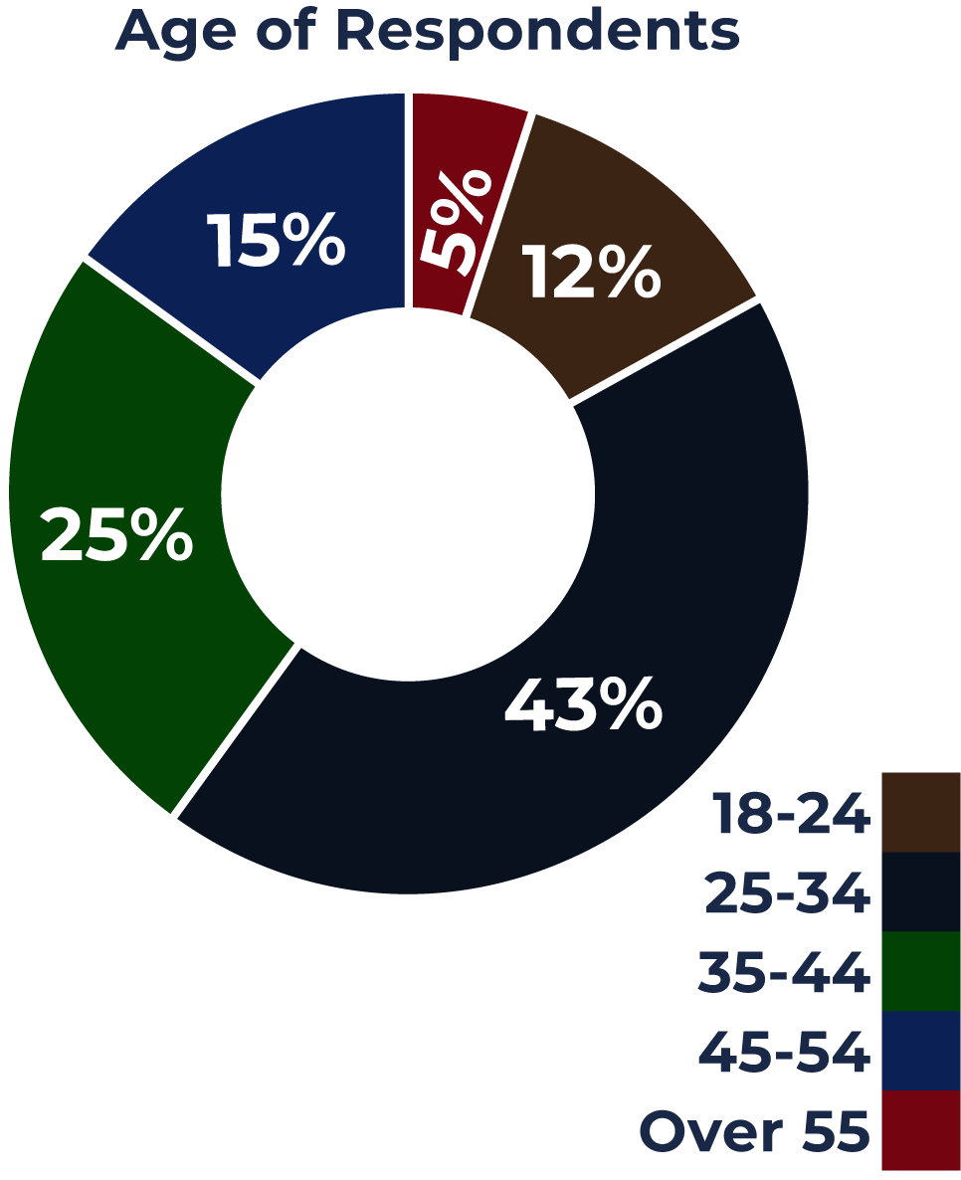

Chart 5.3: Age of Respondents
Interpretation:
Respondents were distributed across a range of age groups, with the largest proportion falling within the 25–34 and 35–44 age categories, indicating strong participation from individuals in active leadership and professional stages of life.
Younger respondents (18–24) were also represented, reflecting emerging leadership interest, while older age groups were less represented in the dataset.
The age distribution suggests that the study captures perspectives from individuals actively engaged in leadership pathways while also highlighting potential gaps in participation among older age groups.

5.5 Disability Type
According to the survey responses, the Deaf were 50% (n = 143); Hard of Hearing: 13 % (n = 39), and Others: 37% (n = 105)
Interpretation:
The majority of respondents identify as Deaf, ensuring that the findings are grounded in the lived experiences of the primary target group. The inclusion of Hard of Hearing and other categories provides additional diversity of perspectives.

5.6 Role in Organisation
The distribution of respondents by role indicates that the majority are general members (32%), followed by those in leadership or executive roles (20%) and staff members (17%).
Volunteers account for 12% of respondents, while youth representatives represent 9%.
Board members and allies each constitute 5% of the sample. This distribution reflects strong participation at the community level while also capturing perspectives from individuals in leadership, governance, and organisational roles.
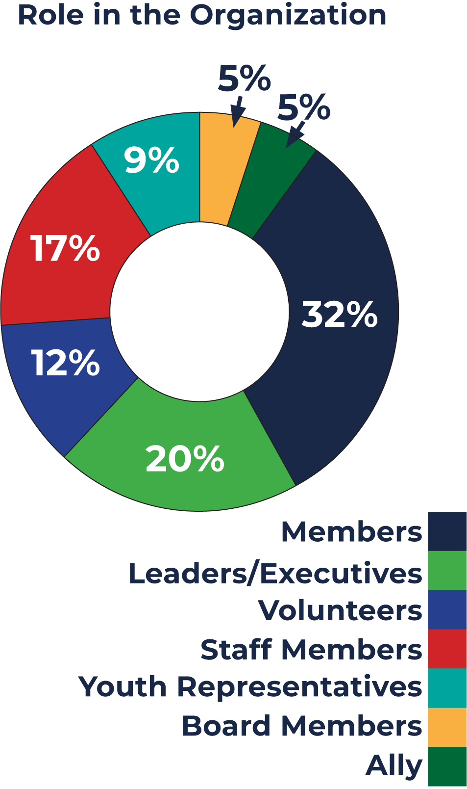

Chart 5.4: Role in the organisation
Interpretation:
The dataset captures perspectives across different levels of engagement, from grassroots members to leadership and governance positions. This strengthens the depth of analysis by incorporating both lived experience and institutional perspectives.

5.7 Length of Involvement
The statistics indicate that those with more than 10 years is 30.5% (n = 86); 1–3 years: 24.1% (n = 68); 4–7 years: 19.9% (n = 56); Less than 1 year: 16.7% (n = 47); 8–10 years: 7.8% (n = 22). This is summarised in the pie chart below:
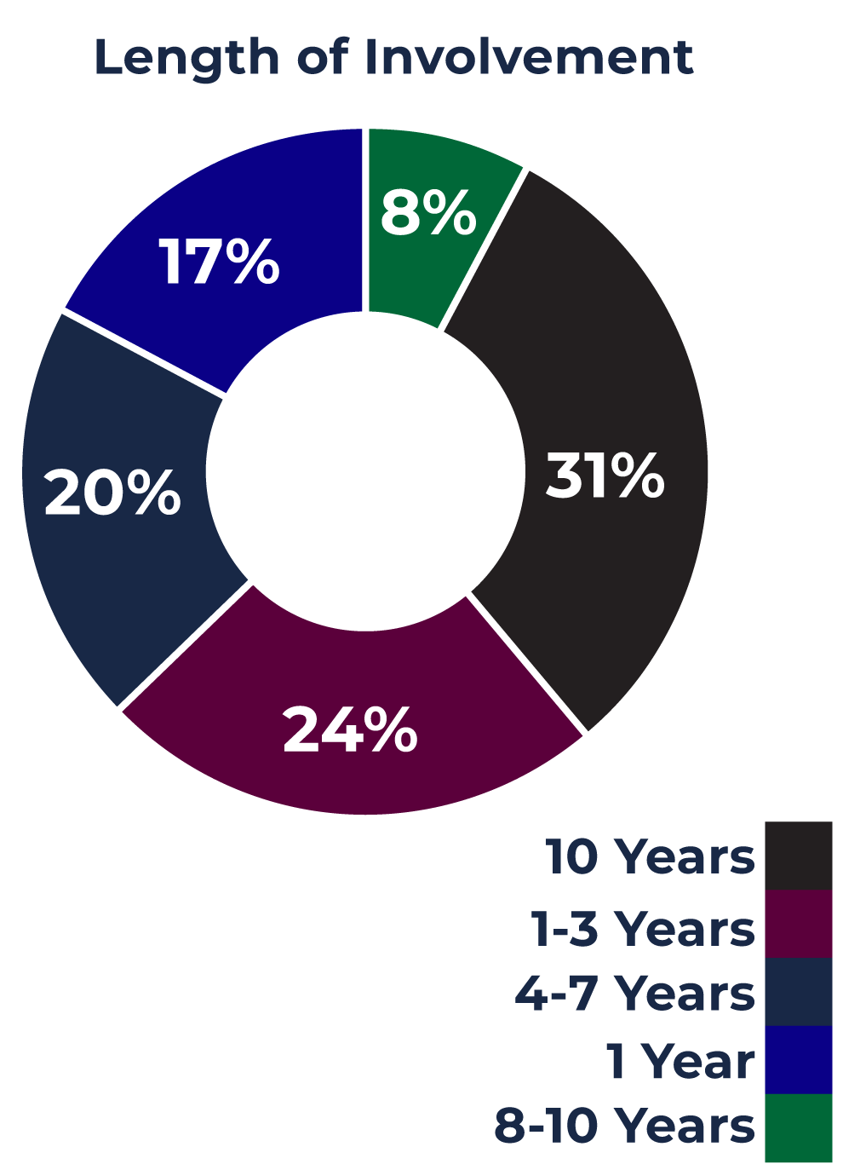

Chart 5.5: Length of Involvement
Interpretation:
A significant proportion of respondents have long-term involvement (over 10 years), indicating strong experience and institutional knowledge. At the same time, the presence of newer participants reflects ongoing engagement and the emergence of new leadership.

5.8 Women in Leadership
A cross-tabulation of gender and leadership status indicates that while a higher number of women occupy leadership positions overall (n = 125), compared to men (n = 65), proportional analysis reveals a different pattern.  A larger proportion of male respondents hold leadership roles relative to their total representation in the sample. | 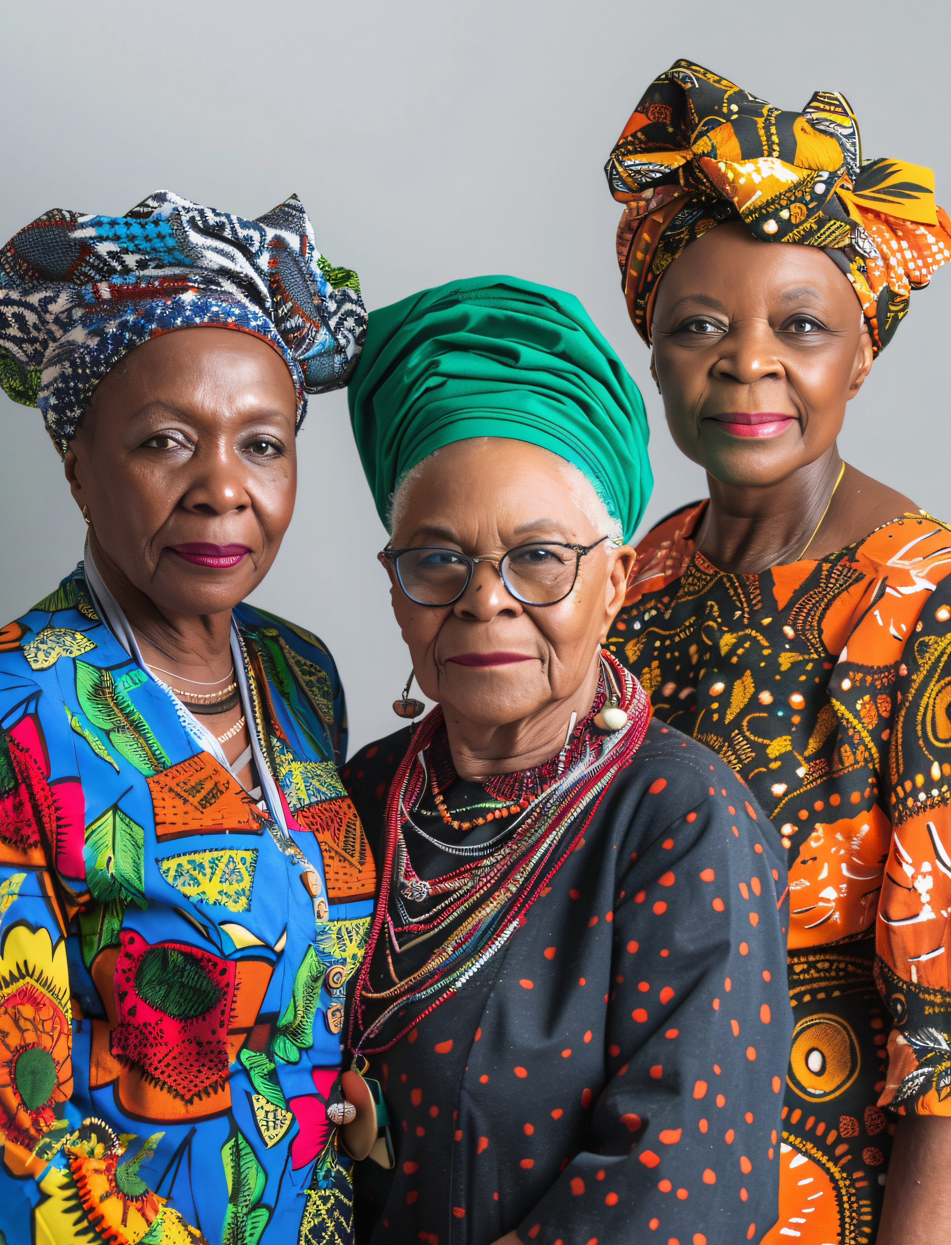
This suggests that, despite strong female participation, structural or institutional factors may still influence leadership access and advancement.
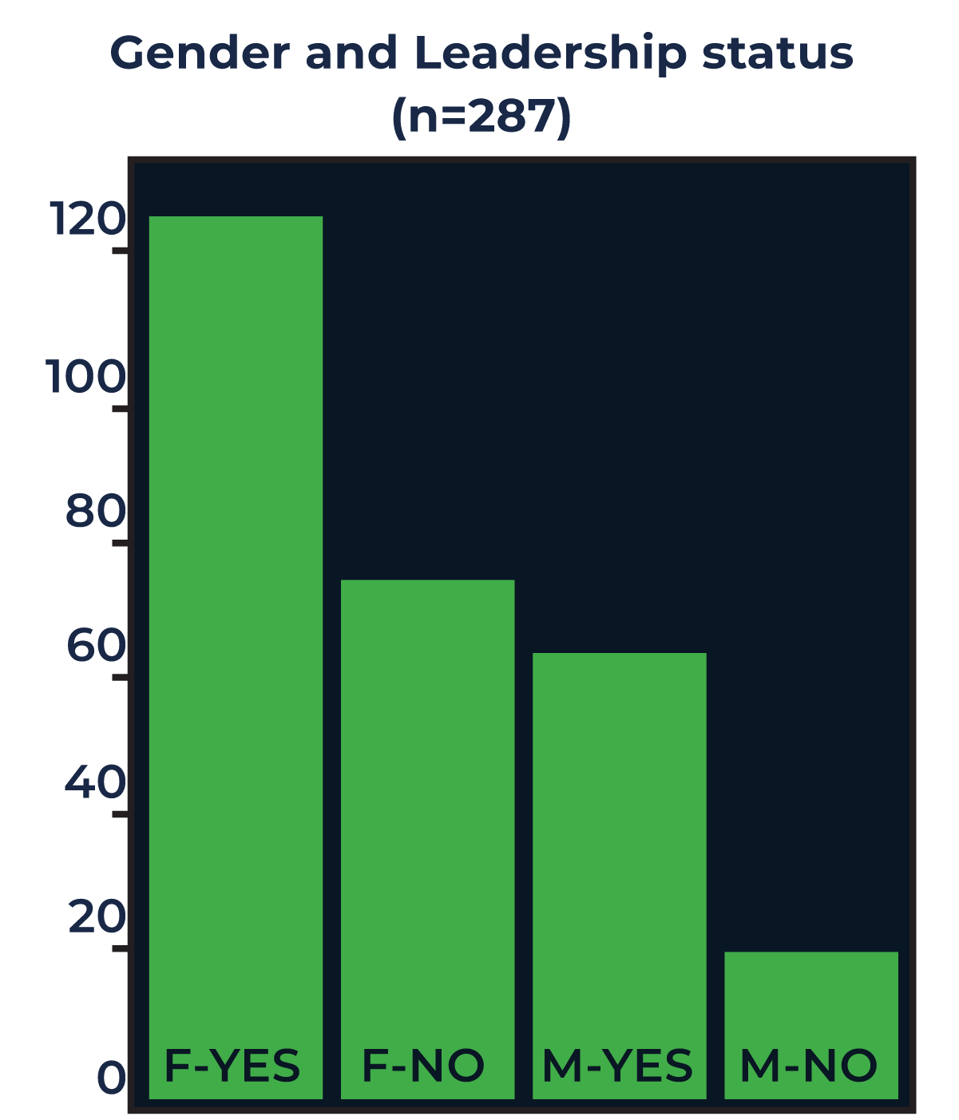
Chart 5.6: Cross Tab - Gender and Leadership status
Interpretation:
These findings reinforce the broader observation that representation alone does not necessarily translate into equitable access to leadership opportunities or influence within organizations.

5.9 Leadership by country
The distribution of leadership varies across countries, with Zimbabwe, Zambia, and Uganda demonstrating relatively higher participation in leadership roles, while other countries show comparatively lower representation. This variation reflects differences in organizational capacity, access to leadership opportunities, and structural conditions across contexts.

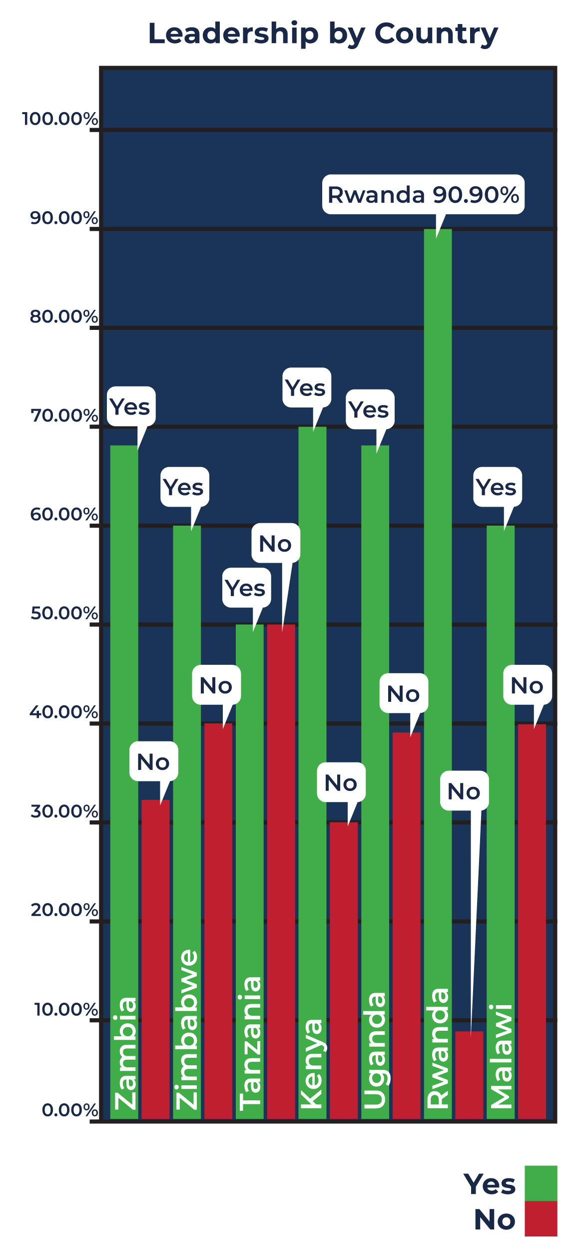 | The chart shows variation in leadership participation across the seven countries. Kenya (approximately 70%), Zambia (about 67%), and Uganda (around 65%) demonstrate relatively higher proportions of respondents in leadership positions. Zimbabwe and Malawi show moderate levels of leadership participation, at approximately 60% each.  Tanzania shows an equal distribution, with 50% of respondents in leadership and 50% not, indicating a balanced yet potentially transitional context for leadership access.
Rwanda shows the highest level of leadership participation (over 90%), with a very small proportion of respondents not in leadership roles.
Chart 5.7: Cross Tab - Leadership by Country
However, this should be interpreted with caution, as it reflects a smaller, more concentrated sample. Across all countries, a notable proportion of respondents are not in leadership positions, reinforcing the broader finding that while participation in organisations is strong, it does not always translate into equitable access to leadership roles.

6. FINDINGS AND DISCUSSION
The findings presented in this section draw from a combination of the online survey, Key Informant Interviews (KIIs), and Focus Group Discussions (FGDs) conducted across Kenya, Malawi, Rwanda, Uganda, Tanzania, Zambia, and Zimbabwe, and complemented by regional survey responses from additional countries. The analysis brings together these multiple sources of data to provide a comprehensive understanding of Deaf women’s leadership, participation, and inclusion across the region.
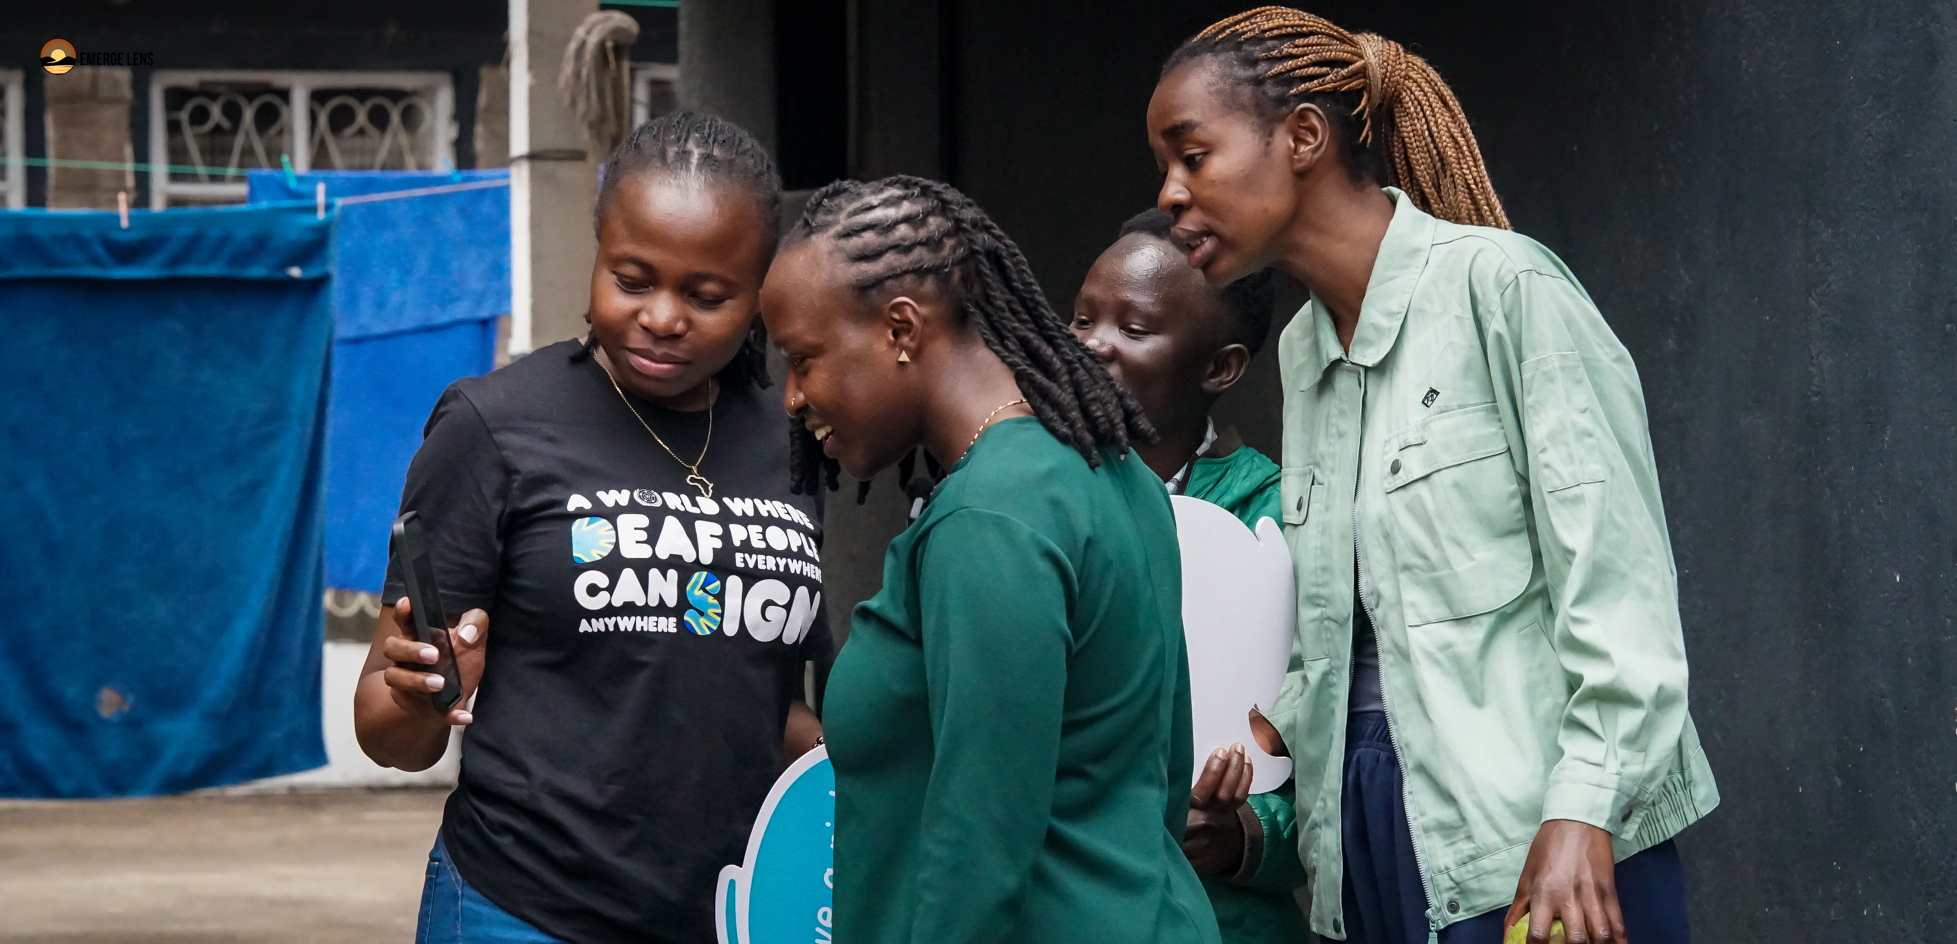
Across all countries and supported by survey data, KIIs, and FGDs, a clear and consistent pattern emerges; a clear and consistent pattern emerges. While Deaf women’s leadership is widely acknowledged and valued, their participation in leadership and governance structures remains constrained by a combination of structural, institutional, and socio-cultural barriers. The findings further reveal that inclusion is often present in form but limited in substance, with many Deaf women occupying spaces without corresponding influence or decision-making power.

6.1 Leadership, Participation, and Inclusion

6.1.1 Knowledge and Capacity on Policy Frameworks
Across the region, there is a general awareness of international and national policy frameworks such as the UN Convention on the Rights of Persons with Disabilities (UNCRPD), the African Disability Protocol (ADP), and the Sustainable Development Goals (SDGs). Survey findings indicate that a substantial proportion of respondents are aware of international and national policy frameworks such as the UNCRPD and SDGs; however, this awareness is not consistently matched by the ability to apply them in advocacy or leadership contexts.
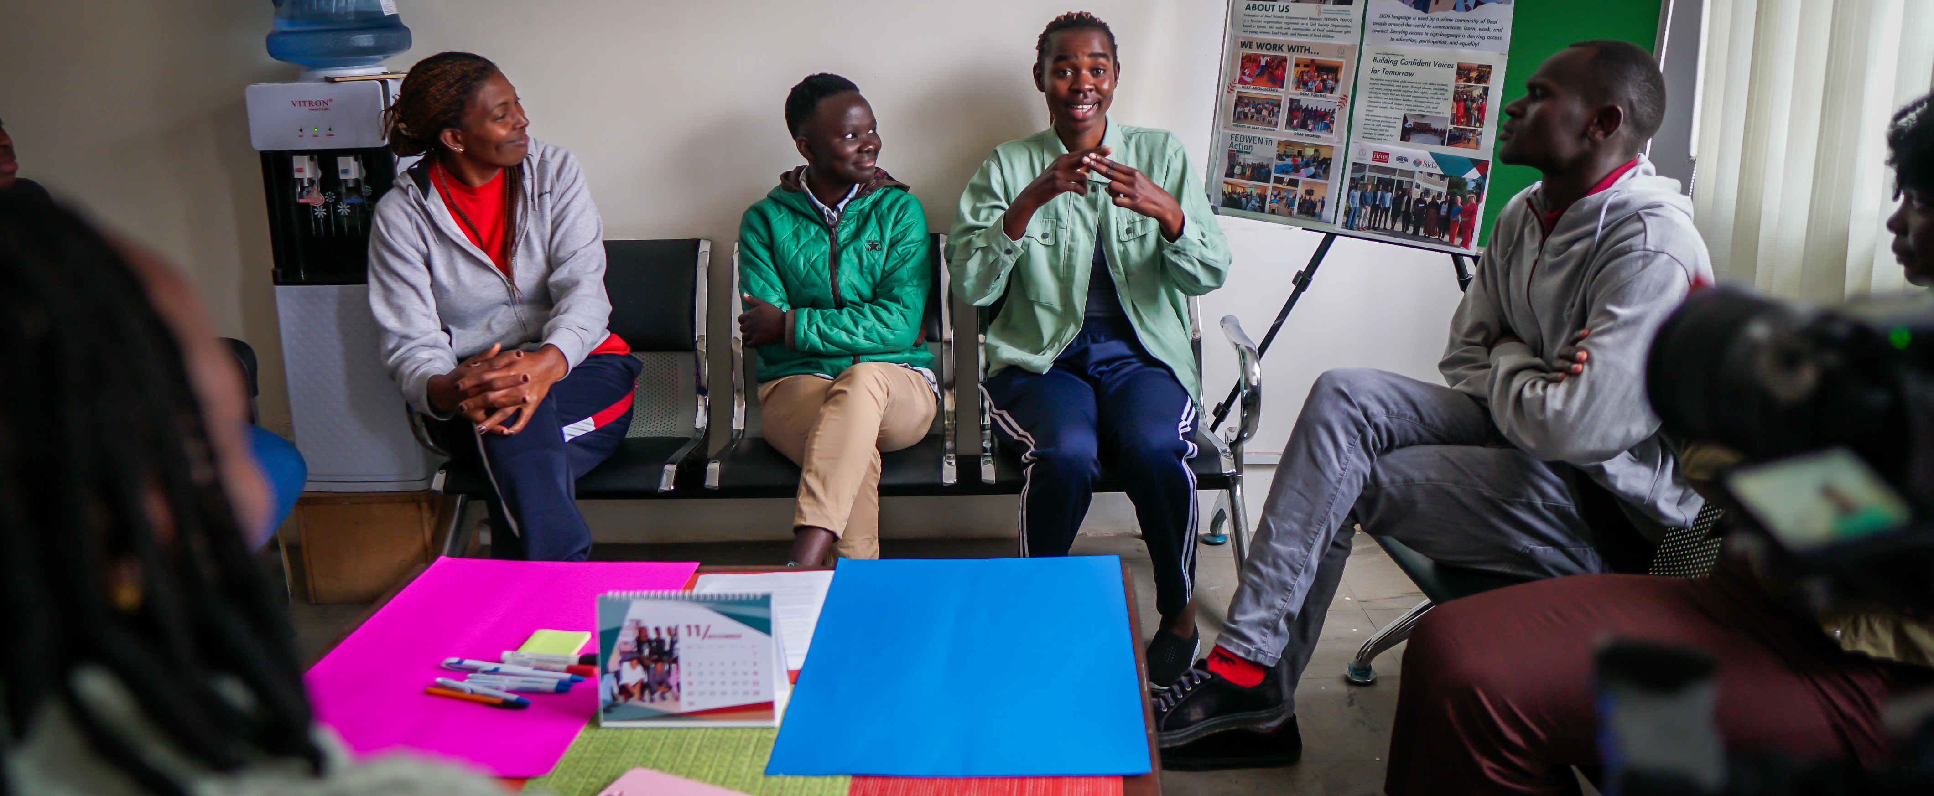
This is largely due to limited practical training on how to translate policy frameworks into action, low legal and policy literacy, and inadequate access to easy-to-read or sign-language-adapted materials.
Insights from KIIs across Uganda, Tanzania, and Zimbabwe reinforce this gap, highlighting limited institutional capacity to translate policy commitments into practice. Informants pointed to weak engagement with policy processes and a lack of technical support for Deaf women to meaningfully utilise these frameworks, such as limited training on policy analysis and interpretation, inadequate guidance on engaging in legislative and advocacy processes, and insufficient support in areas such as proposal writing, monitoring and evaluation, and strategic advocacy planning.
Malawi findings further reinforce this gap between policy awareness and practical application. Key informants highlighted that although organisations align with frameworks such as the Malawi National Disability Act and the UNCRPD, many Deaf women lack access to these instruments in accessible formats and are not adequately supported to engage with them in practice. Additionally, limited legal literacy and the absence of targeted policy training programs for Deaf women constrain their ability to translate rights awareness into advocacy action. In addition to gaps in policy application, findings indicate that leadership and rights awareness are often delivered in fragmented ways, limiting their practical impact. While some organisations provide training on human rights, SRHR, and advocacy, these initiatives are not always integrated into broader leadership development pathways. As a result, Deaf women may acquire knowledge in isolated areas without sufficient support to translate this into sustained engagement in governance and policy processes.
Experiences shared in Focus Group Discussions further illustrate how this gap manifests in everyday contexts. Participants described a disconnect between knowing about rights and being able to act on them. In Kenya, for instance, communication barriers exacerbate this challenge, as access to information relies on the availability of sign language interpretation and accessible formats.
As one female participant in Kenya noted: "Information delivered in sign language is not just a preference, it is a necessity.”
Evidence from Rwanda further highlights gaps in capacity to apply policy frameworks. Key informants reported that there are currently no structured training programs available for Deaf women on international instruments such as the UNCRPD, CEDAW, or SDGs, largely due to funding constraints.
Thus, these findings suggest that the challenge is not only one of awareness but also of access, capacity, and enabling environments that allow Deaf women to translate knowledge into action.

6.1.2 Leadership Representation
The results indicate that Deaf women occupy leadership roles throughout the region, however, their representation is inconsistent and frequently limited to lower or mid-level positions. While survey respondents strongly affirmed the leadership potential of Deaf women, organisational practices do not consistently support their progression into senior decision-making roles. Key informants attributed these findings to entrenched institutional hierarchies and gendered power dynamics that limit advancement. One of the participants in the KIIs in Zambia acknowledged having a gender balance policy in their structures, however, regardless of this policy, the organisation remained male-dominated due to the limited leadership capacity of women within their organisation's locality.
A male director of one Deaf Association in Zambia had this to say: "Our organisation has a gender policy. Although we do not strictly reserve positions for women we ensure balance in appointments where we have an equal number of men and women. The problem is that some women feel less confident and feel they lack the capacity to lead, and therefore, they shy away from standing during elections or applying for these positions. So I think the biggest problem is a lack of capacity. There's a need for more leadership programs for Deaf women to strengthen their capacity and confidence”.
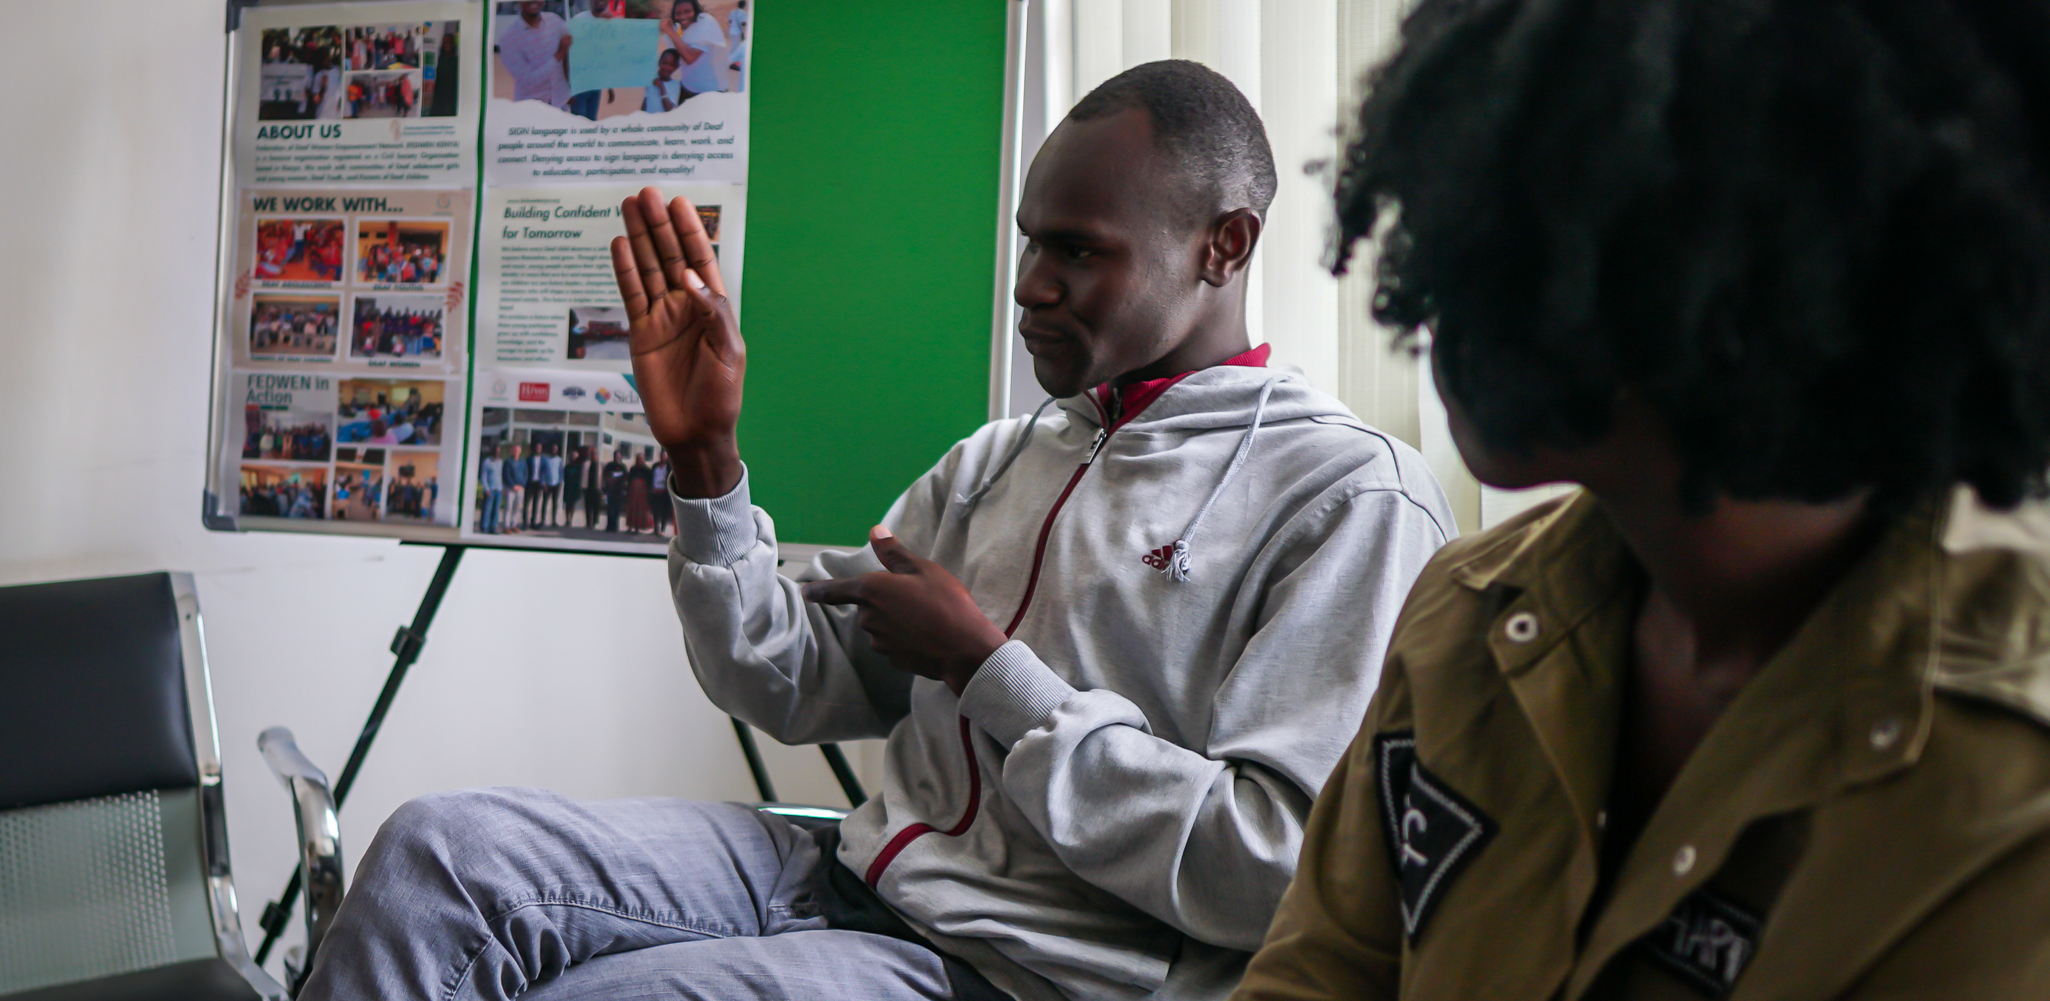
In Rwanda, formal governance structures include representation of Deaf women at Board level, as well as dedicated Women’s Committees where leadership is fully held by Deaf women. However, representation remains uneven, with women still fewer than men in broader governance structures.
FGD discussions further reflect these structural constraints, with participants describing their inclusion as largely symbolic.
A participant from one of the FDGs in Uganda noted, “We are included, but we are not heard.”
In Kenya, participants highlighted that even within Deaf-led organisations, leadership spaces remain male-dominated, with limited deliberate efforts to promote Deaf women into senior roles. This points to a layered form of exclusion, where Deaf women face barriers not only in mainstream systems but also within their movements. Additionally, participants pointed to the lack of systematic data on Deaf women’s representation in leadership. Key informants noted that limited monitoring and documentation make it difficult to accurately track participation and progress, thereby weakening accountability and targeted intervention efforts. Current evidence suggests that Deaf women’s presence in leadership remains extremely low across institutions, emphasizing the need for improved data systems to inform inclusive leadership strategies.
Evidence from Zimbabwe further reinforces the extent of underrepresentation of Deaf women in leadership structures. Participants described the current situation as “severely limited,” noting that Deaf women are frequently excluded from key decision-making processes and that their priorities are often overlooked in policy and governance spaces. Even within Deaf-led organisations, leadership opportunities for women remain uneven, with some spaces still dominated by men or lacking a clear focus on women’s leadership advancement.
Malawi reflects similar patterns of underrepresentation. Across organisational structures, women occupy approximately 20% of leadership positions, both at executive and secretariat levels, indicating a persistent gender imbalance even within Deaf-led institutions.
While democratic governance systems exist, cultural norms, low educational attainment, and limited confidence among Deaf women continue to restrict their participation in leadership contests.
Beyond representation gaps, governance structures themselves may unintentionally reinforce exclusion. Evidence from KIIs shows that while leadership systems are formally democratic, structural inequalities, such as lower educational attainment and limited exposure to leadership processes, affect who is able to contest and succeed in leadership positions.
This suggests that equal opportunity frameworks alone are insufficient without targeted support to prepare Deaf women for leadership roles.
In addition, leadership representation is shaped by systemic factors beyond organisational structures. Evidence from KIIs indicates that Deaf women remain underrepresented in senior leadership roles, despite their increasing involvement in program implementation and advisory functions.
This reflects broader patterns of educational inequality, gender bias, and limited access to leadership pathways, which continue to restrict progression into decision-making positions.
As noted by one informant, this underrepresentation is not a reflection of capability, but rather the result of long-standing systemic exclusion across education and professional development pathways
Across countries, the findings emphasize the important distinction between representation and influence. Being present in leadership structures does not necessarily translate into meaningful participation or decision-making power.
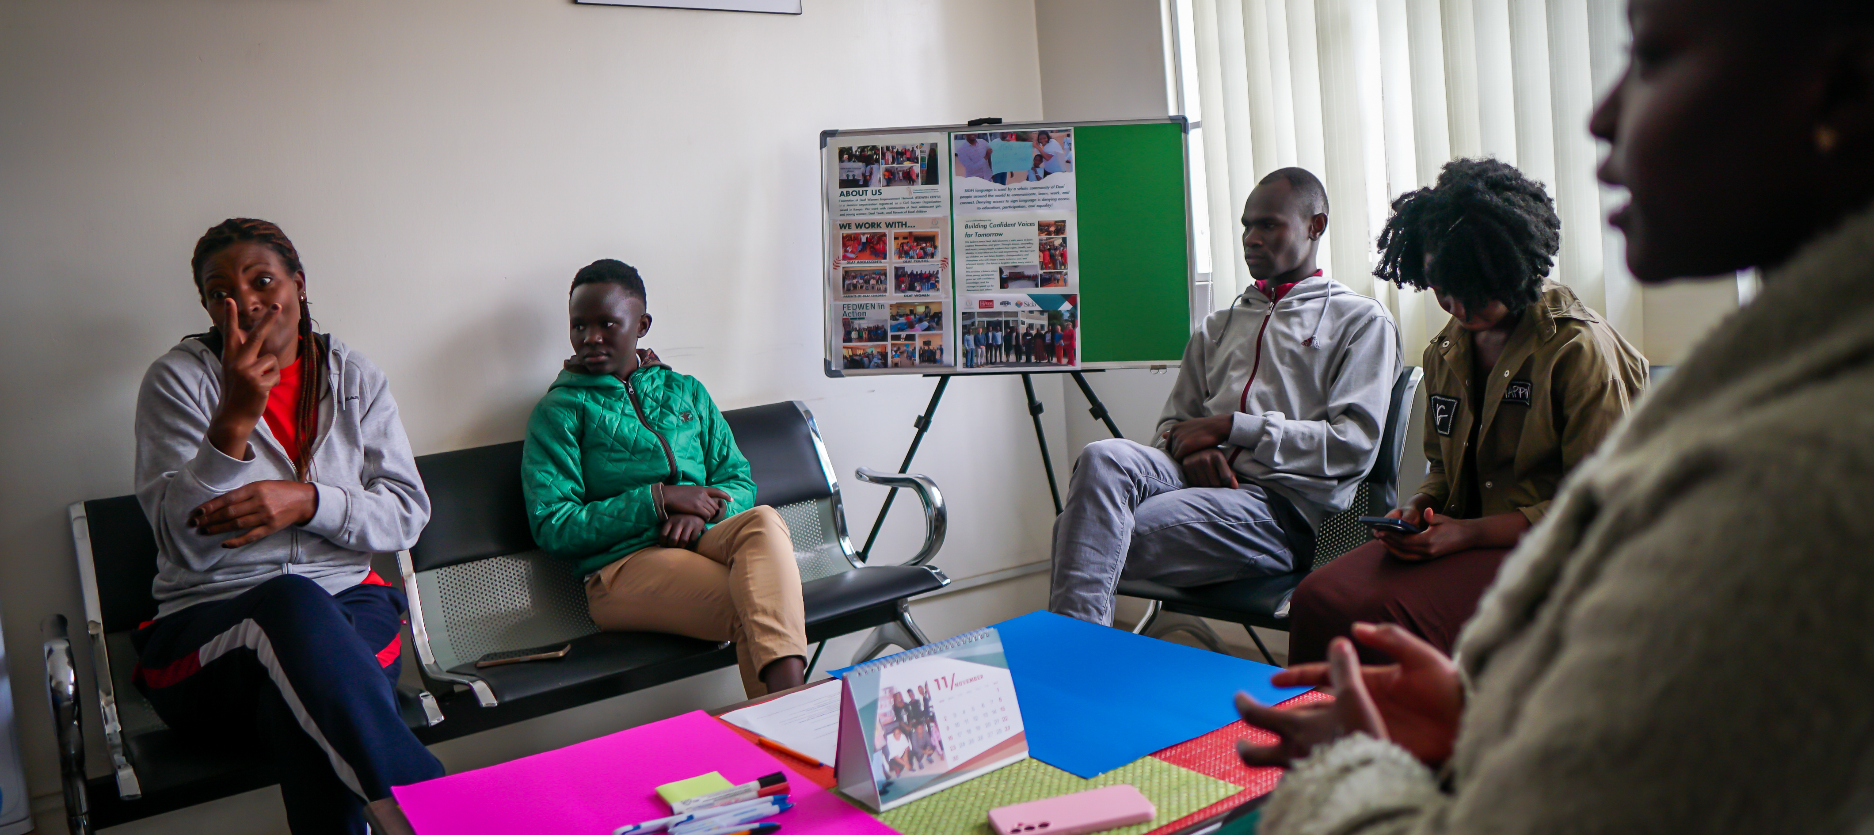

6.1.3 Barriers to Leadership
The barriers affecting Deaf women’s leadership are complex, intersecting, and mutually reinforcing. Survey findings consistently identified communication barriers, financial constraints, discrimination, and limited access to information as the most frequently reported challenges across countries.
KIIs expand on these findings by pointing to systemic issues such as weak institutional accountability, lack of inclusive governance systems, and gaps between policy commitments and implementation.
Furthermore, FGDs across the focus region provided a deeper understanding of how these barriers are experienced in practice. Communication challenges remain the most immediate and pervasive constraint, with participants describing situations where meetings take place without qualified interpreters or where interpretation is inadequate.
One female participant from Malawi stated: “Meetings happen without interpreters, so we just sit and watch.”
Findings from KIIs in Malawi and Rwanda strongly reinforce the centrality of communication barriers, with institutions frequently failing to provide sign language interpreters, effectively excluding Deaf women from leadership and decision-making spaces.
Language diversity, literacy challenges, and the high cost of interpretation services further worsened communication barriers in Zambia.
Financial constraints also limit participation, particularly where attending meetings or training requires personal resources.
Exclusion occurs not only in formal communication settings but also in informal and relational settings, where influence often takes shape.
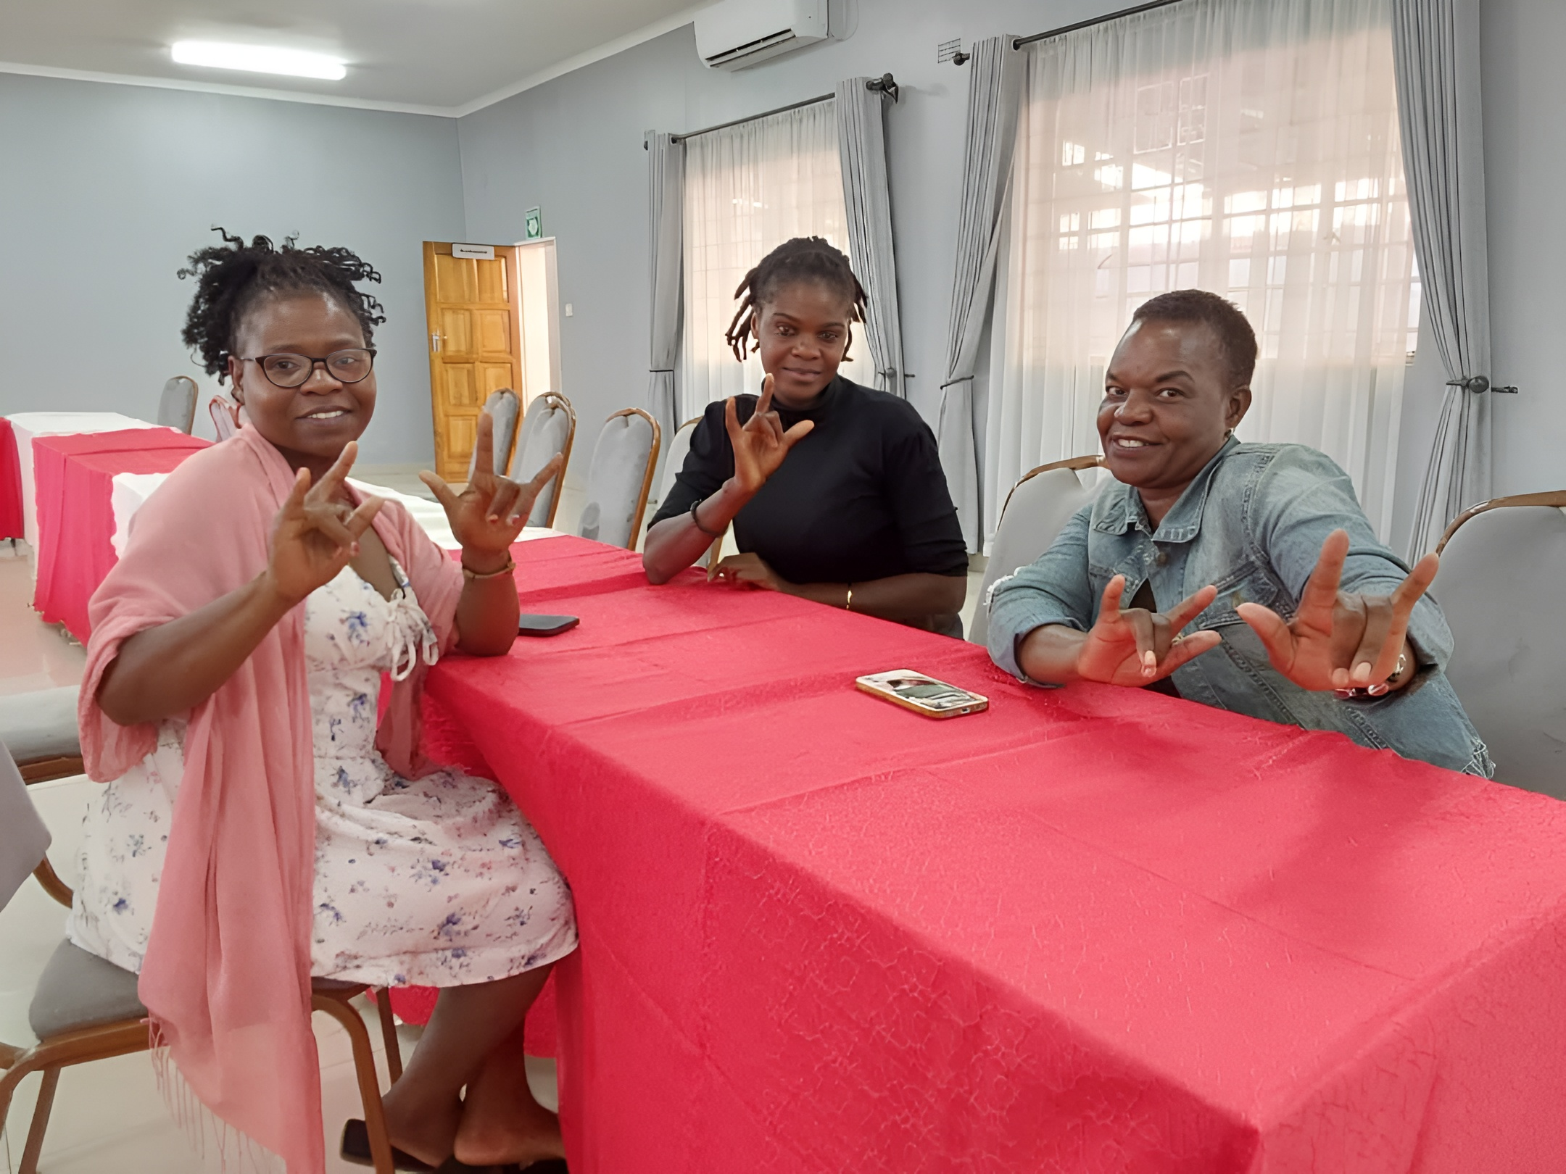Respondents emphasized that networking settings, such as side meetings and informal discussions, are often unavailable to Deaf women, hindering their capacity to cultivate relationships, obtain information, and sway decisions. Even where interpretation is provided, it is not always tailored to technical or policy discussions, resulting in gaps in understanding and reduced participation. Over time, this limited engagement can reinforce perceptions of disengagement and further exclude Deaf women from leadership opportunities.
Beyond the availability of interpretation, the quality and contextual appropriateness of interpretation emerged as a critical issue. Participants highlighted that interpreters are often not adequately trained in technical or policy-related content, resulting in misinterpretation or oversimplification of key discussions. Variations in sign language across regions further limit comprehension and effective participation, even where interpretation is provided.
Another important dimension emerging from the findings is the role of institutional perceptions in shaping exclusion. In several contexts, the cost of inclusion, particularly the provision of sign language interpretation and accessible communication, was perceived as a burden rather than a responsibility. This perception discourages institutions from investing in inclusive practices and reinforces systemic exclusion, limiting Deaf women’s access to leadership and decision-making spaces.
Social and gendered factors further shape the extent to which Deaf women are able to engage in leadership. Participants described how domestic responsibilities, early motherhood, and limited access to education significantly restrict their time, mobility, and confidence to pursue leadership opportunities. Experiences of discrimination, both as women and as persons with disabilities, continue to reinforce exclusion, often undermining self-confidence and limiting visibility in leadership spaces.
In addition to these structural and socio-economic barriers, a notable dimension emerging from Kenya relates to intra-community dynamics that hinder leadership development. Participants described a lack of mutual support, alongside practices of gatekeeping and what was referred to as a “pull-down” culture, where emerging leaders are not consistently supported by those already in positions of influence. Similar sentiments were echoed by participants across Uganda, Malawi, and Tanzania, where some FGD respondents noted that competitive behaviours among Deaf women leaders are often driven by limited access to resources and opportunities. Furthermore, low educational attainment among Deaf girls, often due to weak inclusive education systems and a lack of specialised teachers, emerges as a foundational barrier that limits long-term leadership opportunities.
In Zambia, participants highlighted how these socio-economic conditions and entrenched perceptions continue to shape leadership opportunities for Deaf women.
As one female participant from Zambia explained: “Deaf women who are leaders are very few due to negative attitudes against them, believing that Deaf women can’t be in leadership… Most Deaf women come from poverty-stricken homes, which limits their participation.”
Structural inequalities, particularly poverty and societal perceptions of capability, continue to restrict access to leadership spaces.
These conditions not only limit individual participation but also shape the broader leadership environment. In contexts of resource scarcity, Deaf women often compete against each other instead of receiving support through collaborative and collective leadership approaches.
As a result, leadership development is constrained not only by external barriers but also by relational dynamics within the community itself.
At the same time, participants identified clear pathways for change. They stressed the importance of deliberately "breaking the ceiling" by raising awareness and focusing on capacity building. This includes strengthening advocacy skills and building practical competencies in organizational and financial management. | 
Such investments are critical to enabling Deaf women to take up leadership roles with confidence, sustain their initiatives, and contribute to more collaborative and inclusive leadership ecosystems.
These findings demonstrate that barriers to leadership are multi-layered, operating at structural, social, and interpersonal levels simultaneously often resulting from limited awareness of rights and opportunities, combined with weak coordination and low literacy levels, contributes to uneven leadership outcomes and reinforce exclusion from higher-level leadership spaces. They also point to the need for deliberate investment in Deaf women-led initiatives, not only to expand opportunities but also to foster collaboration, mentorship, and unity among Deaf women across the region. Findings further suggest that strengthening leadership outcomes will require coordinated efforts that address both systemic constraints and internal community dynamics, ensuring that Deaf women are supported through inclusive, well-resourced, and sustainable leadership pathways.

6.1.4 Access to Leadership Opportunities
Access to leadership development opportunities remains limited and uneven across the region. Survey findings indicate a clear lack of structured mentorship programs, leadership training, and defined pathways for progression. In Rwanda, access to leadership development opportunities has declined due to reductions in donor funding. Key informants noted that previous leadership and advocacy training programs for Deaf women have been discontinued, leaving a significant gap in structured capacity development. This sentiment is echoed in KIIs, where institutional actors acknowledged the absence of deliberate systems to nurture and support emerging Deaf women leaders. Leadership pathways are frequently informal, disjointed, and reliant on personal initiative rather than organized assistance.
FGD participants across all countries reinforced the importance of mentorship, noting that the absence of role models and guidance systems makes it difficult to navigate leadership spaces. In Kenya, this gap is particularly pronounced, with participants describing a “vacuum” in mentorship and professional support structures. Limited visibility of role models within leadership spaces is closely linked to the absence of mentorship. With relatively few Deaf women occupying senior leadership positions, emerging leaders often lack opportunities for guidance, exposure, and professional growth. This gap not only affects skills development but also shapes leadership identity, making it more difficult for Deaf women to envision themselves in leadership roles and navigate institutional barriers.
Young Deaf women in Zambia expressed strong concerns about the lack of mentorship and guidance from more experienced Deaf women leaders, noting that this gap limits their ability to navigate leadership pathways and build confidence in advocacy and governance spaces. Many described leadership as something they must “figure out alone,” with few structured opportunities for learning, shadowing, or support from those already in positions of influence.
However, this perspective stands in notable contrast to sentiments expressed by older Deaf women in Kenya, who articulated a sense of exclusion from leadership development initiatives that are often heavily targeted toward youth. Rather than positioning themselves as gatekeepers, many older women emphasized their willingness and readiness to support younger leaders but highlighted that they are rarely engaged, consulted, or included in capacity-building programs.
One participant in Kenya stated, “Stop oppressing older deaf women, we have more needs than young people.”
These perspectives reveal not a lack of willingness to mentor, but a disconnect in how leadership development systems are structured and implemented. While younger women in Zambia experience an absence of mentorship, older women in Kenya feel systematically overlooked and underutilized as potential mentors. This suggests that existing programs may be inadvertently reinforcing generational silos, rather than fostering intergenerational exchange and continuity in leadership.
These findings point to the need for more intentional, structured, and inclusive mentorship models that bridge this gap, recognizing older Deaf women as critical resources for leadership development while simultaneously creating accessible and supportive pathways for young women to learn, grow, and lead. Additionally, we can conclude from these findings that leadership development systems are not only limited but also unevenly distributed across age, geography, and socio-economic status.
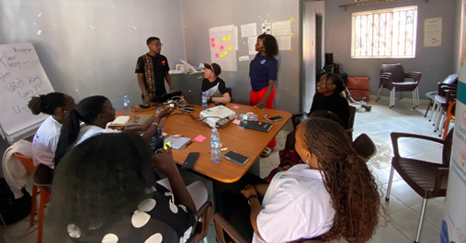

6.1.5 Institutional Support and Inclusion
Institutional support for Deaf women’s leadership remains inconsistent across the region. Survey findings indicate that while some organisations have adopted gender and inclusion policies, implementation remains inconsistent across countries.
Malawi findings illustrate that while some organisations provide training in areas such as leadership, sexual harassment prevention, and economic empowerment, these initiatives are not systematically targeted at Deaf women and remain insufficient in scale. Institutional perceptions that Deaf participation is “expensive” due to interpreter costs further limit inclusive programming and reinforce exclusion.
Additionally, key informants across Zimbabwe and Uganda highlighted the lack of accountability mechanisms and resource allocation to support inclusive leadership. Inclusion is often articulated as a priority but is not embedded within organisational systems or processes. In Zimbabwe, institutional challenges are further compounded by the limited capacity of Deaf women-led organisations to compete for funding. Smaller Organizations, often led by Deaf women, face difficulties accessing resources in a funding landscape dominated by larger and more established entities. This constrains their ability to scale initiatives, sustain leadership development efforts, and influence policy processes, despite their critical role in advancing Deaf women’s rights.
FGD participants reinforced this gap, noting that programs seldom address the specific needs of Deaf women. Respondents across the region observed that few organisations have targeted initiatives focused on empowering Deaf women, despite broader commitments to inclusion. This reflects a broader pattern in which inclusion is approached in general terms, without sufficient attention to the intersecting realities of gender and disability. Furthermore, the sustainability of Deaf women-led initiatives remains a significant concern. While grassroots structures such as women’s groups and savings initiatives contribute to empowerment, many struggle to scale or sustain their activities due to limited technical capacity, weak coordination, and insufficient funding. This limits their ability to transition from local empowerment efforts into broader leadership influence and institutional engagement
Findings from Kenya also highlight the impact of declining donor funding on Deaf women’s leadership structures. The discontinuation of dedicated platforms, such as women’s wings within organizations, has significantly reduced opportunities for coordinated engagement, mentorship, and leadership development. This stresses the importance of sustained investment in institutional structures that specifically support Deaf women’s leadership, rather than short-term or project-based interventions.
In addition, existing capacity-building systems often reinforce exclusion through their design. Many training opportunities require participants to cover costs or rely on external organizers to provide accessibility, placing a disproportionate burden on Deaf women who already face economic constraints. This creates an implicit “glass ceiling,” where those unable to afford participation are systematically excluded from leadership development opportunities.

6.1.6 Participation in Advocacy and Policy Spaces
Deaf women actively engage in community-level advocacy, particularly in awareness-raising, mobilization, and participation in disability movements. Survey findings indicate a strong interest and commitment to advocacy among Deaf women. However, participation in higher-level policy and decision-making spaces remains limited. KIIs attribute these challenges to structural exclusion, lack of accessible platforms, and limited recognition of Deaf women as key stakeholders in policy processes. FGD discussions further clarify the nature of participation. Many participants across the region described feeling excluded from important meetings and decision-making processes, with opportunities often limited to a small group of individuals.
Participation at national, regional, and international levels, including engagement in African Union (AU) and United Nations (UN) advocacy spaces, remains limited and uneven. While a small number of Deaf women have participated in such forums, this largely depends on external support and organizational affiliation rather than on structured pathways. Many participants reported limited awareness of these opportunities, as well as barriers related to cost, accessibility, and complex application processes. Even where participation occurs, it does not consistently translate into influence, with experiences of tokenistic inclusion persisting across contexts.
A KII respondent from Zimbabwe lamented, “International advocacy spaces are not accessible to most Deaf women. Without funding, information, and guidance, it is almost impossible to participate.”
FGD participants from Uganda shared a similar sentiment, “We hear about international meetings focusing on women empowerment under UN Women, but we don’t know how to get there or who chooses the participants. Even when someone goes, they don’t always come back to share or represent all of us.”
In Malawi, Deaf women’s participation in decision-making remains particularly limited, with key informants noting that most Deaf women are rarely consulted in policy or organisational processes. Where participation exists, it is often confined to local or community-level forums, with limited pathways to influence national or regional policy engagement. In addition, disparities in policy awareness continue to affect the quality of participation. Some participants reported limited familiarity with international and regional frameworks such as the United Nations Convention on the Rights of Persons with Disabilities (UNCRPD) and the Convention on the Elimination of All Forms of Discrimination Against Women (CEDAW), which constrain their ability to engage effectively in policy dialogue and advocacy processes. This gap reinforces unequal participation, where only a small group of individuals with prior exposure are able to influence discussions.
Similarly, in Kenya, participants highlighted experiences of tokenism, where inclusion is perceived as symbolic rather than meaningful.  Even where opportunities for participation exist, meaningful engagement is often constrained by power imbalances and limited preparation. Key informants noted that Deaf women are sometimes invited to consultations | 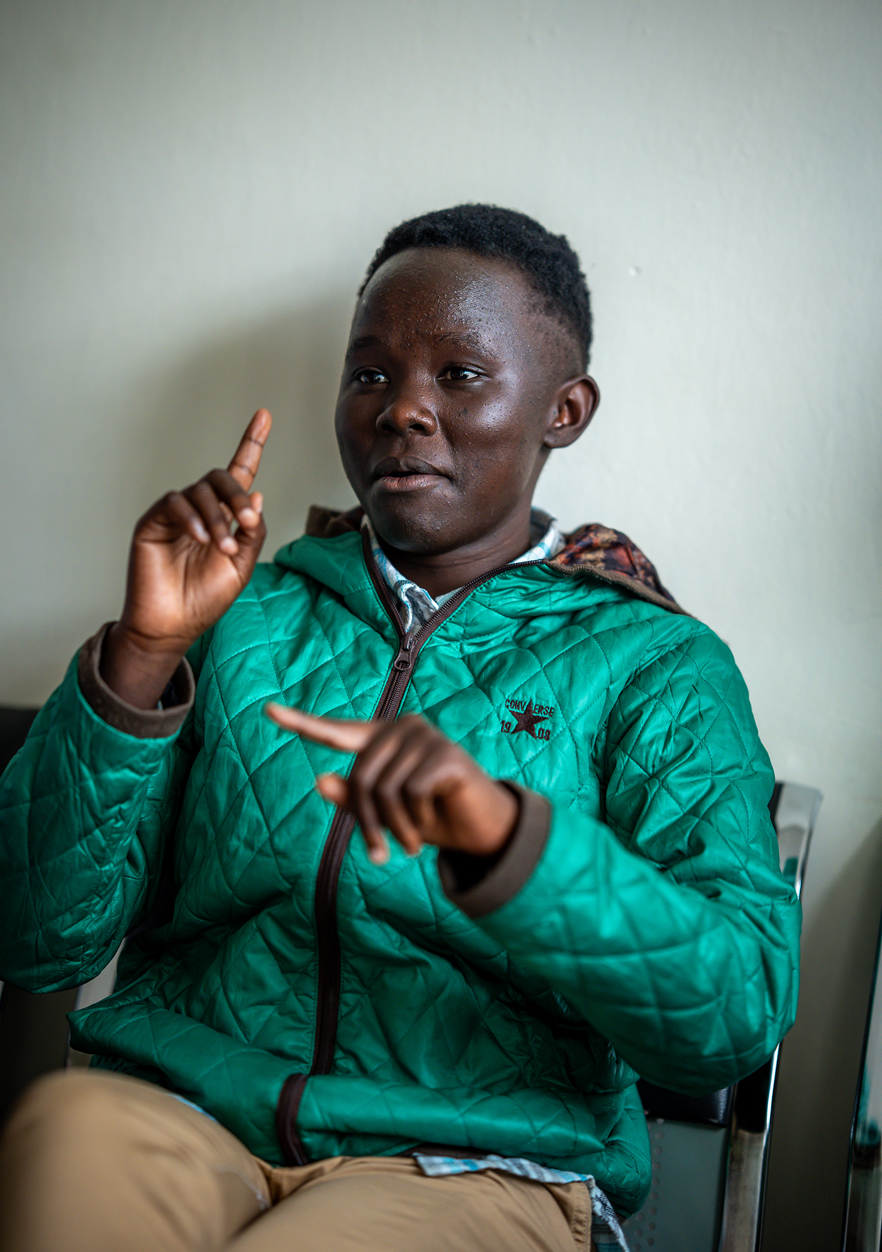
without adequate support, preparation, or access to information, resulting in participation that is largely symbolic. Participation is further limited by the design of training and policy engagement spaces, which are often delivered using complex and technical language that is not adapted for accessibility. Participation is further limited by the design of training and policy engagement spaces, which are often delivered using complex and technical language that is not adapted for accessibility. This limits their ability to contribute effectively and reinforces patterns of tokenistic inclusion within policy and decision-making spaces.
One participant from Zimbabwe lamented, “We are only invited so organizations can look inclusive.”
At the same time, findings from Zimbabwe illustrate both the potential and limitations of Deaf women’s engagement in advocacy. Participants highlighted their involvement in national advocacy initiatives such as the Disability Bill Campaign and the Equal Zimbabwe Campaign, demonstrating growing visibility and contribution to policy processes. However, despite these gains, participation remains uneven, with Deaf women often underrepresented compared to other disability groups and concentrated within a small number of well-connected organisations. These findings suggest that while participation exists, it is often constrained in terms of quality and influence, limiting the ability of Deaf women to shape decisions and outcomes.

6.2 Priority Needs and Areas for Support
Across the region, there is strong alignment around the need for targeted interventions to strengthen Deaf women’s leadership. Survey respondents identified leadership development, mentorship, policy engagement training, and economic empowerment as key priorities. KIIs emphasized the importance of institutional reform, including the development of structured leadership programs and accountability mechanisms. FGDs expanded these priorities to include practical and context-specific needs. In Kenya, participants highlighted the importance of safeguarding mechanisms in schools, access to sexual and reproductive health information, and intergenerational approaches to leadership development.
The findings from Malawi and Zambia highlight additional priority needs, including the urgent finalization and implementation of the National Inclusive Education Policy, increased disability-targeted funding, and expanded advocacy on Deaf rights. There is also strong emphasis on
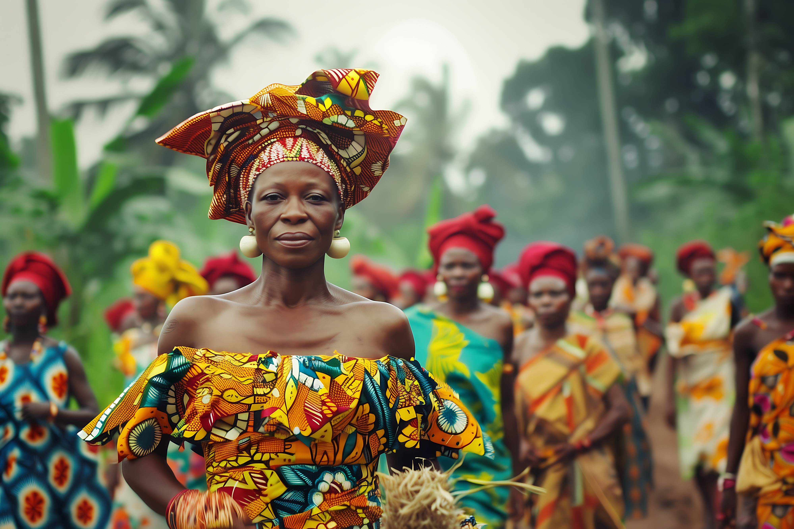leadership training, mentorship, and policy literacy programs, alongside economic empowerment initiatives to address structural inequalities.
Participants in Zimbabwe also highlighted the importance of expanding capacity strengthening beyond foundational leadership training to include technical and professional skills. These include monitoring and evaluation, proposal writing, governance, and public speaking, all of which are critical for enabling Deaf women and their organisations to compete effectively for funding and participate meaningfully in policy and advocacy processes. There was also a strong emphasis on peer-to-peer learning, with participants noting that training led by Deaf women themselves enhances relevance, confidence, and practical application of skills.
Participants from Rwanda emphasized the need for leadership and governance training, digital literacy, networking opportunities, and capacity building on international policy instruments. Additional priorities include increased funding for Deaf women-led initiatives, recognition of sign language, and strengthened regional collaboration platforms.
Across countries, the results highlight a clear demand for opportunities that move beyond awareness towards practical support, enabling Deaf women to participate meaningfully in leadership and governance. There is also a growing need to strengthen organizational and technical capacity at both individual and institutional levels. Participants emphasized the importance of skills such as proposal writing, financial management, governance, and monitoring and evaluation, which are essential for accessing funding and sustaining leadership initiatives. Without these competencies, Deaf women-led organizations remain disadvantaged in competitive funding environments.

6.3 Summary of Key Findings
The triangulated findings from the survey, Key Informant Interviews (KIIs), and Focus Group Discussions (FGDs) present a coherent and consistent picture of Deaf women’s leadership across East and Southern Africa. While variations exist across countries, the evidence points to shared structural patterns that shape participation, representation, and leadership outcomes.
A central finding is the persistent gap between awareness and application of policy frameworks. Although many Deaf women demonstrate familiarity with instruments such as the UNCRPD and SDGs, this knowledge is not consistently translated into practice. This gap is reinforced by limited access to information in accessible formats, low legal literacy, and insufficient institutional support to enable meaningful engagement in advocacy and policy processes.
In terms of leadership representation, Deaf women are present within organizational structures; however, their participation remains uneven and often concentrated at lower levels. Across all data sources, there is a clear distinction between presence and influence. Deaf women may occupy positions within organizations, but this does not necessarily translate into decision-making power or authority. Structural inequalities, gendered norms, and limited leadership preparation continue to restrict progression into senior roles.
Access to leadership opportunities is similarly fragmented. The absence of structured mentorship systems, leadership training, and clearly defined pathways for advancement limits the development of emerging leaders. These gaps are further shaped by disparities related to age, geography, education, and socio-economic status, resulting in an uneven and exclusionary leadership pipeline.
The barriers to leadership identified across the region are multi-layered and intersecting. Communication challenges, including both the absence and poor quality of interpretation, remain a primary constraint. Financial limitations, discrimination, and gaps in education further restrict participation. These structural barriers are heightened by institutional limitations, including weak policy implementation, limited accountability, and perceptions of accessibility as a cost burden rather than a responsibility. In addition, socio-cultural factors such as gender norms, domestic responsibilities, and low confidence continue to shape leadership trajectories.
Institutional support for Deaf women’s leadership remains inconsistent. While policies promoting inclusion exist, their implementation is often weak and insufficiently targeted. Many initiatives are short-term, fragmented, or not specifically designed to address the intersecting realities of Deaf women. As a result, inclusion is frequently reflected in policy commitments rather than in sustained practice.
Participation in advocacy is strongest at the community level, where Deaf women are actively engaged in awareness-raising and grassroots mobilisation. However, their involvement in higher-level policy and decision-making spaces remains limited and, in some cases, symbolic. Power imbalances, inaccessible processes, and limited preparation continue to constrain meaningful engagement.
At the same time, the findings highlight a strong demand for capacity strengthening. Across all countries, Deaf women expressed the need for leadership training, mentorship, policy literacy, and economic empowerment. There is also increasing recognition of the need to strengthen technical and organisational competencies, including governance, financial management, and resource mobilisation.
Overall, the findings emphasize the need for coordinated and multi-level interventions that move beyond awareness towards practical, inclusive, and sustainable leadership systems. Strengthening Deaf women’s leadership will require addressing both systemic constraints and internal community dynamics, while creating structured, accessible, and well-resourced pathways for meaningful participation and influence.

6.4 Cross-Cutting Regional Insights
The results show that there is a deeply entrenched and multi-layered pattern of exclusion in Kenya, Malawi, Rwanda, Uganda, Tanzania, Zimbabwe, and Zambia. This pattern is caused by the intersection of gender, disability, socio-economic inequality, and institutional limitations. While contexts differ, the overall experience of Deaf women across the region reflects a common reality: Leadership potential exists, but enabling systems remain weak, fragmented, or inaccessible.
A consistent theme across all countries is the gap between representation and influence. Deaf women are increasingly present within organisations and advocacy spaces, yet their participation is often limited in terms of authority, visibility, and decision-making power. This is reinforced by organisational cultures, governance structures, and policy processes that do not adequately support inclusive Deaf-led and gender-responsive leadership.
The findings further reveal that barriers to leadership are not singular but operate across multiple and interconnected levels. Structural barriers, such as limited access to education, financial constraints, and weak institutional support, interact with sociocultural factors, including gender norms, domestic responsibilities, and discriminatory attitudes. At the same time, relational dynamics within communities, including limited mentorship, competition over scarce resources, and weak peer support systems, also shape leadership opportunities and trajectories.
Evidence from Zambia and Kenya highlights generational and mentorship gaps, where younger women lack guidance while older women feel excluded from leadership development processes. In Zimbabwe, the concept of “double disadvantage” exposes the impact of gender and disability, while also illustrating the additional burden of economic and institutional exclusion.
Malawi findings bring particular attention to the critical role of inclusive education systems as a foundation for leadership. Weak education systems, lack of specialised teachers, and limited access to accessible learning environments significantly restrict the long-term leadership pipeline for Deaf women. These perspectives highlight a persistent gap between policy commitments and implementation. While Malawi has aligned with international frameworks, the absence of accessible formats, limited enforcement, and insufficient funding continue to undermine meaningful inclusion.
Evidence from Rwanda highlights the impact of funding constraints on leadership development systems, demonstrating how reductions in donor support can directly disrupt training, mentorship, and advocacy capacity for Deaf women.
Importantly, the findings also highlight emerging opportunities. Across all countries, Deaf women demonstrate strong motivation to lead, with increasing engagement in advocacy, community mobilisation, and policy processes. However, limited access to resources, fragmented capacity-building initiatives, and insufficient institutional backing often constrain these efforts.
A key cross-cutting issue emerging from the findings lies in balancing inclusive participation with effective representation. While some stakeholders advocate for broad inclusion of all Deaf women in leadership and advocacy spaces, others raise concerns about the challenges posed by low literacy levels and limited exposure to policy processes. This “representation paradox” highlights the need for hybrid approaches that combine inclusive participation with targeted capacity building, ensuring both equity and effectiveness in leadership engagement. Closely linked to this is a broader disconnect between grassroots empowerment and leadership progression. Although community-level initiatives play an important role in building confidence and encouraging participation, they do not consistently translate into representation within formal leadership structures. This gap calls for the need for stronger linkages between grassroots engagement and institutional leadership pathways to ensure continuity and upward mobility for Deaf women leaders. Overall, the regional picture points to the need for a shift from fragmented and symbolic inclusion towards more coordinated, systemic, and intersectional approaches that strengthen leadership pathways, enhance institutional accountability, and foster collaborative ecosystems for Deaf women’s leadership.
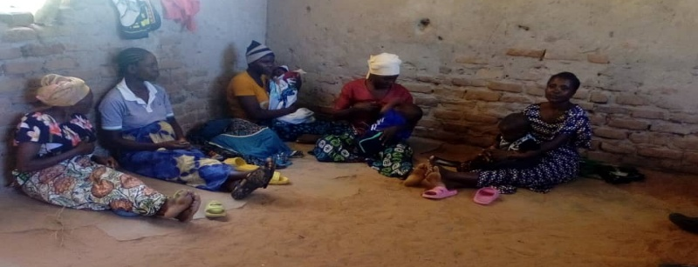

6.5 Participation in Cross-Movement Spaces
Across the region, Deaf women’s participation in advocacy and leadership spaces is evident, particularly within disability-focused movements. Findings from the survey, KIIs, and FGDs indicate that many Deaf women are actively engaged in awareness-raising, community mobilization, policy advocacy, and participation in national and regional disability platforms. Participation is most visible at local and national levels, with more limited engagement at regional and international levels.
However, this participation is uneven and often remains concentrated within disability-specific spaces. Engagement in broader cross-movement platforms, such as women’s rights movements, feminist spaces, and mainstream policy and governance processes, remains comparatively limited. While Deaf women are present in some of these spaces, their involvement is often ad hoc, opportunity-driven, and not sustained through structured or institutional pathways.
A key finding across all data sources is that participation does not consistently translate into influence. Deaf women may be included in consultations, forums, or advocacy activities, yet their ability to shape decisions, influence agendas, or occupy leadership roles within these spaces remains constrained. This reflects a broader pattern observed throughout the assessment, where inclusion is often symbolic rather than substantive.
Several interconnected barriers underpin this limited participation in cross-movement spaces. These include lack of accessibility, particularly the absence or inconsistency of sign language interpretation, limited access to information about opportunities, and financial constraints associated with attending meetings, trainings, or regional forums. In addition, respondents highlighted exclusion from stakeholder processes, noting that Deaf women are often not invited or recognised as key actors within broader advocacy and policy platforms.
Social and structural factors further shape participation. Limited exposure to policy and advocacy processes, low confidence, and gaps in leadership preparedness affect the ability of Deaf women to engage effectively in multi-sectoral spaces.
At the same time, intersectional dynamics play a significant role. Deaf women experience marginalisation both within disability movements, where leadership may be male-dominated, and within women’s rights and feminist spaces, where disability inclusion is often insufficiently addressed. This dual exclusion limits their visibility and influence across both spheres.
Overall, the findings suggest that while Deaf women are actively contributing to advocacy efforts, their participation in cross-movement organisations remains fragmented and constrained.
Strengthening this engagement will require deliberate efforts to improve accessibility, expand outreach and inclusion in stakeholder processes, and build the capacity and confidence of Deaf women to engage in diverse leadership and policy spaces.

7. CONCLUSIONS
This Regional Needs Assessment highlights a consistent and compelling reality across East and Southern Africa. Deaf women possess the potential, motivation, and lived experience necessary to lead, yet they remain constrained by systems that do not adequately support their participation and advancement. The findings demonstrate that the challenge is not one of individual capacity but of structural and institutional limitations. While Deaf women are increasingly visible within organizations and advocacy spaces, their participation is often restricted in scope and influence. Leadership opportunities remain uneven, mentorship systems are weak or absent, and institutional frameworks do not consistently translate commitments to inclusion into practice.
The assessment also points out the complex nature of the barriers faced by Deaf women. These barriers are not isolated but intersect across multiple dimensions, including poverty, limited access to education, communication challenges, gender norms, and institutional exclusion. | 
In addition, internal community dynamics, such as competition for limited resources and weak mentorship structures further shape and, in some cases, constrain leadership pathways. These layered challenges reinforce patterns of exclusion and limit the progression of Deaf women into positions of influence.
At the same time, the findings reveal important opportunities for transformation. Deaf women in all countries are actively advocating for their rights, taking part in policymaking, and showing that they are ready to lead. However, these efforts are often concentrated at the grassroots level and do not consistently translate into sustained leadership within formal governance and decision-making structures. Bridging this gap between participation and power remains a critical priority.
Addressing these challenges requires a shift in approach. Leadership development for Deaf women cannot be addressed in isolation. It must be understood as part of a broader ecosystem that requires a holistic approach integrating education, capacity building, institutional reform, and adequate resource allocation. Without addressing these interconnected elements, efforts to strengthen leadership will remain fragmented and insufficient to achieve sustainable change. Advancing Deaf women’s leadership, therefore, calls for a deliberate transition from symbolic inclusion to meaningful, sustained participation. This includes strengthening institutional accountability, creating accessible and structured leadership pathways, investing in long-term capacity development, and addressing both structural and relational barriers. It also requires expanding opportunities for Deaf women to engage not only at the community level but across national, regional, and international decision-making spaces.
Finally, the transformation of leadership systems depends on a fundamental shift in how Deaf women are recognized and supported, not as beneficiaries of inclusion efforts, but as leaders, decision-makers, and agents of change. Enabling this shift is essential to building inclusive, equitable, and responsive governance systems across the region.

8. RECOMMENDATIONS
The findings of this assessment point to the need for coordinated, multi-level interventions that address both individual capacity and systemic barriers. Strengthening Deaf women’s leadership requires sustained investment in inclusive systems, institutional reform, and leadership development pathways. To achieve this, the following recommendations are made:

8.1 Strengthening Leadership Pathways and Mentorship
There is a need to establish structured and sustained leadership development pathways that include mentorship, coaching, and practical exposure to leadership processes. Programs should intentionally bridge generational gaps by engaging both emerging and experienced Deaf women, fostering intergenerational dialogue learning and continuity in leadership.

8.2 Institutional Reform for Inclusive Governance
Organizations should develop, review, and strengthen governance structures, policies, and leadership processes to ensure they are inclusive, transparent, and gender responsive. This includes embedding accountability mechanisms, promoting equitable representation, and creating formal leadership pipelines for Deaf women.
Governments should prioritize the finalization and implementation of inclusive education policies, ensuring adequate resourcing, teacher training, and accessibility measures to strengthen long-term leadership pathways for Deaf women.

8.3 Investment in Communication Accessibility
Ensuring full accessibility in leadership and policy spaces is critical. This includes investment in qualified sign language interpreters, accessible information formats, and inclusive communication systems that enable Deaf women to participate meaningfully in decision-making processes. There's an urgent need to address systemic exclusion caused by the perception of accessibility as a cost burden by integrating mandatory budgeting for sign language interpretation and accessibility services in all programs.

8.4 Expanding Capacity Beyond Advocacy
Capacity-building initiatives should go beyond advocacy training to include organizational management, financial management, digital skills, and resource mobilization. These competencies are essential for strengthening leadership effectiveness and ensuring the sustainability of Deaf women-led initiatives. Additionally, there is a need to expand legal literacy and policy engagement training to enable Deaf women to actively utilize national and international frameworks.

8.5 Addressing Socio-Economic Barriers
Targeted support is required to address financial constraints, including transport expenses, participation stipends, and economic empowerment initiatives. Programs should also consider the impact of domestic responsibilities and provide flexible and inclusive participation models. | 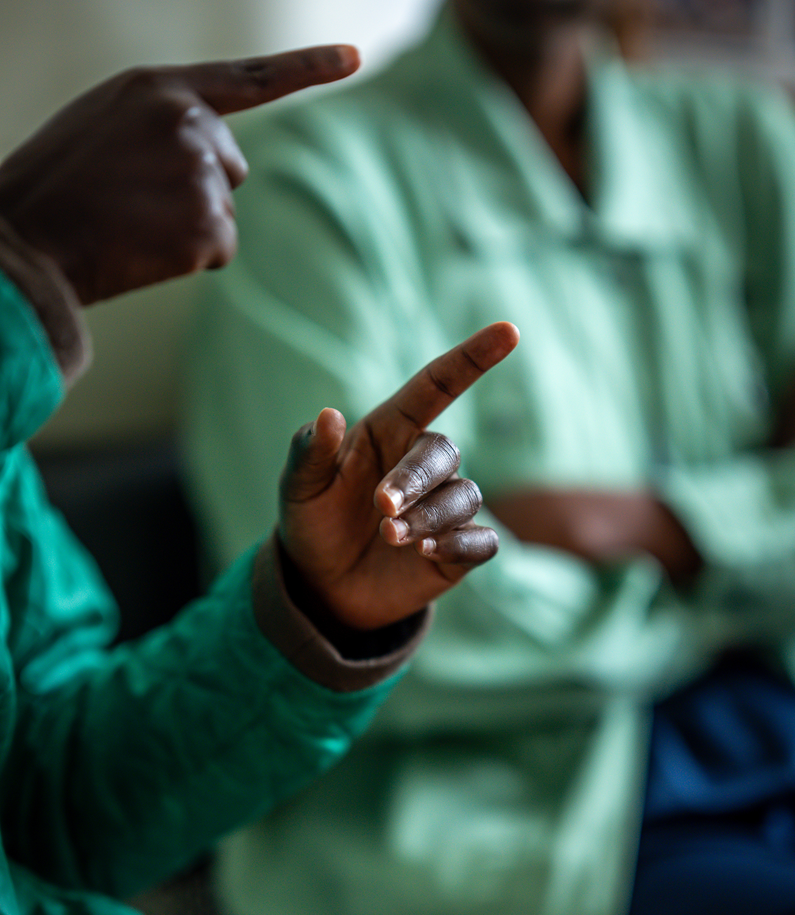
Furthermore, there is a need to increase disability-targeted funding and economic empowerment programs, including access to grants, soft loans, and livelihood initiatives.

8.6 Strengthening Peer Support and Community Cohesion
Efforts should be made to foster collaboration, mentorship, and peer support within Deaf communities. Addressing intra-community dynamics, such as gatekeeping and competition, will be critical to building collective leadership and shared progress.

8.7 Strengthening Institutional Funding and Sustainability
Dedicated and sustained funding for Deaf women-led organizations is essential. This will enable organizations to build long-term programs, strengthen leadership pipelines, and increase their influence in advocacy and policy spaces.

8.8 Promoting Regional Collaboration and Learning
Building on existing initiatives such as the BRIDGE Project, there is a need to strengthen regional platforms for collaboration, peer learning, and collective advocacy. Sharing knowledge and exchanging ideas across countries can speed up the development of leaders and make a bigger difference. In addition, sustained investment in research and evidence generation will be critical to tracking progress, identifying emerging issues, and ensuring that interventions remain responsive to the needs of Deaf women across the region.
There is also a need to strengthen the linkage between grassroots initiatives and formal leadership systems. This includes creating structured pathways that enable Deaf women engaged at the community level to transition into organisational and policy leadership roles, ensuring continuity, sustainability, and broader representation within governance structures.

8.9 Establishing Regional Digital Platforms and Resource Hubs
There is a need to establish regional digital platforms and resource hubs for Deaf women leaders to facilitate knowledge sharing, mentorship, and collaboration. Such platforms can centralize tools, training materials, and best practices, while also strengthening peer networks and cross-country learning to accelerate leadership development across the region.

8.10 Strengthening Participation in International and Regional Leadership Forums
There is a need to strengthen the inclusion and representation of Deaf women in international and regional leadership and advocacy forums, ensuring their meaningful participation in global disability, gender, and development platforms. This includes supporting access through funding, provision of sign language interpretation and other accessibility measures, and preparatory capacity building to enhance effective engagement. Strengthening participation at these levels will enable Deaf women to influence regional and global agendas, contribute to policy dialogues, and amplify their voices within international decision-making spaces.

9. COUNTRY SPOTLIGHTS
The findings from the East and Southern Africa region assessment show that there are both common patterns and unique factors that affect Deaf women's leadership.

9.1 Kenya
Kenya presents a complex and layered picture of Deaf women’s leadership, characterized by both visible progress and persistent structural and internal challenges. Participants demonstrated strong recognition of the leadership potential of Deaf women, with several examples of women-led initiatives and entrepreneurial activities contributing meaningfully to community development.
Deaf women leaders were seen as critical in bridging communication gaps and ensuring access to information within the community.
Despite this progress, significant gender disparities remain within leadership structures. Deaf women continue to be underrepresented in senior decision-making positions, including within Deaf-led organizations. Participants highlighted that leadership spaces are often male dominated, with limited targeted efforts to promote Deaf women into executive roles.
A defining feature of the Kenyan context is the prominence of intra-community dynamics affecting leadership development. Participants described a lack of structured mentorship, coupled with practices of gatekeeping and limited peer support.
This has contributed to what some referred to as a “pull-down” culture, where emerging leaders feel unsupported by those already in positions of influence.
In addition, the findings reveal an important generational dimension. Older Deaf women expressed frustration at being excluded from capacity-building programs, which are often designed with a strong focus on youth.
At the same time, younger women reported limited access to mentorship and guidance, pointing to a disconnect in leadership development systems.

9.2 Rwanda
In Rwanda, Deaf women’s leadership reflects a mixed picture of visible participation alongside structural and resource-related constraints. Survey findings indicate a notably high proportion of respondents in leadership roles, with over 90% identified as occupying leadership positions. However, this should be interpreted with caution, as it reflects a relatively small and concentrated sample of already active individuals rather than widespread inclusion across the Deaf women population.
Beyond survey data, institutional insights reveal that formal governance structures exist with deliberate inclusion mechanisms for Deaf women, although representation remains uneven.

For example, within national organizations, Deaf women are represented at the board level but remain fewer than men, while dedicated structures such as Women’s Committees provide spaces where Deaf women hold full leadership.

Despite these structures, leadership participation remains constrained by several systemic barriers. Limited access to education, lack of leadership training opportunities, and financial constraints continue to restrict the ability of Deaf women to progress into and sustain leadership roles. In addition, communication barriers, including the lack of sign language interpreters and limited access to information, further limit meaningful participation in governance and policy processes.

A key challenge emerging in the Rwandan context is the decline in leadership and capacity-building opportunities due to funding limitations. While some organisations previously provided training in leadership and advocacy, these initiatives have been discontinued following reductions in donor funding.

As a result, there are currently limited or no structured training opportunities for Deaf women on leadership, governance, or the use of international policy instruments such as the UNCRPD, CEDAW, or SDGs.

Participation in public consultations and policy dialogues is increasing but remains uneven. Deaf women leaders within organized structures actively engage in advocacy and consultations; however, broader participation is still limited, with many Deaf women excluded due to structural, financial, and accessibility barriers.

Priority needs identified include strengthening leadership and governance training, expanding mentorship systems, improving digital literacy and networking opportunities, and increasing funding for Deaf women-led initiatives. There is also a strong call for the recognition of sign language, improved accessibility in all engagement spaces, and the establishment of regional platforms for knowledge sharing and collaboration.

Overall, the Rwandan context reflects a situation where structures for inclusion are emerging, but remain under-resourced and unevenly accessible, highlighting the need for sustained investment in leadership development, institutional capacity, and inclusive systems to ensure that Deaf women’s participation translates into meaningful leadership and influence.

9.3 Malawi
In Malawi, Deaf women’s leadership is shaped by a combination of structural, educational, and institutional barriers. While governance systems within Deaf-led organisations are largely democratic, women’s representation remains low, with approximately 20% participation in leadership structures.
Participation in decision-making processes is limited, with many Deaf women not being meaningfully consulted in organizational or policy spaces. This reflects broader systemic exclusion reinforced by communication barriers, particularly the lack of sign language interpreters in leadership and governance environments.
A defining feature of the Malawi context is the impact of weak inclusive education systems on leadership development. Low educational attainment among Deaf girls, driven by limited access to specialized teaching and inclusive learning environments, significantly constrains the leadership pipeline.
Despite these challenges, there are emerging efforts to support Deaf women’s empowerment, including leadership training, economic empowerment initiatives, and women-led committees within organizations. However, these efforts remain fragmented and insufficiently targeted to address systemic barriers.
Key priorities identified include the urgent finalization and implementation of the National Inclusive Education Policy, increased investment in disability-inclusive programming, and expanded leadership and rights-based training. Strengthening institutional accountability, accessibility, and funding mechanisms will be critical to advancing Deaf women’s leadership in Malawi.

9.4 Uganda
In Uganda, Deaf women’s participation in community-level advocacy is increasingly visible, with many women actively engaged in mobilisation, awareness-raising, and disability rights initiatives.
This engagement reflects a growing recognition of their leadership potential and commitment to advancing inclusion within their communities. However, this participation does not consistently translate into influence within formal leadership and policy spaces, where decision-making power remains limited.
Key informants pointed to institutional barriers that continue to restrict Deaf women’s advancement. While organisational frameworks may formally allow participation, they often lack deliberate mechanisms to support progression into leadership roles. As a result, Deaf women are frequently present in governance structures without corresponding authority or influence, reflecting a broader gap between inclusion and meaningful participation.
FGD participants highlighted communication barriers as a persistent constraint, particularly in formal meetings and policy engagements where sign language interpretation is absent, inadequate, or inconsistent. These barriers not only limit participation but also restrict access to critical information, reducing opportunities for engagement and leadership development.
Social and economic factors further shape leadership trajectories. Financial limitations, coupled with domestic responsibilities and limited access to education and training, constrain the ability of many Deaf women to participate consistently in leadership and advocacy processes.
These challenges contribute to a pattern where engagement remains concentrated at community level, with limited transition into higher-level decision-making spaces.
In sum, the Ugandan context reflects a situation where participation is present but constrained in depth and influence, highlighting the need for stronger institutional systems, accessible leadership pathways, and targeted support to enable Deaf women to move from engagement to leadership.

9.5 Tanzania
In Tanzania, Deaf women are involved in organizations and community projects, showing that they are interested in and capable of being leaders and advocates.
However, their progression into leadership roles remains limited, reflecting systemic gaps in institutional support and leadership development pathways. Institutional systems were described as insufficiently responsive, with limited implementation of gender-responsive policies and a lack of structured mechanisms to identify, support, and promote Deaf women into leadership positions. While inclusion is often acknowledged in principle, it is not consistently operationalized in practice, resulting in limited advancement opportunities.
Participants pointed out that limited information sharing often restricts access to leadership opportunities. Opportunities for training, engagement, and leadership are frequently concentrated among a small group of individuals, leaving many potential leaders excluded due to lack of awareness or access. This creates a cycle in which the same individuals continue to participate, while others remain on the margins.
Communication barriers, financial constraints, and limited mentorship opportunities further restrict leadership development. In addition, participants emphasized the importance of building confidence and advocacy skills, particularly for Deaf women who have had limited exposure to leadership spaces.
Without structured support and guidance, many remain hesitant to pursue leadership roles despite having the potential to do so.
The Tanzanian context therefore calls for more inclusive and accessible systems that expand access to opportunities, strengthen mentorship structures, and support a broader pool of Deaf women to engage in leadership and governance.

9.6 Zambia
In Zambia, the findings point to a combination of structural limitations and capacity-related challenges affecting Deaf women’s leadership. While policies promoting inclusion are in place, their practical impact remains uneven, with Deaf women often occupying lower-level positions within organizational structures rather than advancing into senior leadership roles.
Participation in decision-making processes is similarly constrained. Deaf women are frequently present in organizational and advocacy spaces, but their roles are largely participatory rather than influential.
A key issue emerging from the findings is the limited availability of mentorship and leadership development opportunities, particularly for young Deaf women. Participants highlighted that experienced leaders are not consistently providing guidance, creating a gap in leadership continuity and progression.
At the same time, capacity-related challenges, including limited access to education, low confidence, and restricted exposure to leadership processes, continue to discourage Deaf women from taking up available opportunities.
Resource constraints further worsen these challenges, as many emerging advocacy initiatives lack the financial and institutional support necessary to sustain their work. Geographical disparities also play a significant role.
Opportunities for training and leadership development are often concentrated in urban areas, leaving Deaf women in rural communities highly marginalized and with limited access to support systems.
Despite these challenges, there are emerging pathways for strengthening leadership. One participant emphasised the importance of “breaking the ceiling” through deliberate investment in awareness raising and capacity building, not only in advocacy but also in organisational management and financial management.
Strengthening these practical competencies was considered critical to enabling Deaf women to take up and sustain leadership roles, as well as to build stronger, more resilient Deaf women-led initiatives.
Overall, the Zambian context reflects a situation where systemic barriers, capacity gaps, and resource limitations intersect.
At the same time, it highlights clear opportunities for targeted interventions focused on mentorship, skills development, and organisational strengthening to expand leadership opportunities and influence for Deaf women.

9.7 Zimbabwe
Zimbabwe reflects a context where Deaf women are increasingly visible within advocacy and community-level initiatives, demonstrating strong commitment to advancing rights and influencing policy processes.
Their participation in national campaigns and legislative processes illustrates both capacity and potential for leadership. However, despite these gains, their representation in leadership and decision-making structures remains severely limited.
Participants attributed this underrepresentation to systemic exclusion and marginalization, which often leads to the oversight of Deaf women in governance structures and policy processes.
Even within disability and Deaf-led organisations, leadership opportunities for women remain uneven, with some spaces continuing to be male-dominated or insufficiently responsive to gender-specific issues.
Barriers to leadership are multifaceted and deeply intersecting. Participants highlighted the concept of a “double disadvantage,” where Deaf women face compounded discrimination based on both gender and disability. These challenges are reinforced by cultural norms that position women within domestic roles, limiting their visibility and acceptance as leaders.
Communication barriers and lack of access to information continue to restrict participation, particularly in formal and policy spaces. In addition, economic constraints and the high cost of reasonable accommodations, such as sign language interpretation, further limit engagement, with many institutions unwilling or unable to absorb these costs.
Issues of confidence and empowerment also emerged strongly, with participants reflecting on how long-standing exclusion has shaped their self-perception and participation in leadership spaces.
At the same time, there is clear evidence of resilience and agency, with Deaf women actively engaging in advocacy and demonstrating readiness to lead.
The Zimbabwean context therefore reflects both progress and persistent exclusion, emphasizing the necessity of sustained investment in inclusive systems, leadership development, and institutional support to translate participation into meaningful leadership and influence.
Across all countries, the evidence points to a consistent and compelling reality: Deaf women have leadership potential, but systems are not designed to support their full participation and advancement.
While the contexts differ, the underlying patterns of exclusion, limited access to opportunities, weak institutional support, communication barriers, and intersecting forms of discrimination remain strikingly similar. At the same time, the country insights reveal a powerful and growing foundation of agency, resilience, and readiness among Deaf women to lead.
Unlocking this potential will require deliberate, sustained, and context-responsive investment in inclusive systems, leadership pathways, and collaborative ecosystems that move beyond symbolic inclusion towards meaningful influence and transformation across the region.

ANNEX I – LIST OF PARTICIPATING ORGANISATIONS
COUNTRY | ORGANISATION
Kenya | - eKtabu  - Light for The World- Kenya  - UNDP (Kenya)  - MAMA CASH  - Kenya National Association of the Deaf  - Kambui School for the Deaf
Rwanda | - Rwanda National Association of Deaf Women  - Rwanda National Union of the Deaf  - Association Generale des Handicaps du Rwanda
Malawi | - Malawi Association of the Deaf  - Malawi Council for Disability Affairs  - Disabled Women in Development  - Humanitarian Development Services  - Parents Of Disabled Children Association of Malawi  - Bible Society of Malawi  - Federation of Disability Organizations In Malawi  - TUJENGE Youth Initiative
Tanzania | - Arusha Deaf Women  - Patandi Teachers College
Uganda | - Reach A Voice Uganda  - Sign Language For All  - Uganda Federation of the Hard of Hearing  - Women in Technology Uganda  - National Association of Deafblind Persons Uganda  - Uganda National Association of the Deaf  - Rising Together Foundation  - Tunawezi Foundation  - Deaf Action Uganda  - Albinism Umbrella  - National Union of Disabled Persons of Uganda (NUDIPU)  - Show Abilities Uganda
Zambia | - Zambia Deaf Youth and Women  - Zambia National Association for the Deaf  - Disability Rights Watch  - Zambia Deaf Society  - Zambia Federation of Disability Organisations  - Youth Enabled Zambia  - Inclusive Society Foundation  - Foundation for Adolescent girls and young people in Zambia  - Zambia National Association for Women with Disabilities  - Federation of Sign Language Interpreters and Translators of Zambia  - Sign Grow Agribusiness Zambia
Zimbabwe | - Deaf Women Included  - Zimbabwe National Association of the Deaf  - Centre for Children with Disabilities  - Deaf Hands at Work  - National Association of Societies for the Care of the Handicapped  - Zimbabwe National Association of Mental Health  - Signs of Hope  - Zimbabwe Deaf Media Trust  - Zimbabwe National Association of the Deaf  - Sign Language Interpreters Association of Zimbabwe

ABOUT THE BRIDGE PROJECT
The Bridge Project, funded by BMZ/GIZ, runs from December 2025 to April 2028. Its overall objective is to strengthen the advocacy capacity, self-determination, and meaningful participation of women-led disability organizations in policy spaces across Africa. The project focuses particularly on Deaf women, Francophone women with disabilities, and women-led networks in East and West Africa. Through strategic support to organizations, peer learning, regional convenings, research on priorities, and cross-movement alliance building with women’s rights actors, BRIDGE aims to build stronger regional leadership, amplify the voices of women with disabilities, and ensure their priorities are reflected in national, regional, and continental decision-making processes.

ABOUT FEDWEN
The Federation of Deaf Women Empowerment Network (FEDWEN Kenya) is a Deaf women-led organization that advances the rights, leadership, and inclusion of Deaf women and girls in Kenya and across the East and Southern African region. Founded in 2008, FEDWEN addresses systemic barriers that limit access to information, services, and decision-making spaces.
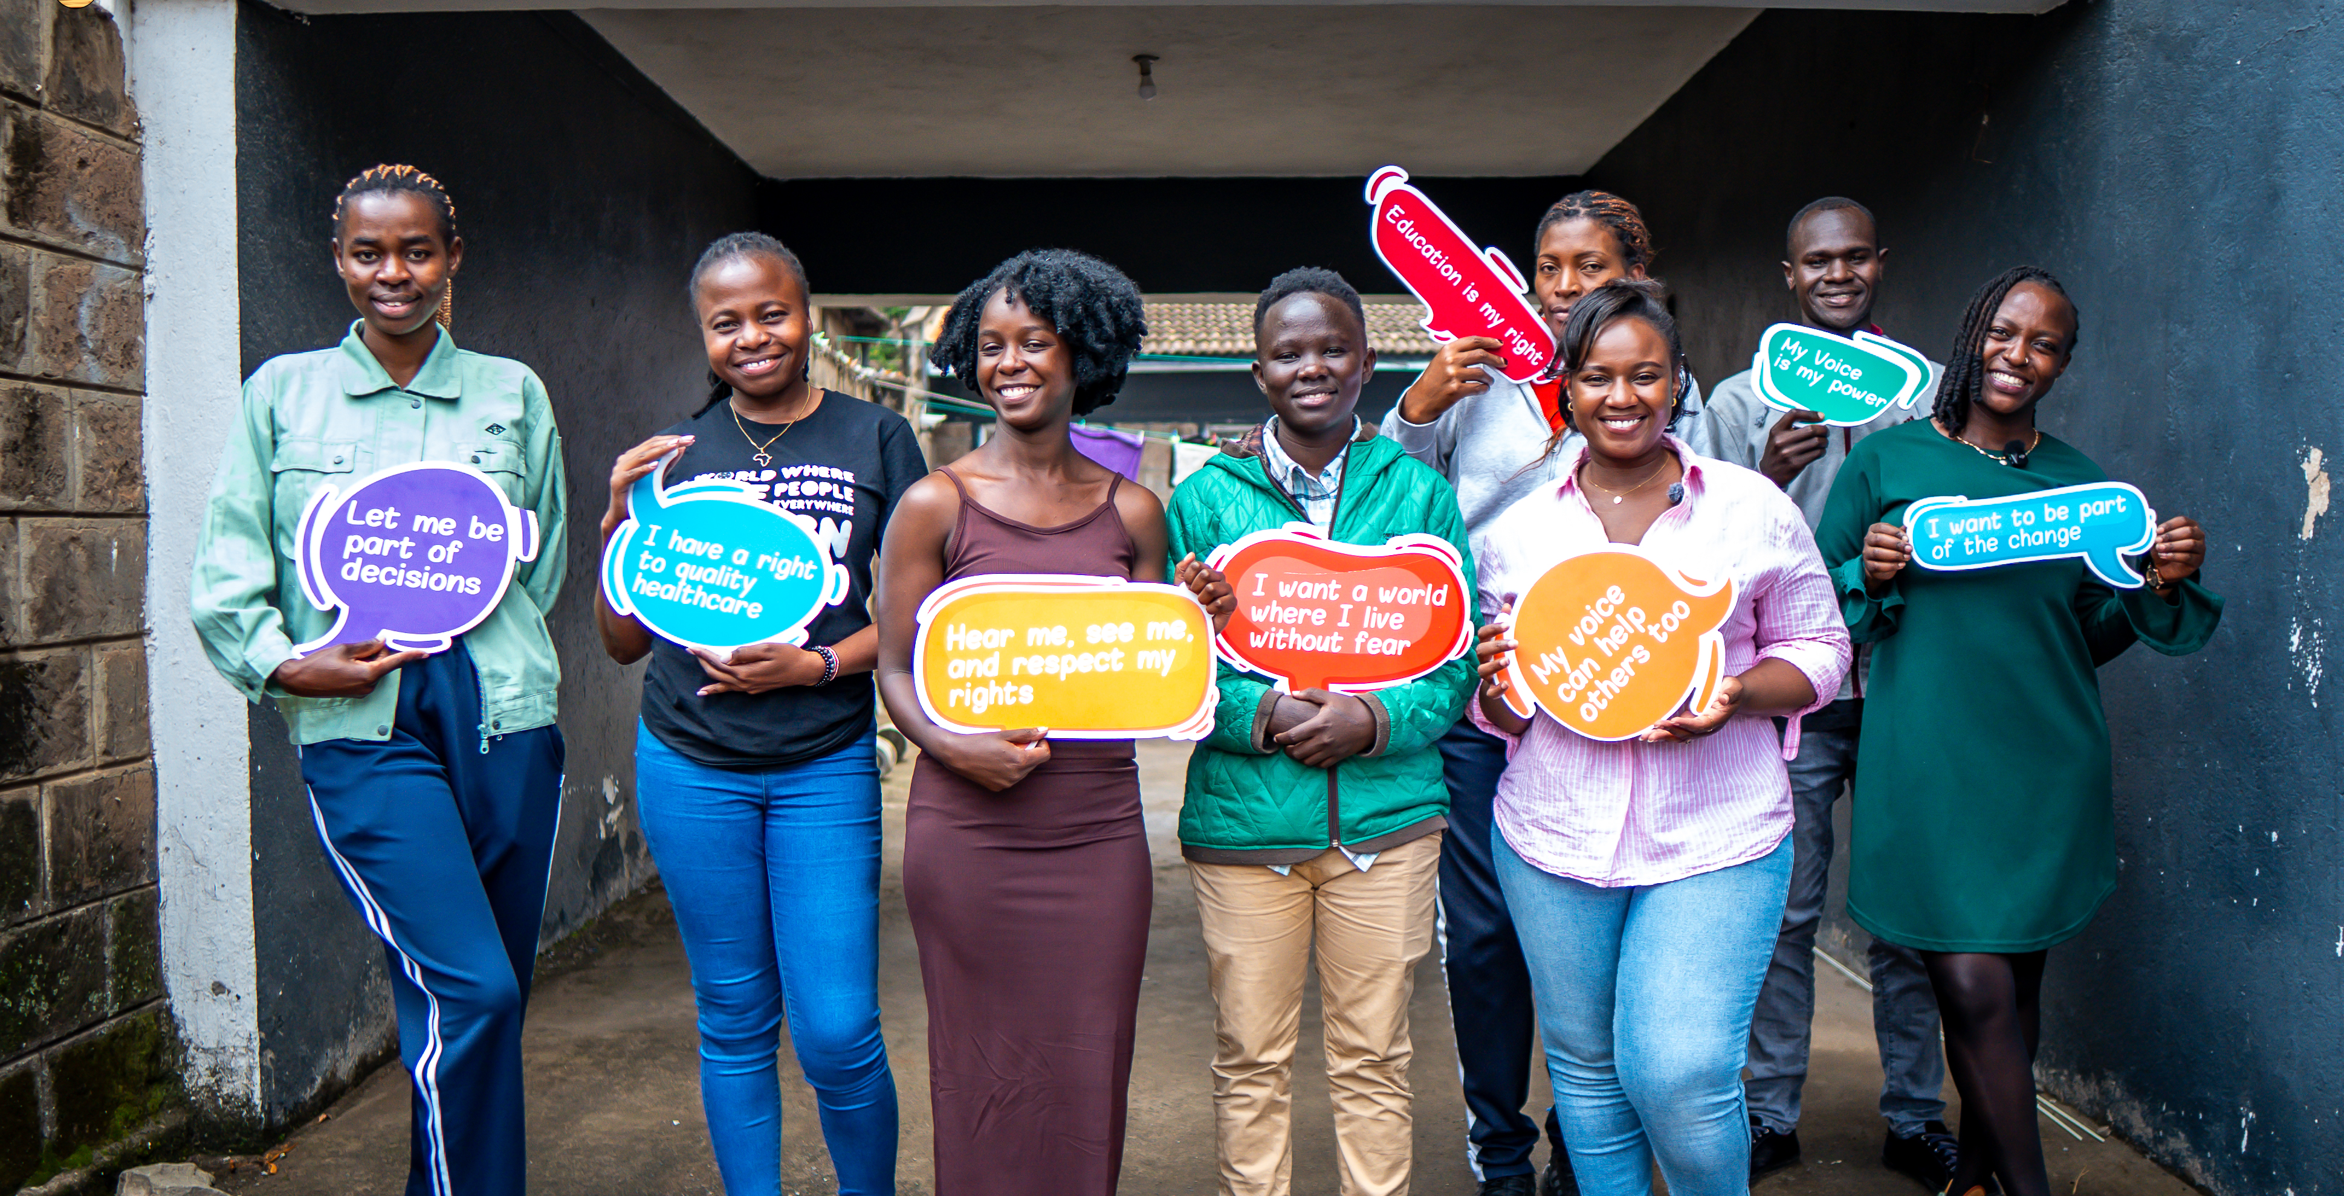
Grounded in a rights-based and intersectional approach, FEDWEN prioritizes Deaf leadership and promotes the meaningful participation of Deaf women in shaping solutions that affect their lives.
The organization’s core work focuses on Sexual and Reproductive Health and Rights (SRHR), prevention of gender-based violence, leadership development, and access to justice.
Building on its growing regional role, including co-convening the World Federation of the Deaf (WFD) Pre-Conference on Gender Equality, this report presents findings from the BRIDGE Project, a regional needs assessment conducted to examine the leadership, capacity, and representation of Deaf women across Eastern and Southern Africa.
The assessment provides critical evidence to inform targeted interventions, strengthen collective advocacy, and advance inclusive leadership within Deaf movements and beyond.
By centring data and lived experiences, this report seeks to influence leadership development, strengthen institutional capacity, and catalyse coordinated regional action that ensures Deaf women are not only represented but leading in decision-making spaces.

fedwenkenya.org

Strengthening the Leadership of Deaf Women
East and Southern Africa

